|  |  |  |  |  |
| --- | --- | --- | --- | --- |
|  |  | | |  |
|  |  | | |  |
|  | Function Group Spec  Body Control System  NFC Entry and Starting | | |  |
|  |  |
|  |  |
|  |  | | |  |
| Document Type | **Function Specification** | | |  |
| Template Version | **6.0** | | |  |
| SysML Report Template Version | **M (4/16/2019)** | | |  |
| Document ID | **2021-05-24** | | |  |
| Document Location |  | | |  |
| Document Owner | **Aaron Bonnell-Kangas (abonnel1)**  **Aaron DeLong (adelong2)**  **Farhan Ehsan (fehsan1)**  **Eugene Karpinsky (ekarpins)**  **Reinaldo Sepulveda (spepulv6)**  **Jonathon Wolf (jwolf53)** | | |  |
| Document Revision | **2021-06-07 (GE2 UPV1)** | | |  |
| Document Status | **Release** | | |  |
| Date Issued | **2020-05-22** | | |  |
| Date Revised | **2021-06-07** | | |  |
| Document Classification | GIS1 Item Number: | **27.60/35** | |  |
| GIS2 Classification: | **Confidential** | |
|  | | | | |
|  | | | | |
| Document Approval | | | | |
| Name | Role | | Email Confirmation | Date |
|  |  | |  |  |

Printed Copies are Uncontrolled

# Disclaimer

**This document contains Ford Motor Company Confidential information. Disclosure of the information contained in any portion of this document is not permitted without the expressed, written consent of a duly authorized representative of Ford Motor Company, Dearborn, Michigan, U.S.A.**

**Copyright, Ó 2021 Ford Motor Company**

This document contains information developed and accumulated by and for FORD MOTOR COMPANY. As such, it is a proprietary document, which, if disseminated to unauthorized persons, would provide others with restricted information, data, or procedures not otherwise available, exposing the FORD MOTOR COMPANY to potential harm.

Employees and suppliers having custody of this specification or authorized to use it must be cognizant of its proprietary nature and ensure that the information herein is not made available to unauthorized persons.

FORD MOTOR COMPANY reserves the right to protect this work as an unpublished copyrighted work in the event of an inadvertent or deliberate unauthorized publication. FORD MOTOR COMPANY also reserves its rights under copyright laws to protect this work as a published work.

This document or portions thereof shall not be distributed outside FORD MOTOR COMPANY without prior written consent. Refer all questions concerning disclosure to the author(s) or to any duly authorized representative of Ford Motor Company.

# Contents

Disclaimer 2

Contents 3

1 Introduction 6

1.1 Document Purpose 6

1.2 Document Audience 6

1.2.1 Stakeholder List 6

1.3 Document Organization 8

1.3.1 Document Context 8

1.3.2 Document Structure 9

1.4 Document Conventions 9

1.4.1 Terminology 9

1.4.2 Requirements Templates 9

2 Logical Architecture 10

2.1 Structure 10

2.2 Logical Architecture 10

3 Function Group Description 12

3.1 Logical System Properties 12

3.2 Logical System Requirements 13

4 Scenarios 18

4.1 Pair with Personal Profile 18

4.2 Unlock/Lock/Double Lock a Vehicle with an NFC Device 18

4.2.1 Additional flows 19

4.3 Add a Physical NFC Card - Retail 21

4.4 Exit Remote Start 22

4.5 Make an NFC Device a MyKey 23

4.6 NFC-DK-UC-009/010 - Friend Device Wiped Remotely/Security Breach 24

4.7 NFC-DK-UC-001 - owner pairing 25

4.7.1 Additional flows 25

4.8 Owner Sends Manage Key 26

4.9 NFC-DK-UC-014 - Owner Device is Wiped Locally 27

4.10 NFC-DK-UC-015/016 - Owner Device Wiped Remotely/Security Breach 28

4.11 NFC-DK-UC-004 - owner terminate friend key Vehicle 29

4.12 NFC-DK-UC-018/019 Vehicle Removed From Primary/Secondary Account 30

4.13 NFC-DK-UC-011/12 - Owner/Friend Terminate Friend Key In Ford Mobile App 31

4.14 NFC-DK-UC-013 - Owner Terminates Owner Key In Native App 32

4.15 NFC-DK-UC-002 - Change Owner Device 33

4.16 NFC-DK-UC-005 - Owner Terminates Friend Key On Native App 34

5 Function Specifications 35

5.1 -1358808721.jpg Deauthorize NFC Starting 36

5.1.1 Function Overview 36

5.1.2 Logical Function Interfaces 36

5.1.3 Function Modeling 37

5.1.4 Function requirements 37

5.1.5 Function Usages 38

5.2 -1358808721.jpg Display NFC Cluster Message 39

5.2.1 Function Overview 39

5.2.2 Logical Function Interfaces 39

5.2.3 Function Modeling 40

5.2.4 Function requirements 40

5.2.5 Function Usages 44

5.3 -1358808721.jpg Enable/Disable NFC Feature On System 45

5.3.1 Function Overview 45

5.3.2 Logical Function Interfaces 45

5.3.3 Function Modeling 46

5.3.4 Function requirements 46

5.3.5 Function Usages 46

5.4 -1358808721.jpg Handle NFC Local Event 47

5.4.1 Function Overview 47

5.4.2 Logical Function Interfaces 47

5.4.3 Function Modeling 48

5.4.4 Function requirements 48

5.4.5 Function Usages 49

5.5 -1358808721.jpg Handle NFC Tap 50

5.5.1 Function Overview 50

5.5.2 Logical Function Interfaces 50

5.5.3 Function Modeling 51

5.5.4 Function requirements 52

5.5.5 Function Usages 53

5.6 -1358808721.jpg Handle Start Button Press 54

5.6.1 Function Overview 54

5.6.2 Logical Function Interfaces 54

5.6.3 Function Modeling 56

5.6.4 Function requirements 56

5.7 -1358808721.jpg Interpret Tap 58

5.7.1 Function Overview 58

5.7.2 Logical Function Interfaces 58

5.7.3 Function Modeling 59

5.7.4 Function requirements 59

5.7.5 Function Usages 60

5.8 -1358808721.jpg Monitor MyKey Creation Status 61

5.8.1 Function Overview 61

5.8.2 Logical Function Interfaces 61

5.8.3 Function Modeling 62

5.8.4 Function requirements 63

5.8.5 Function Usages 63

5.9 -1745828276.jpg Set NFC MyKey State 64

5.9.1 Function Overview 64

5.9.2 Logical Function Interfaces 64

5.9.3 Function Modeling 64

5.9.4 Function requirements 64

5.9.5 Function Usages 65

6 Revision History 66

6.1 Template Revisions 68

7 Appendix 69

7.1 Data Dictionary 69

7.1.1 Logical Messages 69

7.1.2 Logical Parameters 75

7.1.3 Logical Data Types (encodings) 76

7.1.4 Technical Signals 81

7.1.5 Technical Parameters 94

7.2 Glossary 96

7.2.1 Definitions 96

7.2.2 Abbreviations 96

**List of Figures**

Figure 1: NFC Logical Domain Structure 10

Figure 2: NFC Logical Architecture 11

Figure 3: Pair with Personal Profile 18

Figure 4: Unlock/Lock/Double Lock a Vehicle with an NFC Device 19

Figure 5: Double Lock or Global Unlock 20

Figure 6: Unlock or Lock 20

Figure 7: Add a Physical NFC Card - Retail 22

Figure 8: Exit Remote Start 22

Figure 9: Make an NFC Device a MyKey 23

Figure 10: NFC-DK-UC-009/010 - Friend Device Wiped Remotely/Security Breach 24

Figure 11: NFC-DK-UC-001 - Pair Owner Device 25

Figure 12: SCENARIO - owner sends manageKey 26

Figure 13: NFC-DK-UC-014 - Owner Device is Wiped Locally 27

Figure 14: NFC-DK-UC-015/016 - Owner Device Wiped Remotely/Security Breach 28

Figure 15: NFC-DK-UC-004 - owner terminate friend key Vehicle 29

Figure 16: NFC-DK-UC-018/019 Vehicle Removed From Primary/Secondary Account 30

Figure 17: NFC-DK-UC-011/12 - Owner/Friend Terminate Friend Key In Ford Mobile App 31

Figure 18: NFC-DK-UC-013 - Owner Terminates Owner Key In Native App 32

Figure 19: NFC-DK-UC-002 - Change Owner Device 33

Figure 20: NFC-DK-UC-005 - Owner Terminates Friend Key On Native App 34

Figure 21: Deauthorize NFC Starting 37

Figure 22: Enable/Disable NFC Feature On System 46

Figure 23: Handle NFC Local Event 48

Figure 24: Handle NFC Tap 51

Figure 25: Handle Start Button Press 56

Figure 26: Interpret Tap 59

Figure 27: Monitor MyKey Creation Status 62

**List of Tables**

Table 1: List of Logical Functions 35

Table 2: Definitions used in this document 96

# Introduction

## Document Purpose

The Function (Group) Specification (FS) specifies an individual function / a group of functions.

To get more information about the concept of feature, function and component level abstraction refer to the [Ford RE Wiki](http://wiki.ford.com/display/RequirementsEngineering/Requirements+Engineering+for+SW+Enabled+Features).

## Document Audience

The FS is authored by the owners of the individual functions. All Stakeholders, i.e., all people who have a valid interest in the functions and their behavior should read and, if possible, review the FS. It needs to be guaranteed, that all stakeholders have access to the currently valid version of the FS.

### Stakeholder List

|  |  |  |  |  |
| --- | --- | --- | --- | --- |
| **Name** | **CDSID** | **Org.** | **Title** | **Project Role** |
| John Van Wiemeersch | jvanviem | RA&E, Adv. Feat. Development | Supervisor | Design Support |
| Aaron DeLong | adelong2 | RA&E, Adv. Feat. Development | Research Engineer | Research Design Lead |
| Vivek Elangovan | velango5 | RA&E, Adv. Feat. Development | Research Engineer | Design Support |
| Rita Trupiano | mtrupia1 | PD, Sys. Eng.,  Distributed Feat. | Feature Owner Supervisor | Feature Owner Supervisor |
| Eugene Karpinsky | ekarpins | PD, Sys. Eng.,  Distributed Feat. | Core Feature Owner | Production Design Lead and Feature Owner |
| Farhan Ehsan | fehsan2 | PD, Sys. Eng.,  Distributed Feat. | Core Feature Owner | Production Design Lead and Feature Owner |
| Aaron Bonnell-Kangas | abonnel1 | PD, Sys. Eng.,  Distributed Feat. | Core Feature Owner | Production Design Lead and Feature Owner |
| Jonathon Wolf | jwolf53 | PD, Sys. Eng.,  Distributed Feat. | Core Feature Owner | Production Design Lead and Feature Owner |
| Matt Swis | mswis | PD, EESE, Body & Security Elec. | Core Security & RF Supervisor | NFC System Owner Supervisor |
| Nisha Patel | npate152 | PD, EESE, Body & Security Elec. | Core NFC Engineer | NFC System Owner |
| David Hernandez | dhern138 | PD, EESE, Body & Security Elec. | Core NFC Engineer | NFC System Owner |
| Suthagaran Nagarasa | snagaras | PD, EESE, Body & Security Elec. | Core NFC Engineer | NFC System Owner |
| Kevin Hille | khille | PD, EESE, Body & DAT SW | Technical Specialist – Immob. | NFC Immobilizer Function Owner, Design Support |
| John Ricks | jricks7 | PD, EESE, Body & DAT SW | Software Supervisor | Software Supervisor |
| John Popovecz | jpopovec | PD, EESE, Body & DAT SW | Body Module SW Supervisor | Body Module SW Supervisor |
| Hosam Irsheid | hirsheid | PD, EESE, Body & DAT SW | Software Engineer | Software Design |
| Sam Mehdi | hmehdi | PD, EESE, Body & DAT SW | Product Design Engineer | Software Design |
| Vishala Pasala | vpasala | PD, EESE, Body & DAT SW | Software Engineer | Software Design |

|  |  |  |  |  |
| --- | --- | --- | --- | --- |
| Maeen Mawari | mmawari | PD, EESE, Body & DAT SW | MBSE Engineer | Software Design |
| Eric Reed | ereed2 | PD, EESE, Body & DAT SW | VSC SW Engineer | Software Design |
| Ahmad Sabri | asabri3 | PD, EESE, Body & DAT SW | PD Engineer | Software Design |
| Jeff Lossing | jlossing | PD, EESE, Body & DAT SW | Software Engineer | Software Design |
| Andrew Hall | ahall185 | PD, EESE, Body & DAT SW | Design Engineer, BCM Software | Software Design |
| Sachin Magar | smagar | PD, EESE, Body & DAT SW | Design Engineer, BCM Software | Software Design |
| Akshita Kulkarni | akulka2 | PD, EESE, Body & DAT SW | Design Engineer, BCM Software | Software Design |
| Adithya Ramachandran | aramac11 | PD, EESE, Body & DAT SW | Software Engineer | Software Design |
| S Bagga | sbagga11 | PD, EESE, Body & DAT SW | Software Engineer | Software Design |
| Gail Cheng | gcheng | PD, In-Vehicle Infotainment & Connectivity | Infotainment Systems Supervisor | Infotainment System Design Supervisor |
| Matthew Borrelli | mborrel4 | PD, In-Vehicle Infotainment & Connectivity | Infotainment Systems Engineer | Infotainment System Design |
| Laura Check | lburek | PD, In-Vehicle Infotainment & Connectivity | SYNC Supervisor | SYNC System Supervisor |
| Iqbal Faheem Sayyed | isayyed | PD, In-Vehicle Infotainment & Connectivity | SYNC Technical Program Manager | SYNC Technical Program Manager |
| Scott Watkins | swatkins | PD, In-Vehicle Infotainment & Connectivity | DI Technical Expert | Driver Information Design Support |
| Stavros Dionyssopoulos | sdionyss | PD, CIED | DI HMI Engineer | Driver Information HMI Support |
| Nicholas Davio | ndavio | PD, CIED | HMI Supervisor | HMI Support Supervisor |
| Mack Dobbie | mdobbie | PD, CIED | HMI Designer | HMI Support |
| Montana Pruett | mpruett2 | PD, CIED | I&E Engineer | I&E Support |
| Patrick Brautigan | pbrautig | PD, CIED | UX Engineer | UX Support |
| Jeffrey Hamel | jhamel7 | PD, Enterprise Connectivity | Product Owner, TPM | Ford Mobile App Design |
| Michael Martinez | mmart664 | PD, Mobility | Product Manager | Ford Mobile App Design |
| Bruce Williams | bwilli28 | PD, EESE, Netcom Core | Product Design Engineer | Electrical Architecture Consult |
| Jim Lawlis | jlawlis | PD, EESE, Advanced Netcom | Technical Specialist - Netcom | Electrical Architecture Consult |
| Nhi Torres | ntorres5 | PD, EESE, Netcom Diag. | Supervisor | Electrical Architecture Consult |
| Eric Paton | epaton | PD, EESE, Netcom Diag. | Engineer | Electrical Architecture Consult |
| Ankita Vyas | avyas8 | PD, EESE, Functional Safety | Functional Safety Engineer | Functional Safety Consult |
| Ahmet Cinar | acinar1 | PD Europe, Underbody EESE | Tech. Expert – Closure Electronics | Closure Design Consult |
| Uwe Zank | uzank | PD Europe, Underbody EESE | Supervisor, Security Electronics | Security Design Consult |
| Denney Vellaramkalayil | dvellara | PD Europe, Underbody EESE | System Engineer, Locking Application | Locking Design Support |
| Henry Popow | hpopow | Quality, EESE | Quality Engineer | Quality Coach |
| Gerard Szczepaniak | gszczepa | Quality, EESE | Quality Engineer | Quality Coach |
| Christina Bloxsom | cbloxsom | SE&SE, ASO, Adv. Policy | Subject Matter Expert | Safety & Regulations Consult |
| Mike Westra | mwestra | IT, Cybersecurity | Technical Leader – Security | Cybersecurity Consult |
| Jochen Schubert | jschub1 | IT, Cybersecurity | Cybersecurity Engineer | Cybersecurity Design Support |
| Dan Zajac | dzajac8 | IT, Cybersecurity | Cybersecurity Supervisor | Cybersecurity Supervisor |
| Jacob Nelson | jnels148 | IT, Cybersecurity | Cybersecurity Engineer | Cybersecurity Design Support |
| Xin Ye | xye7 | IT, Cybersecurity | Technical Specialist - Security | Cybersecurity Consult |
| Simon Hurr | shurr | IT, Cybersecurity | Security Application Specialist | Cybersecurity Consult |
| Mike Simons | msimon78 | IT, CVP&P, PaaK | Systems Engineer | Off Board Function Owner Lead |
| Faten Fawaz | ffawaz | IT, CVP&P, Basic Design | Basic Design Architect | Backend Infrastructure Design Lead |
| Steve Craig | scraig33 | IT, CVP&P, Integration | Technical Program Manager | Backend Infrastructure Design Support |
| Yona Shaposhnik | yshaposh | IT, MPS, Mobility Arch. | Solution Architect | Backend Infrastructure Design Support |
| Michelle Moody | mmoody1 | IT, Mobility, FCS | Director | Project Champion – Fleet |
| Robert Johnson | rjohns75 | IT, Mobility, FCS | Product Marketing Manager | Project Champion – Fleet |
| Mustapha Elkhatib | melkhat1 | IT, Mobility, FCS | Product Manager | Fleet Infrastructure Design Support |
| Geoffrey Scofield | gscofiel | IT, Mobility, FCS | Product Engineer | Fleet Infrastructure Design Support |
| Jennifer Oak | joak | MS&S, US Marketing | Connected Marketing Manager | Project Champion – Retail |
| Timothy Son Hing | tsonhin1 | MS&S, US Marketing | Marketing Manager | Project Champion – Retail |

## Document Organization

### Document Context

Refer to the [Specification Structure page](http://wiki.ford.com/display/RequirementsEngineering/Specification+templates) in the [Ford RE Wiki](http://wiki.ford.com/display/RequirementsEngineering/Requirements+Engineering+for+SW+Enabled+Features) to understand how the FS relates to other Ford Requirements Documents and Specifications.

### Document Structure

The structure of this document is explained below:

**Section 1** – Introduction how to use this document including responsibilities and requisite documents. Explains the tterminology. Gives a clarification of the definitions, concepts and abbreviations used in the document.

**Section 2** – Function Group Description. Gives an overview and the purpose of the function group.

**Section 3** – Functional Architecture: Specifies the overall functional architecture of the function group

**Section 4** – Function Specifications: Specifies the logical functions of the function group in detail

**Section 5** – List of Open Concerns

**Section 6** Revision history including a list of new or modified requirements. The requirements in this document are tagged, and this section contains different types of tables listing all, new, or changed requirements by their title and page no.

**Section 7** – Appendix: Presenting additional data mainly in a tabular form, e.g., a data dictionary

## Document Conventions

### Terminology

When referring to aspects of the system design, this document uses standardized language to avoid ambiguity and confusion. The following terms are of particular relevance to this document:

|  |  |
| --- | --- |
| **Term** | **Definition** |
| Configuration parameter | A property of a system that is stored in nonvolatile memory and not expected to be changed during system operation. Examples include assigned serial numbers that are unique to each module and static. |
| Runtime variable | A property of a system that can be read and modified during normal system operation. The variable might be stored in volatile or nonvolatile memory. Examples include stored/saved records, system states, and measured values. |
| Message | A message defines a data structure whose elements are all transmitted simultaneously. The message might be transmitted within a single system, or across a network between two separate systems.  The term “message” is used here to reduce confusion when discussing automotive system behaviors. As it is used in this document, a “message” is identical to the concept of a “signal” as defined in UML/SysML.  A message may or may not contain *signals* – see below. |
| Signal | A signal is a single data element within a message. A signal cannot be transmitted independently of a message, but a message can be transmitted without any signals.  As it is used in this document, a signal corresponds to the UML/SysML concept of a *property*. |

### Requirements Templates

Each requirement, use case or scenario in this specification shall follow the corresponding template given in the document template *Specification_Macros.dotm* at [RE Wiki - Specification Templates](http://wiki.ford.com/display/RequirementsEngineering/Specification+templates?src=contextnavpagetreemode).

#### Identification of Requirements

#### Requirements Attributes

The templates provided by *Specification_Macros.dotm* define a list of attributes for each requirement. This helps to classify the requirement. The attributes are explained at [RE Wiki - Requirements Attributes](http://wiki.ford.com/display/RequirementsEngineering/Requirements+Attributes?src=contextnavpagetreemode).

# Logical Architecture

The NFC Entry and Starting feature is designed assuming the following system structure. The components shown are the logical systems; they may map one-to-one onto a physical module, or one physical module might house multiple logical systems.

## Structure

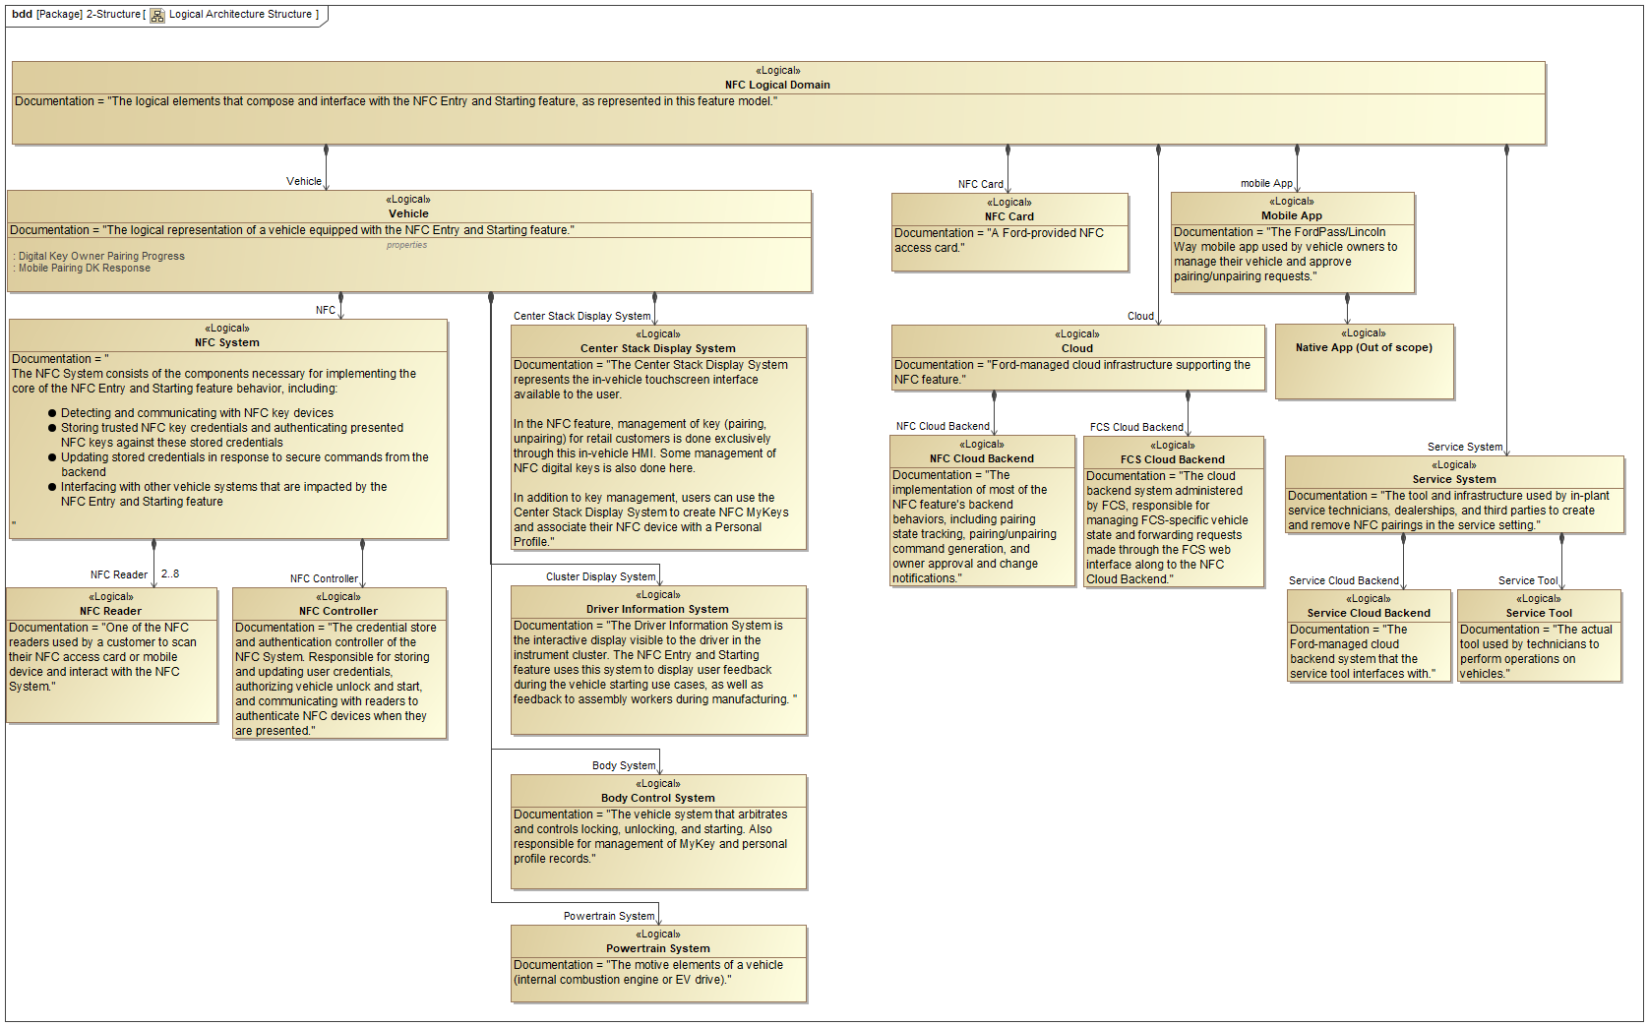

Figure 1: NFC Logical Domain Structure

## Logical Architecture

The Logical Architecture diagram shows the messages that flow between different elements of the NFC Logical Domain. Details on the contents of the messages shown here can be found in the Data Dictionary provided as an appendix.

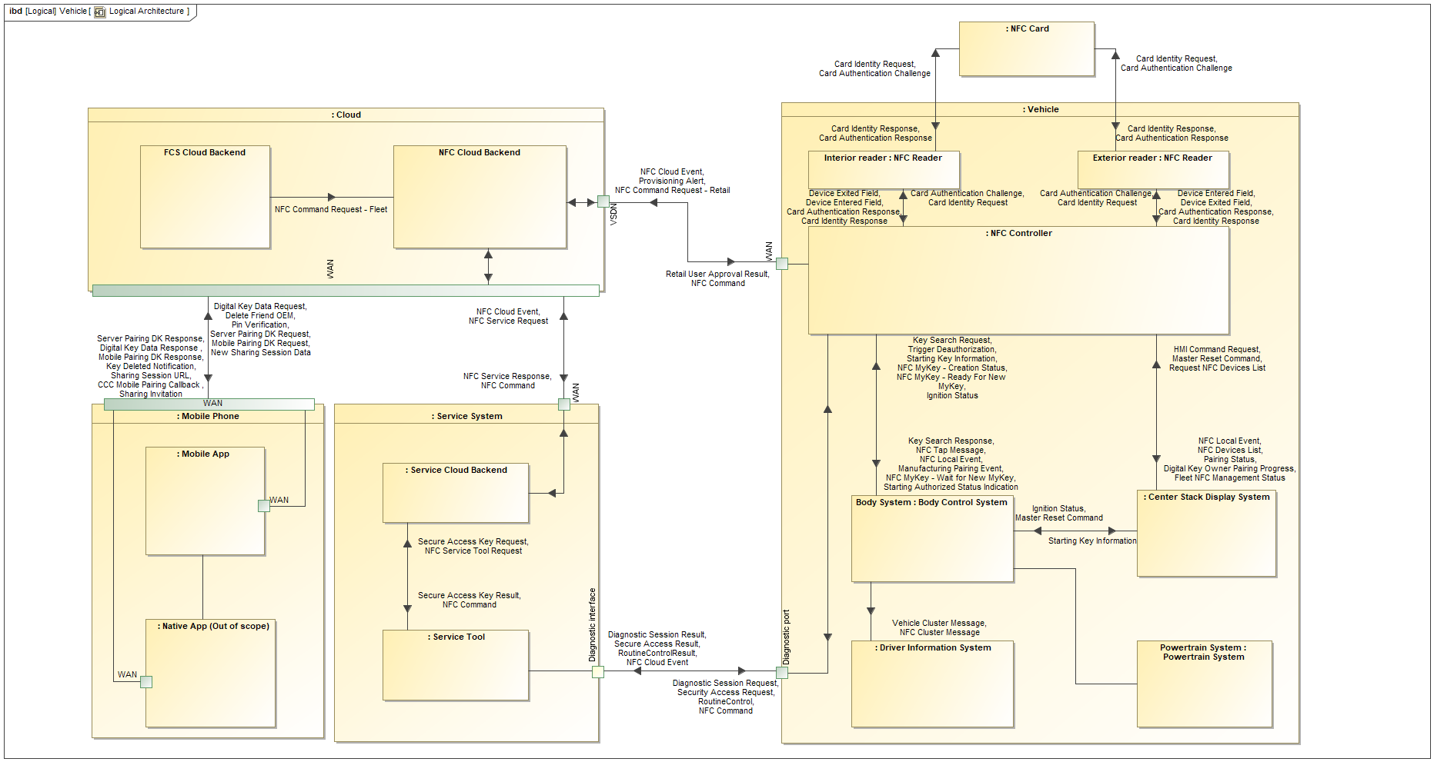

Figure 2: NFC Logical Architecture

# Function Group Description

This Function Group consists of documentation about the logical system component -1630405514.jpg **Body Control System.**

## Logical System Properties

#### Configuration Parameters

|  |  |  |
| --- | --- | --- |
| **Parameter name** | **Data type** | **Description** |
| Key Search Timeout | 2106322276.jpg period duration | The duration that the BCM will wait to receive responses to the Key Search Request after |
| Ready for New MyKey Timer | 999803322.jpg period duration[second] | The duration that the Body Control System will wait to complete its MyKey programming related operations before exiting the MyKey creation process.  Default value = 30 seconds |
| Indication delay | 999803322.jpg period duration[second] | The duration that the Body Control System will transmit its Drive Info indication related signal with non-NULL values before transitioning/transmitting NULL  Default duration = 1 second |
| NFC Cluster Warning Display Duration | 999803322.jpg period duration[second] | The duration that an NFC cluster message should remain visible before expiring. |

#### Runtime Variables

|  |  |  |
| --- | --- | --- |
| **Variable name** | **Data type** | **Description** |
| Waiting For New NFC MyKey | 999803322.jpg Boolean | The Waiting For New NFC MyKey property is set to TRUE when the user has initiated the process of creating a new MyKey. When Waiting For New NFC MyKey is TRUE, the Body Control System will configure the NFC device that triggers the next authorized NFC tap to be a MyKey. |
| NFC enabled | 999803322.jpg Boolean | Whether or not the Body Control System is configured to perform NFC-related behaviors and accept authorizations and commands from the NFC system. Set to FALSE when a vehicle does not have NFC or NFC is disabled. |
| Door Lock State | -1220267902.jpg Door Lock Status | The current state of the vehicle's door locks, as tracked by the locking subsystem of the Body Control System. |
| Secure Idle Status | 999803322.jpg Boolean | The status of the vehicle's Secure Idle feature. |
| Ignition Status | -123237053.jpg Ignition Status | The state of the vehicle's ignition. |
| Remote Start Active | 999803322.jpg Boolean | The state of the vehicle's Remote Start feature. |
| MyKey Record | -694434946.jpg MyKey Record | A single entry in the MyKey status table maintained by the Body Control System. |
| Cabin PK search result | 999803322.jpg Boolean | True = Passive device was detected within the cabin  False = Passive device was not detected within the cabin |
| Lock Requestor | -1220267902.jpg Locking Requestor | Interior Trim Switch = vehicle was locked using the interior trim switch  Else = vehicle was locked not using the interior trim switch |
| Last Unlock Source | -1220267902.jpg Locking Source | The source of the last vehicle unlocking request that was received by the Body Control System. |
| Starting Key Type | -1220267902.jpg NFC Key Type | If the vehicle is running (ignition in RUN or ACC), and it was started by an NFC access card or CCC-compatible digital key, this variable contains the key type of the key that started the vehicle, which is one of the below:  Factory Key = Vehicle was started with a "Factory" NFC Key  Retail User Key = Vehicle was started with an NFC Key that was programmed to the vehicle through the in-vehicle display  Fleet User Key = Vehicle was started with an NFC Key that was remotely programmed to the vehicle through the fleet management system  If the vehicle is not running, or if a key other than an NFC access card/CCC digital key started the vehicle, this variable is null. |
| Starting Key Index | 999803322.jpg Integer | The index of the key that was used to start the vehicle |
| Starting Key Source | -123237053.jpg Starting Authorization Source | When the vehicle is running (ignition in RUN or ACC states), this variable contains the origin of the key that started the vehicle.  This also defines the namespace for the "Starting Key Index" runtime variable.  If the vehicle is not running, this variable is null. |

## Logical System Requirements

REQ-NFC-ES-2 Update MyKey Level

When the Body Control System receives the Update MyKey Level signal, the Body Control System shall call the Make an NFC Device a MyKey function using the fingerprint parameter of the Update MyKey Level signal.

REQ-NFC-ES-15 Store Current MyKey Level

The Body Control System shall store the current MyKey Level of the key used to start the vehicle. This value is undefined when the vehicle is not on.

REQ-NFC-ES-17 Store Current NFC Key Type

The Body Control System shall store the current NFC Key type that indicates whether the NFC Device used to start the vehicle was a Factory Key or a User Key. This value is undefined when the vehicle is not on.

REQ-NFC-ES-18 Publish current NFC Key Type

When the vehicle is started (ignition = RUN) with any key type, the Body Control System shall regularly transmit a message with all of the following information:

1. The source of the authorizing key that was used to start the car (NFC card or CCC digital key, legacy PaaK key, PEPS keyfob, etc)
2. If the key that authorized starting was an NFC key, the key index assigned to that key
3. If the key that authorized starting was an NFC key, the key type of that key (factory key or user key)

Item 2 must be the NFC key index when the starting key is an NFC key. When the starting key is not an NFC key, item 2 should be the index of the non-NFC key, but it may be null. See REQ-NFC-ES-90 for more details on the starting NFC key index.

Item 3 shall be transmitted as null when the starting key is not an NFC key.

**Rationale**: This message is used to enable or disable functionality on the in-vehicle HMI based on the type of key that started the vehicle. It also provides starting key information for data analytics and other features.

*This requirement references the following elements:*

* 270704727.jpg Starting key priority (System Requirement)
* 270704727.jpg Handle Start Button Press: Store Starting Key Index (System Requirement)

REQ-NFC-ES-61 Key Search Response timeout

If the Body Control System sends a Key Search Request to the NFC System, and no response is received within the timeout duration set by the Key Search Timeout configuration property, the NFC System shall be considered unauthorized. Any response to the Key Search Request received after this timeout expires shall be considered invalid.

**Rationale**: If the Body Control System sends a Key Search Request to the NFC System, and no response is received within the timeout duration set by the Key Search Timeout configuration property, the NFC System shall be considered unauthorized. Any response to the Key Search Request received after this timeout expires shall be considered invalid.

*This requirement references the following elements:*

* 270704727.jpg Key Search Timeout parameter (System Requirement)

REQ-NFC-ES-86 Store Starting Key Type for NFC-authorized starts

When the vehicle is started (ignition changes to RUN), and an NFC device authorized starting, the Body Control System shall store the key type (factory key or user key) of the NFC key that authorized starting, as provided by the NFC System in the Starting Authorization Response message.

When the vehicle is started with a non-NFC key, this value is undefined, and may be stored as null.

**Rationale**: The Body Control System is the only system on the vehicle that knows which key was used to start the vehicle (since starting authorization can come from one of several independent systems). This information is published to the rest of the vehicle (see REQ-NFC-ES-18) and used by the in-vehicle HMI to determine whether certain options should be accessible during the current drive cycle.

*This requirement references the following elements:*

* 270704727.jpg Publish current NFC Key Type (System Requirement)

REQ-NFC-ES-110 Body Control System Operational Behavior: Handle NFC Tap

The Body Control System shall call the "Handle NFC Tap" Function after it receives an updated NFC Tap Message, with valid values for "Device Paired", "Tap Location" and "Tap Duration" and the following conditions are true:

- "NFC Enabled" configuration parameter of the of the Body Control System is True

- Body Control System runtime status "Door Lock Status" has a valid value

- Body Control System runtime status "Secure Idle Status" has a valid value

*refer to data dictionary for full signal encoding/valid value list

REQ-NFC-ES-131 Body Control System Operational Behavior: Call Monitor MyKey Creation Status function

When the Body control System receives an "NFC MyKey - Wait for new MyKey" request signal = "True", while:

- The "NFC Enabled" configuration parameter of the Body Control System == True

The Body Control System Operational Behavior shall call the "Monitor MyKey Creation Status" Function.

REQ-NFC-ES-132 Body Control System Operational Behavior: Handle Start Button Press

When the Body Control System receives a "Start Button Press" signal = True while:

- The "NFC Enabled" configuration parameter of the Body Control System == True

- Body Control System runtime status "Remote Start Status" has a valid value

- Body Control System runtime status "Ignition Status" has a valid value

The Body Control System shall call the "Handle Start Button Press" function

REQ-NFC-ES-133 Body Control System Operational Behavior: Handle NFC Command Complete

When the Body Control System received an updated "NFC Command Complete" Message while:

- The "NFC Enabled" configuration parameter of the Body Control System == True

The Body Control System shall call the "Handle NFC Command Complete" function with the following signals received within the "NFC Command Complete" message:

- "Command Type"

- "Successful"

- "Key Type"

- "NFC Key Index"

REQ-NFC-ES-152 Activating personal profile with NFC Device

The vehicle shall apply the personal profile settings associated with an NFC Device when the user does any of the following:

- Unlocks the vehicle with an Exterior Reader scan

- Interior Reader scan while the vehicle is not running

REQ-NFC-ES-185 Multiple NFC Devices associated to one personal profile

It shall be possible to pair one or more NFC Devices to a Personal Profile, even if the Personal Profile has one or more keys of a different type already associated with it.

REQ-NFC-ES-186 NFC Device associated to at most one Personal Profile

An NFC Device shall be associated with at most one Personal Profile.

REQ-NFC-ES-208 Publish current NFC Key Type

The Body Control System shall publish the current NFC Key Type to other vehicle systems when vehicle is started.

*This requirement references the following elements:*

* 270704727.jpg Store Starting Key Type for NFC-authorized starts (System Requirement)

REQ-NFC-ES-284 No Fast Restart for NFC key cycles

When the vehicle is started with an NFC key, Fast Restart behavior (allowing vehicle start without a key for a short time after ignition off) shall not be available for that drive cycle. Fast Restart may be available for drive cycles where NFC keys were not used to start the vehicle.

REQ-NFC-ES-303 No Slam Lock

The Body Control System shall enable Slam Lock Protection on vehicles with NFC.

**Rationale**: To prevent a user from locking their NFC Device within the cabin if it was used to enter or start the vehicle

REQ-NFC-ES-330 Body Control System: "Last Unlock Source" runtime variable

The Body Control System shall store the logical source that caused the last vehicle unlock so that it is possible to determine whether the last unlock was caused by an NFC device tap or some other source. This specification refers to this value as the "Last Unlock Source" runtime variable.

REQ-NFC-ES-331 Body Control System: "Display NFC Cluster Message" behavior

The Body Control System shall execute the "Display NFC Cluster Message" state machine. When the active state of the state machine changes, the Body Control System shall transmit a "NFC Cluster Message" message with the "Indication" value set to the current state.

For example, if the state machine transitions to the "Scan Digital Key to Drive" state, the Body Control System shall transmit a "NFC Cluster Message" message whose "Indication" value is "Scan Digital Key to Drive".

REQ-NFC-ES-332 Body Control System: "NFC Cluster Warning Display Duration" configuration parameter

The Body Control System shall store a configurable value in non-volatile memory that represents the number of seconds that an NFC cluster message should remain on the cluster display after it is triggered. This specification refers to this value as the "NFC Cluster Warning Display Duration" configuration parameter.

REQ-NFC-ES-338 No 5kph key fob check

When the vehicle is on and was started with an NFC key, the Body Control System shall not perform a key search when the vehicle speed hits 5kph.

REQ-NFC-ES-339 Key search when attempting to exit Secure Idle:

The Body Control System shall send a key search to the NFC System whenever the user attempts to drive while in Secure Idle or otherwise attempts to exit Secure Idle.

REQ-NFC-ES-356 Loss of communications with Body Control System causes DTC

When communication with the Body Control System is lost or interrupted (for example, if an expected message from the Body Control System is not received), a DTC shall be triggered.

**Rationale**: Requested by Cybersecurity

REQ-NFC-ES-359 Key Search Timeout parameter

The Body Control System shall have a configuration parameter, referred to in this documentation as Key Search Timeout, which controls the starting authorization response timeout duration described in REQ-NFC-ES-61.

**Rationale**: We expect that the BCM team already has this timeout implemented for other starting authorization sources. Note that this timeout is not related to a user card swipe - it is the time that the NFC System has to respond to the BCM, whether or not it is authorized.

*This requirement references the following elements:*

* 270704727.jpg Key Search Response timeout (System Requirement)

REQ-NFC-ES-395 Starting key priority

If the NFC System is in the Starting Authorized state, and another type of valid vehicle key is present when the user attempts to start the vehicle, the NFC key shall be considered the "starting key" for the purposes of REQ-NFC-ES-18.

For example, if the user has scanned a valid NFC key, and then attempts to start the vehicle while a valid PEPS fob is inside the vehicle cabin, the NFC key shall be the starting key, and the key information published in the signals described in REQ-NFC-ES-18 shall be the index and key type of the NFC key.

**Rationale**: We need to define starting key priority so that the user has a consistent experience when starting the vehicle with multiple keys present.

As an active (non-passive) key type, NFC should be prioritized because this type of key is activated only with a positive user action.

*This requirement references the following elements:*

* 270704727.jpg Publish current NFC Key Type (System Requirement)

REQ-NFC-ES-401 Starting Key Information message behavior

The Starting Key Information signals described in REQ-NFC-ES-18 shall change only according to the following rules:

* The signals shall change value only when the vehicle's ignition status changes from any state into RUN, or vice versa.
* The signals shall not change value while the vehicle's ignition remains in RUN (for example, a module reset that occurs while the vehicle is running shall not cause a change in the transmitted values).

REQ-NFC-ES-405 Manufacturing Pairing Event causes turn signal flash and sounder alert

When the Body Control System receives a Manufacturing Pairing Event message whose "Successful" property is True, it shall flash the vehicle's turn signals once, and chirp the vehicle's sounder, if available.

If the "Successful" property of the received message is False, it shall both flash the turn signals and chirp the sounder, if available, three times quickly.

This behavior may be gated by logic that causes it to occur only when the vehicle is being manufactured.

*This requirement references the following elements:*

* -1020699506.jpg Manufacturing Pairing Event (Logical Signal)

# Scenarios

This section shows specific scenarios that the Body Control System has a role in.

## Pair with Personal Profile

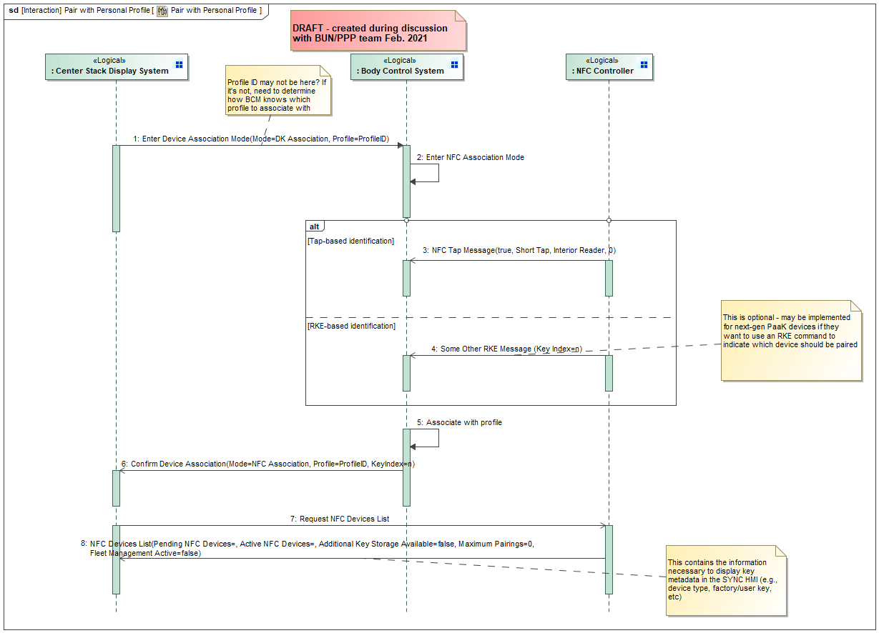

Figure 3: Pair with Personal Profile

## Unlock/Lock/Double Lock a Vehicle with an NFC Device

This is the "entry" part of "NFC Entry and Starting"

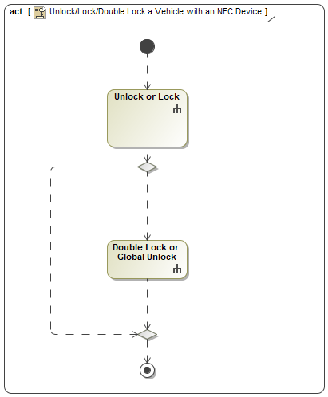

Figure 4: Unlock/Lock/Double Lock a Vehicle with an NFC Device

### Additional flows

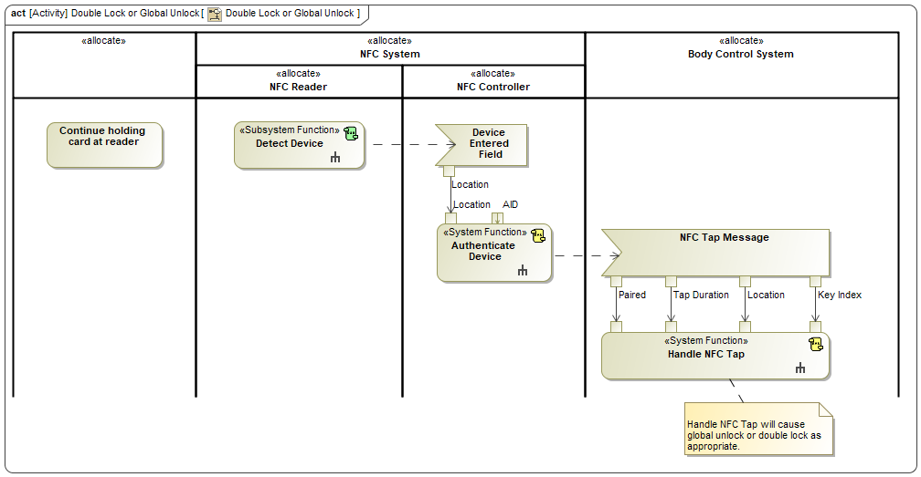

Figure 5: Double Lock or Global Unlock

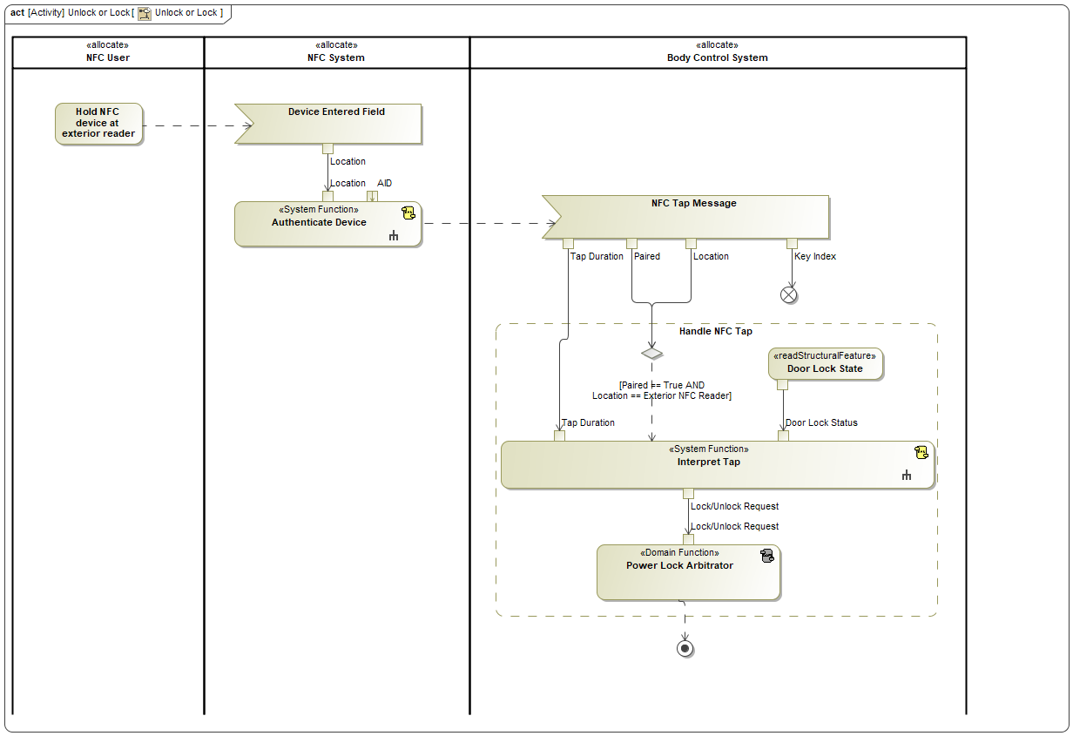

Figure 6: Unlock or Lock

## Add a Physical NFC Card - Retail

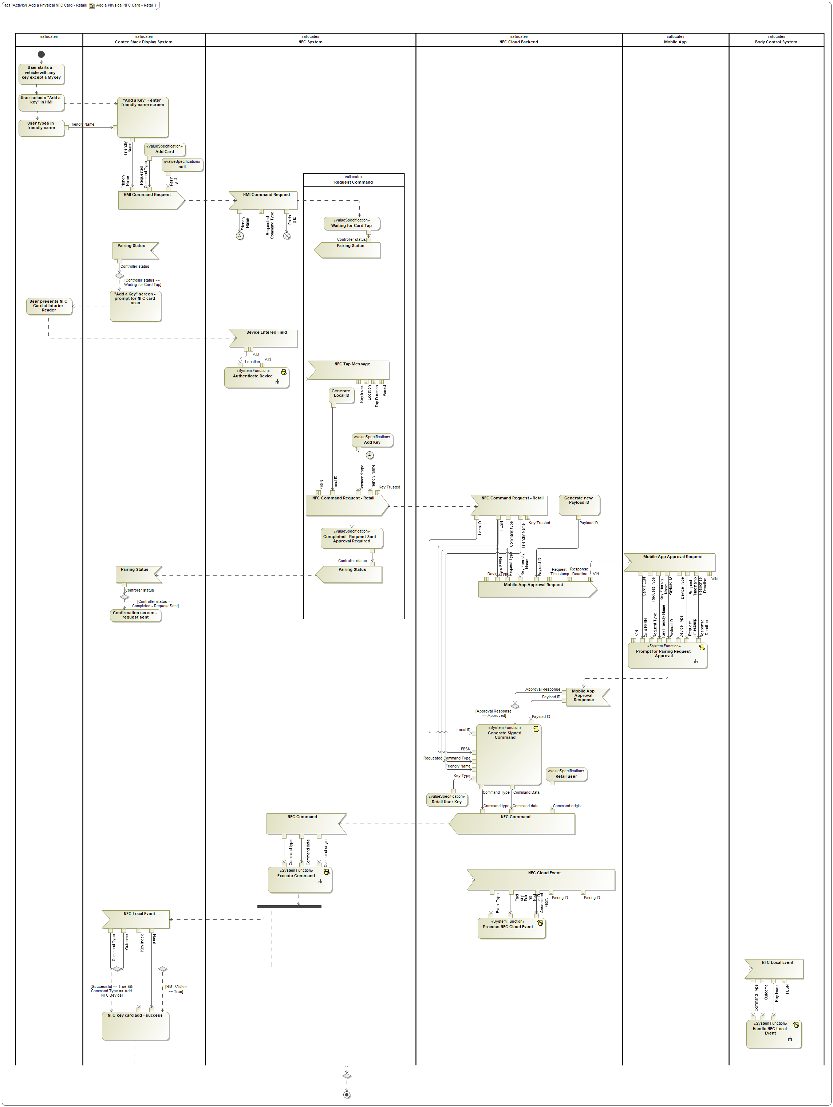

Figure 7: Add a Physical NFC Card - Retail

## Exit Remote Start

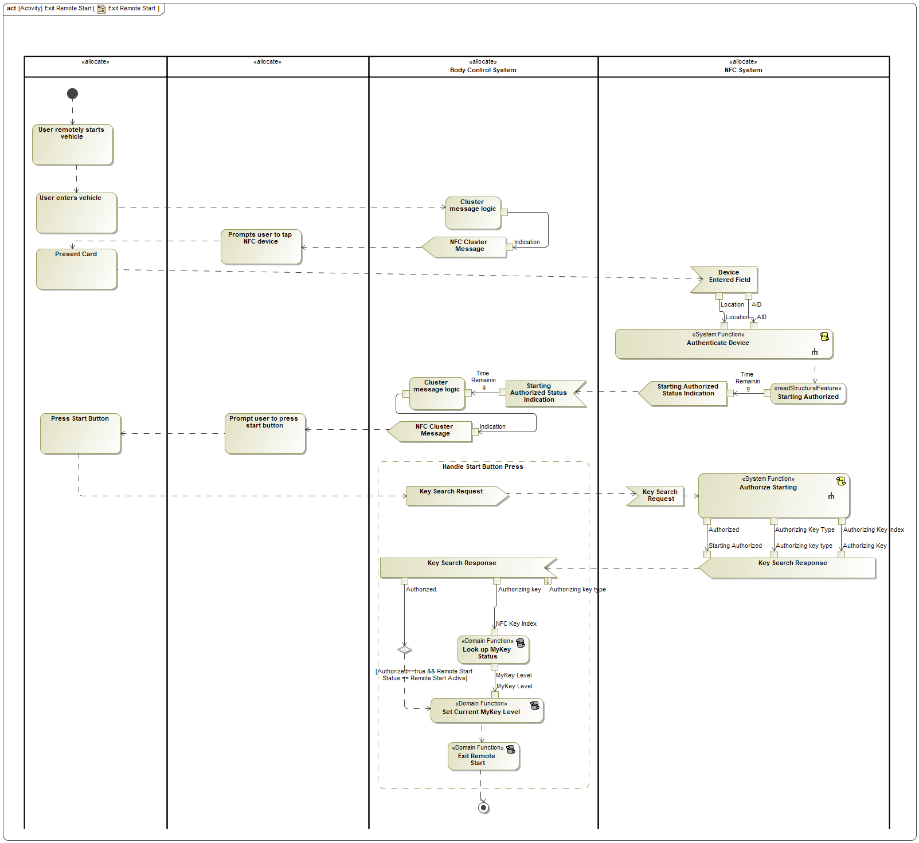

Figure 8: Exit Remote Start

## Make an NFC Device a MyKey

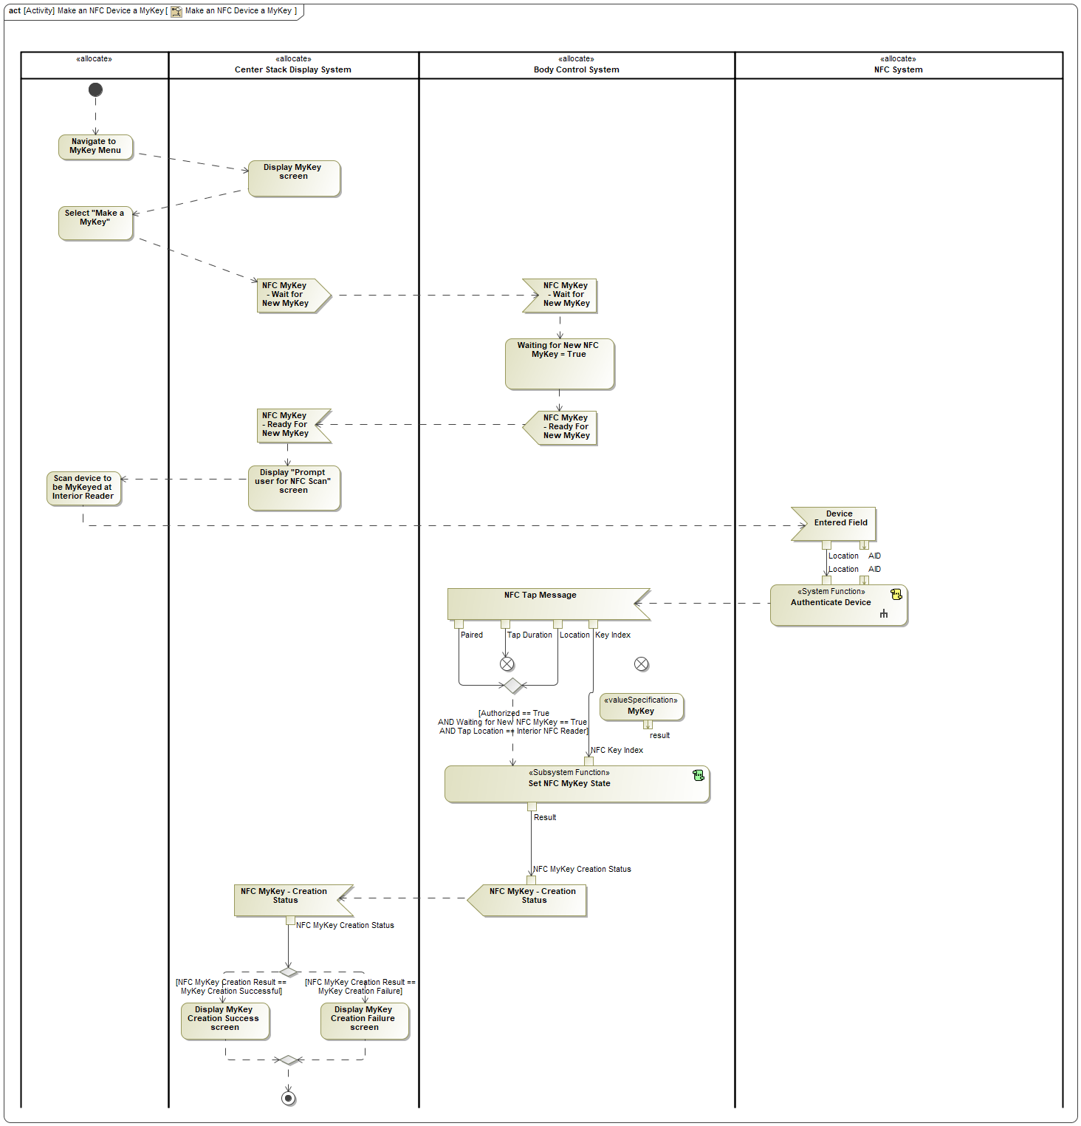

Figure 9: Make an NFC Device a MyKey

## NFC-DK-UC-009/010 - Friend Device Wiped Remotely/Security Breach

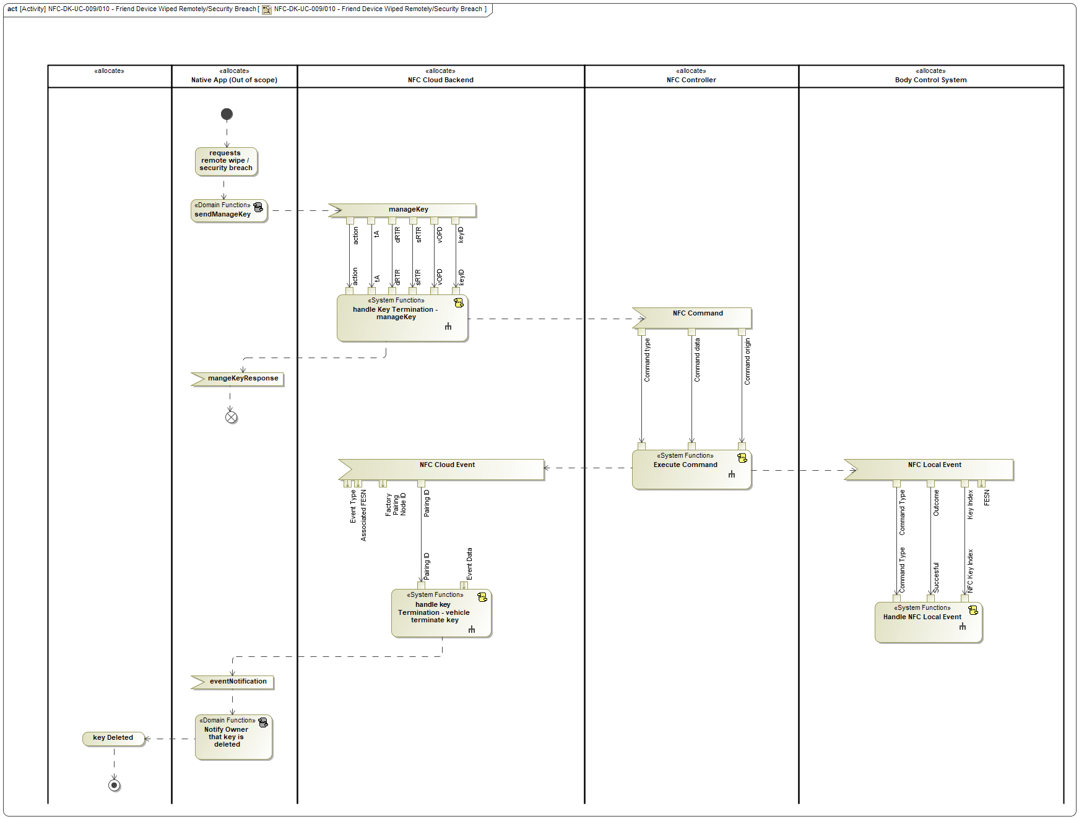

Figure 10: NFC-DK-UC-009/010 - Friend Device Wiped Remotely/Security Breach

## NFC-DK-UC-001 - owner pairing

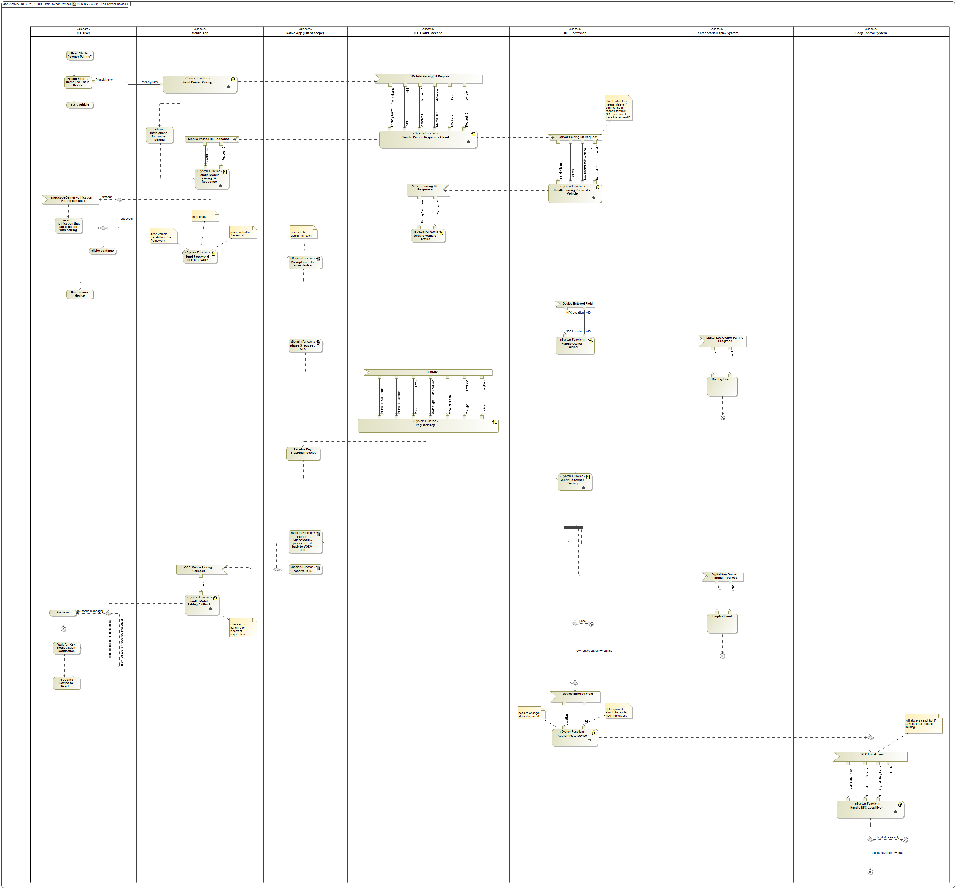

Figure 11: NFC-DK-UC-001 - Pair Owner Device

### Additional flows

## Owner Sends Manage Key

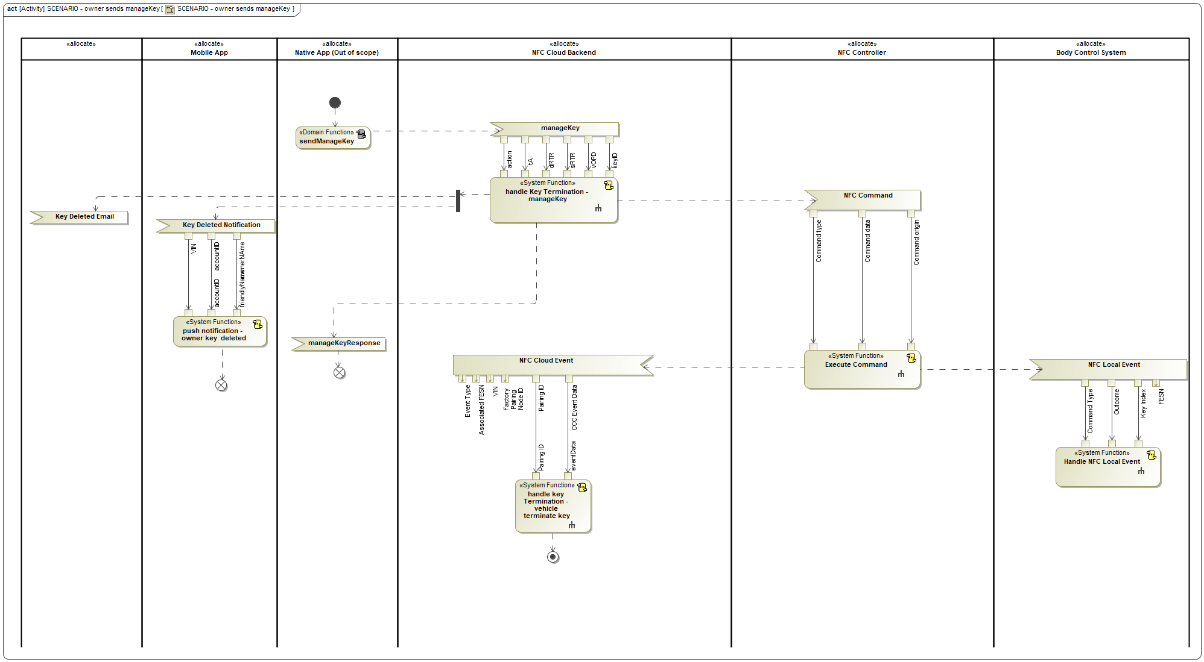

Figure 12: SCENARIO - owner sends manageKey

## NFC-DK-UC-014 - Owner Device is Wiped Locally

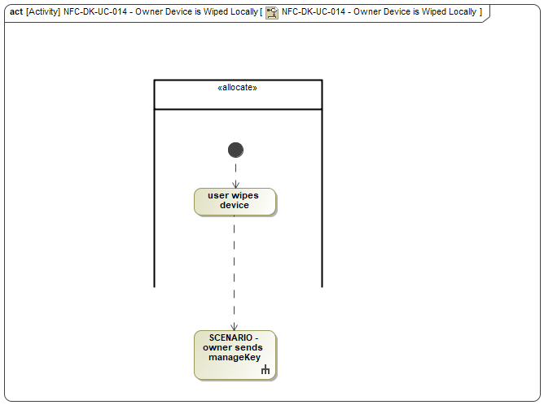

Figure 13: NFC-DK-UC-014 - Owner Device is Wiped Locally

## NFC-DK-UC-015/016 - Owner Device Wiped Remotely/Security Breach

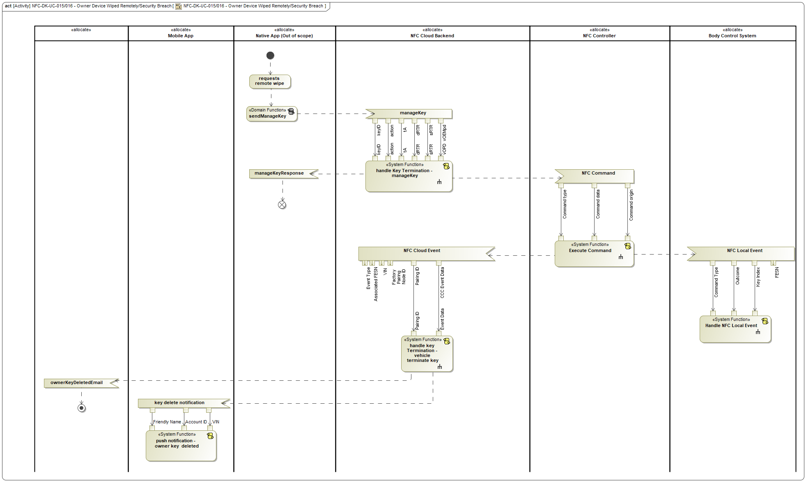

Figure 14: NFC-DK-UC-015/016 - Owner Device Wiped Remotely/Security Breach

## NFC-DK-UC-004 - owner terminate friend key Vehicle

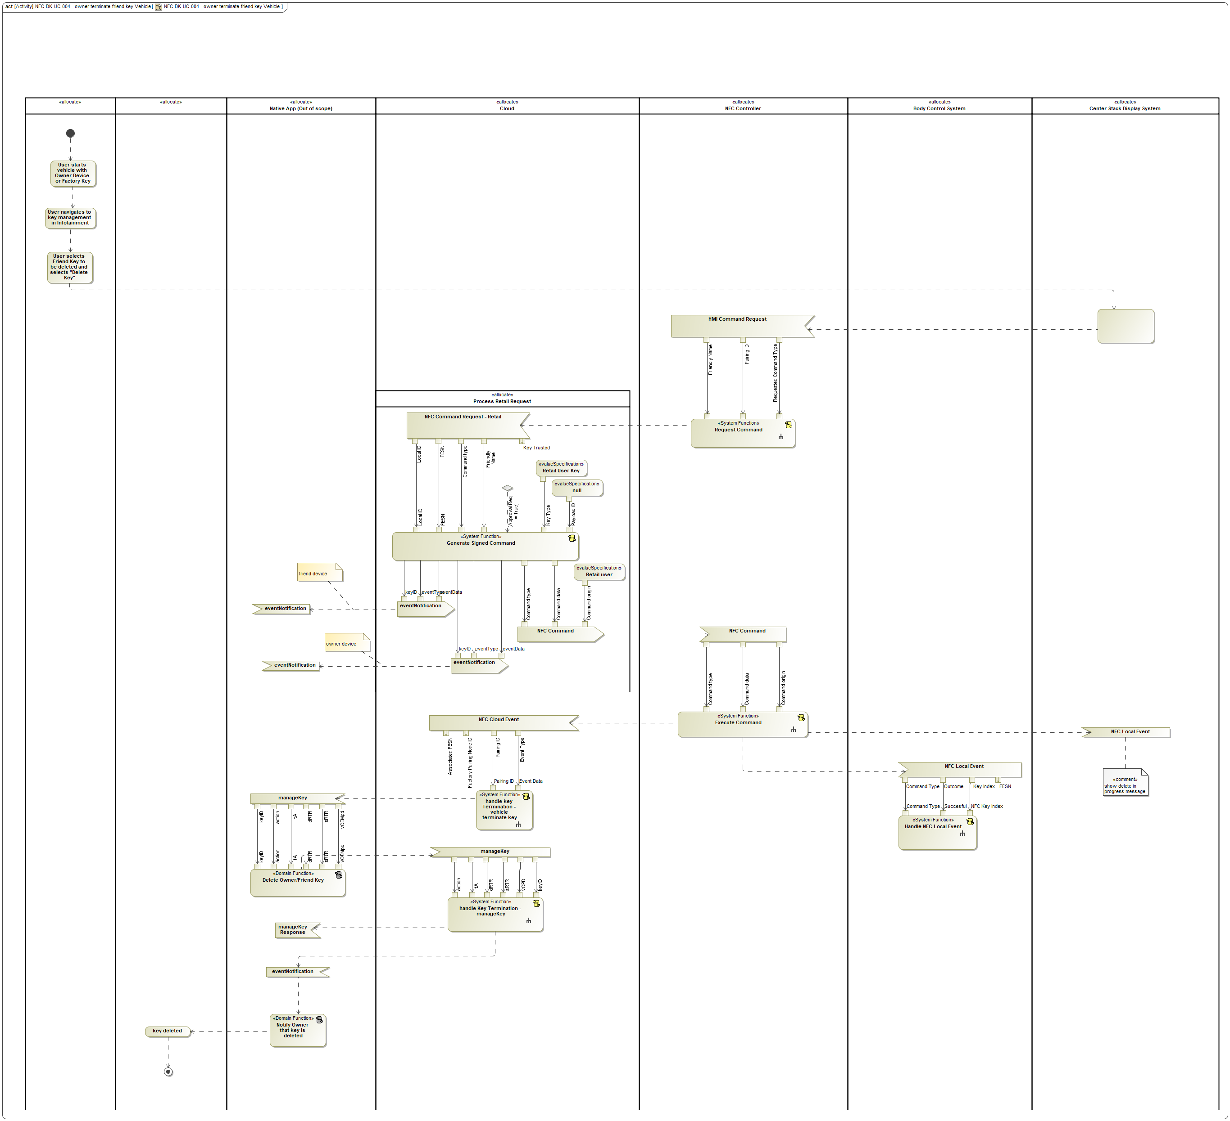

Figure 15: NFC-DK-UC-004 - owner terminate friend key Vehicle

## NFC-DK-UC-018/019 Vehicle Removed From Primary/Secondary Account

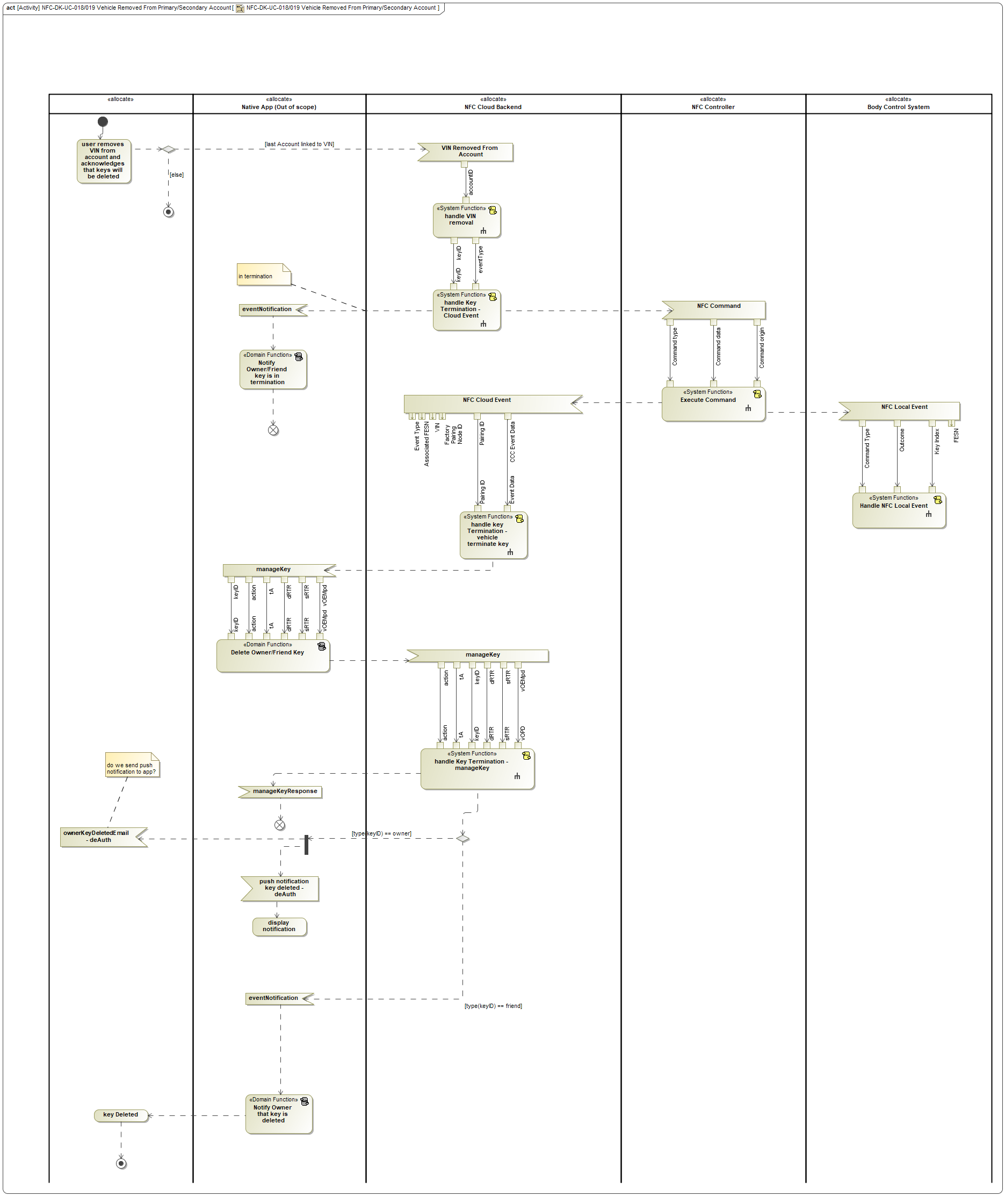

Figure 16: NFC-DK-UC-018/019 Vehicle Removed From Primary/Secondary Account

## NFC-DK-UC-011/12 - Owner/Friend Terminate Friend Key In Ford Mobile App

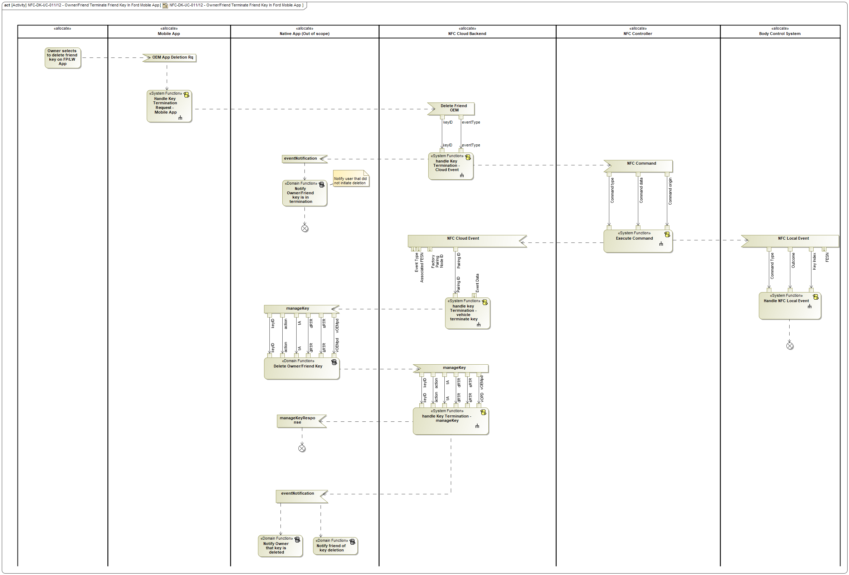

Figure 17: NFC-DK-UC-011/12 - Owner/Friend Terminate Friend Key In Ford Mobile App

## NFC-DK-UC-013 - Owner Terminates Owner Key In Native App

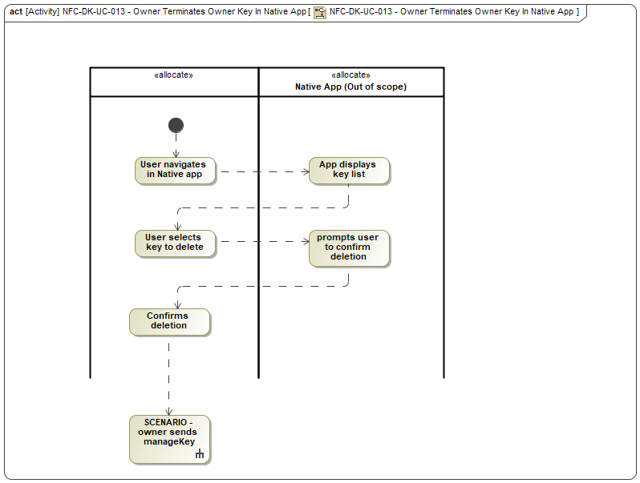

Figure 18: NFC-DK-UC-013 - Owner Terminates Owner Key In Native App

## NFC-DK-UC-002 - Change Owner Device

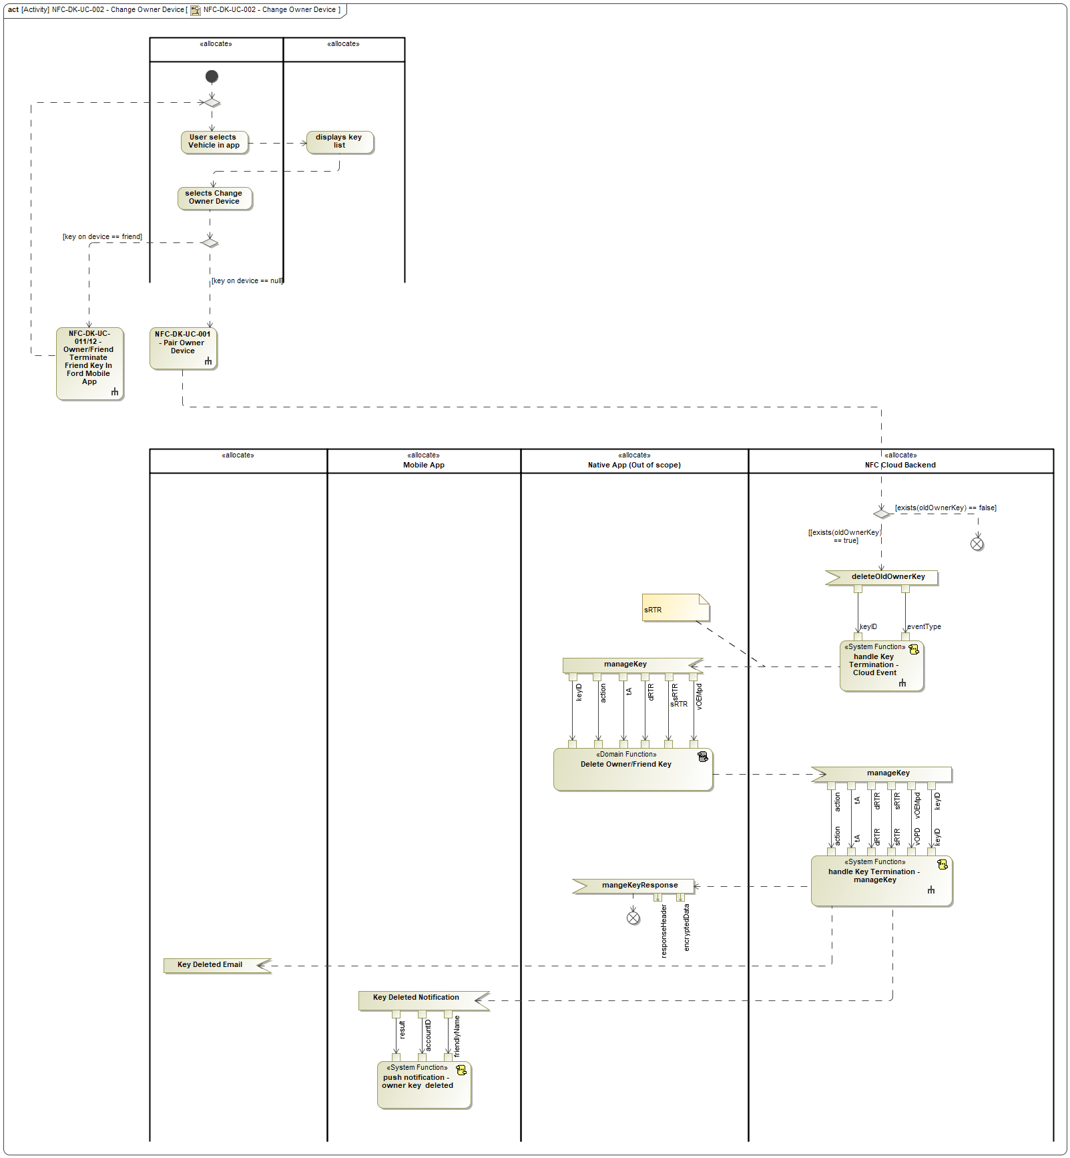

Figure 19: NFC-DK-UC-002 - Change Owner Device

## NFC-DK-UC-005 - Owner Terminates Friend Key On Native App

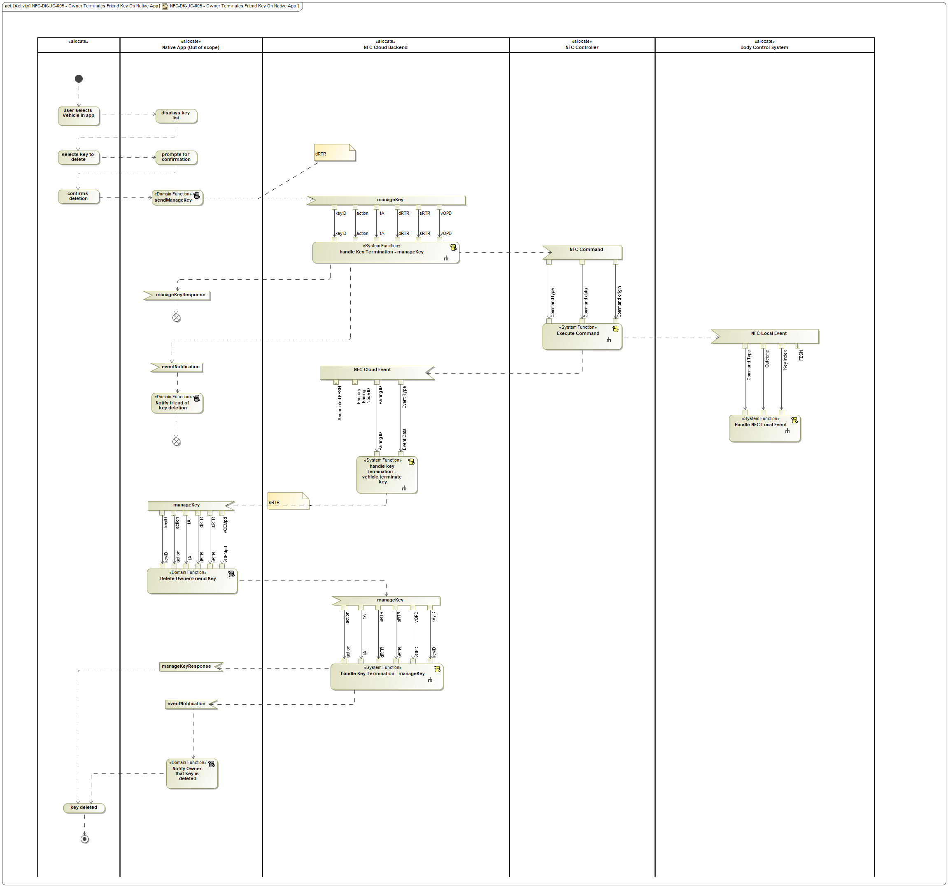

Figure 20: NFC-DK-UC-005 - Owner Terminates Friend Key On Native App

# Function Specifications

The following functions are allocated to the -1630405514.jpg **Body Control System**:

|  |  |  |
| --- | --- | --- |
| **Function Name** | **Function Description** | **ASIL** |
| -1358808721.jpg Deauthorize NFC Starting <<System Function>> | This function will transmit a request to the NFC System to exit its "Starting Authorized" state, after either the vehicle is locked from the exterior or the ignition transitions to OFF. |  |
| -1358808721.jpg Display NFC Cluster Message <<System Function>> | Determines which NFC-related message, if any, should be shown to the driver in the vehicle's cluster. |  |
| -1358808721.jpg Enable/Disable NFC Feature On System <<System Function>> | Change the internal configuration of the system to enable or disable behaviors related to the NFC feature. |  |
| -1358808721.jpg Handle NFC Local Event <<System Function>> | Called whenever an NFC Command Complete Message is received. Performs any housekeeping that is necessary in response to changes that have occurred in the NFC system (for example, updating MyKey tables in response to key adds/deletes). |  |
| -1358808721.jpg Handle NFC Tap <<System Function>> | Handle NFC Tap receives every NFC Tap event that occurs and determines what actions, if any, to take as a result. |  |
| -1358808721.jpg Handle Start Button Press <<System Function>> | Handle start button press will result in the vehicle starting or stopping, exiting remote start, and setting the current mykey level based on receiving a key search response from the NFC System |  |
| -1358808721.jpg Interpret Tap <<System Function>> | This function interprets an user's NFC Tap to determine whether the user action should be interpreted as an unlock request or a lock request. |  |
| -1358808721.jpg Monitor MyKey Creation Status <<System Function>> | This function exits the Body Control System out of its "waiting for MyKey" state if the user does not take any action or the system does no create a MyKey within a specified time frame |  |
| -1745828276.jpg Set NFC MyKey State <<Subsystem Function>> | Given an NFC Key Index and a specified MyKey level, update the Body Control System's internal MyKey tables to set that NFC Key to that MyKey level. |  |

Table 1: List of Logical Functions

## -1358808721.jpg Deauthorize NFC Starting

### Function Overview

#### Description

This function will transmit a request to the NFC System to exit its "Starting Authorized" state, after either the vehicle is locked from the exterior or the ignition transitions to OFF.

Function is allocated to:

* -1630405514.jpg Body Control System <<Logical>>

### Logical Function Interfaces

#### Logical Inputs

**Variable Reads**

|  |  |  |  |
| --- | --- | --- | --- |
| **Variable Name** | **Data type** | **Description** | **Implementation Signal** |
| Door Lock State | 1624642619.jpg Door Lock Status | The current state of the vehicle's door locks, as tracked by the locking subsystem of the Body Control System. |  |
| Ignition Status | -123237053.jpg Ignition Status | The state of the vehicle's ignition. |  |
| Lock Requestor | 1624642619.jpg Locking Requestor | Interior Trim Switch = vehicle was locked using the interior trim switch  Else = vehicle was locked not using the interior trim switch |  |

#### Logical Parameters

No logical parameters.

#### Logical Outputs

#### Logical Signals

**Sent**

|  |  |  |
| --- | --- | --- |
| **Signal Name** | **Description** | **Realizing Element** |
| Trigger Deauthorization | Trigger Deauthorization is a signal sent from the Body Control System to the NFC System to cause the NFC System to exit the Starting Authorized state when either of the follow conditions occur:  - A vehicle is started  - An exterior door lock occurs |  |

No signals received.

### Function Modeling

#### State Charts / Activity Diagrams / Sequence Diagrams / Decision Tables

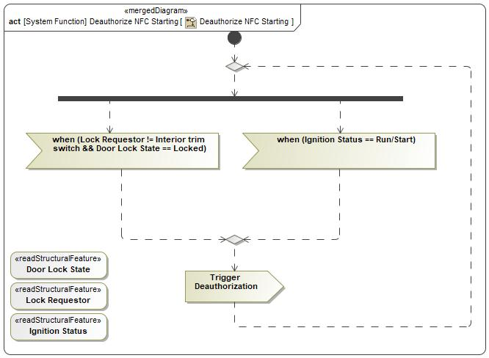

Figure 21: Deauthorize NFC Starting

### Function requirements

REQ-NFC-ES-109 Trigger deauthorization when doors locked from exterior

When the Body Control System's runtime status update to:

- "Door Lock State" == Locked

- "Door Lock Requestor" != Interior trim switch

Then the Deauthorize NFC Starting function shall transmit a "Trigger Deauthorization" signal

**Rationale**: NFC System needs this trigger to cause starting deauthorization when the user triggers a lock from the outside of the vehicle.

REQ-NFC-ES-283 Trigger deauthorization when ignition transitions to Run/Start

When either of the following occurs:

* vehicle's ignition state changes from OFF to RUN, and Remote Start is not active
* vehicle enters a motive state from a nonmotive state (for example, exiting Secure Idle, or exiting Remote Start)

then the Body Control System shall transmit a "Trigger Deauthorization" message to the NFC System.

**Rationale**: NFC System needs this trigger to cause starting deauthorization when vehicle is started

### Function Usages

## -1358808721.jpg Display NFC Cluster Message

### Function Overview

#### Description

Determines which NFC-related message, if any, should be shown to the driver in the vehicle's cluster.

Function is allocated to:

* -1630405514.jpg Body Control System <<Logical>>

### Logical Function Interfaces

#### Logical Inputs

**Function Inputs**

|  |  |  |
| --- | --- | --- |
| **Input Name** | **Data type** | **Description** |
| Secure Idle State | -123237053.jpg Secure Idle Status | If the vehicle's transmission is locked in the park position or not |
| Remote Start State | 427440319.jpg RemoteStartStatus_ET | Indicate whether remote start is active or not |
| NFC Starting Authorization Timer | 2106322276.jpg time |  |
| Last Unlock Source | 1624642619.jpg Locking Requestor | Method by which the vehicle was previously locked |
| Ignition State | 1624642619.jpg Ignition_Status | The ignition status of the vehicle |

#### Logical Parameters

No logical parameters.

#### Logical Outputs

**Function Outputs**

|  |  |  |
| --- | --- | --- |
| **Output Name** | **Data type** | **Description** |
| Message | 1624642619.jpg NFC Cluster Message | Driver information specific signal for displaying vehicle starting/device scanning related instructions |

#### Logical Signals

No signals sent.

No signals received.

### Function Modeling

#### State Charts / Activity Diagrams / Sequence Diagrams / Decision Tables

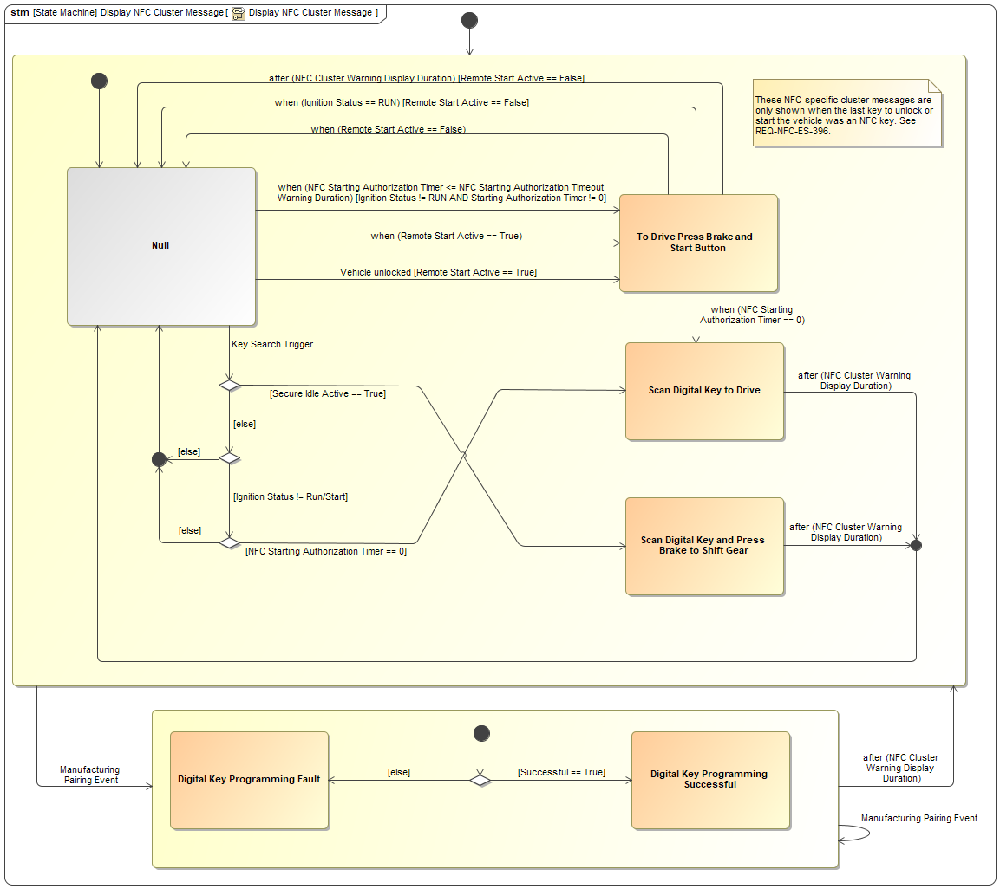

### Function requirements

REQ-NFC-ES-321 Display NFC Cluster Message: Message logic when key search is triggered

When a key search is triggered on the Body Control System, no valid keys are found, and the NFC cluster message display criterion specified in REQ-NFC-ES-396 is satisfied...

...if Secure Idle is active, the NFC Cluster Message "Scan Digital Key And Press Brake To Shift Gear" shall be displayed;

otherwise, if the ignition status is NOT "RUN" or "START", and the NFC Starting Authorization Timer is zero (starting authorization expired), the NFC Cluster Message "Scan Digital Key to Drive" shall be displayed;

otherwise, no NFC Cluster Message shall be displayed (other vehicle cluster messages may be displayed).

*This requirement references the following elements:*

* 270704727.jpg Conditions for displaying NFC cluster messages (System Requirement)

REQ-NFC-ES-322 Display NFC Cluster Message: "To Drive Press Brake and Start Button" timeout

If Remote Start is not active, the NFC Cluster Message shall return to Null after the "To Drive Press Brake And Start Button" message has been shown for the duration specified in the NFC Cluster Warning Display Duration configuration parameter.

If Remote Start is active, the message shall not time out.

REQ-NFC-ES-323 Display NFC Cluster Message: "To Drive Press Brake and Start Button" not displayed after transition to RUN

If Remote Start is not active, and the "To Drive Press Brake and Start Button" message is being shown, the NFC Cluster Message shall return to NULL when the vehicle ignition status changes to RUN from any other state.

REQ-NFC-ES-324 Display NFC Cluster Message: "To Drive Press Brake and Start Button" not displayed after exit from Remote Start

If the "To Drive Press Brake and Start Button" message is being shown, and the vehicle's Remote Start status changes from active (nonmotive due to remote start) to any other state, the NFC Cluster Message shall return to NULL.

REQ-NFC-ES-325 Display NFC Cluster Message: show "To Drive Press Brake and Start Button" when in Remote Start

If the NFC Cluster Message is NULL and either of the following occurs:

* The last unlock source was an NFC device, and the vehicle's Remote Start status changes from inactive to active; or
* while the vehicle is in the Remote Start state, one or more doors is unlocked using an NFC device

then the NFC Cluster Message shall change to "To Drive Press Brake and Start Button".

REQ-NFC-ES-326 Display NFC Cluster Message: Display "Scan Digital Key to Drive" when NFC Starting Authorization Timer reaches 0

When the NFC Starting Authorization Timer changes to 0 from any other value, and the NFC Cluster Message is "To Drive Press Brake and Start Button", the NFC Cluster Message shall change to "Scan Digital Key to Drive".

REQ-NFC-ES-327 Display NFC Cluster Message: "Scan Digital Key to Drive" timeout

The NFC Cluster Message shall return to NULL after the "Scan Digital Key to Drive" message has been shown for the duration specified in the NFC Cluster Warning Display Duration configuration parameter.

REQ-NFC-ES-328 Display NFC Cluster Message: Messages for Manufacturing Pairing Events

If a Manufacturing Pairing Event message is received by the Body Control System:

* ...if the "Successful" parameter of the message is True, then the NFC Cluster Message shall change to "Digital Key Programming Successful".
* ...otherwise, the NFC Cluster Message shall change to "Digital Key Programming Fault".

REQ-NFC-ES-329 Display NFC Cluster Message: "Digital Key Programming" message timeout behavior

After either the "Digital Key Programming Fault" or the "Digital Key Programming Successful" message is displayed for a duration specified in the "NFC Cluster Warning Display Duration" configuration parameter, the NFC Cluster Warning shall return to NULL.

If another Manufacturing Pairing Event message is received by the Body Control System, and the message would cause the NFC Cluster Warning to change to the state it is already in, the NFC Cluster Warning shall not change its value, and the message display duration shall be calculated from the time of the most recently received Manufacturing Pairing Event message.

REQ-NFC-ES-330 Body Control System: "Last Unlock Source" runtime variable

The Body Control System shall store the logical source that caused the last vehicle unlock so that it is possible to determine whether the last unlock was caused by an NFC device tap or some other source. This specification refers to this value as the "Last Unlock Source" runtime variable.

REQ-NFC-ES-331 Body Control System: "Display NFC Cluster Message" behavior

The Body Control System shall execute the "Display NFC Cluster Message" state machine. When the active state of the state machine changes, the Body Control System shall transmit a "NFC Cluster Message" message with the "Indication" value set to the current state.

For example, if the state machine transitions to the "Scan Digital Key to Drive" state, the Body Control System shall transmit a "NFC Cluster Message" message whose "Indication" value is "Scan Digital Key to Drive".

REQ-NFC-ES-332 Body Control System: "NFC Cluster Warning Display Duration" configuration parameter

The Body Control System shall store a configurable value in non-volatile memory that represents the number of seconds that an NFC cluster message should remain on the cluster display after it is triggered. This specification refers to this value as the "NFC Cluster Warning Display Duration" configuration parameter.

REQ-NFC-ES-396 Conditions for displaying NFC cluster messages

Display of NFC-specific cluster warning messages shall be conditional according to the following rules:

* If the vehicle has been locked or unlocked using any method other than the interior trim switch since the last vehicle start, and the device used to lock or unlock the vehicle was an NFC device or CCC smart device, then the NFC-specific cluster warning messages shall be displayed.
* Otherwise, if the device most recently used to start the vehicle was an NFC device, then the NFC-specific cluster warning messages shall be displayed.
* Otherwise, the NFC-specific cluster warning messages shall not be displayed.

*This requirement references the following elements:*

* 270704727.jpg Display NFC Cluster Message: Message logic when key search is triggered (System Requirement)

REQ-NFC-ES-402 Display NFC Cluster Message: prompt for start when NFC Starting Authorization Timer crosses threshold value

The Body Control System shall have a configuration parameter, "NFC Starting Authorization Timeout Warning Duration", that controls the NFC Starting Authorization Timer value that triggers a cluster warning to start the vehicle.

When the Display NFC Cluster Message state machine is in the NULL state, and the NFC Starting Authorization Timer changes from any value greater than the NFC Starting Authorization Timeout Warning Duration to any value less than or equal to the NFC Starting Authorization Timeout Warning Duration, and all of the following are true:

* Ignition status is not RUN
* Starting Authorization Timer value is not zero

then the NFC Cluster Message state machine shall display the "To Drive Press Brake and Start Button" message for vehicles equipped with a start button, or "To Drive Press Brake and Select D/R Gear" for vehicles equipped with "Drive Control Optimization" (DCO)

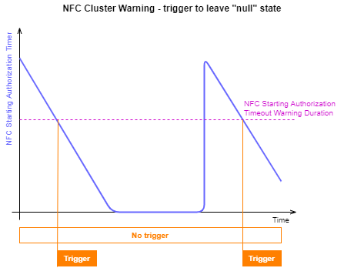

REQ-NFC-GE2-2 Display NFC Cluster Message: "To Drive Press Brake and Select D/R Gear" timeout

If Remote Start is not active, the NFC Cluster Message shall return to Null after the To Drive Press Brake And Select D/R Gear message has been shown for the duration specified in the NFC Cluster Warning Display Duration configuration parameter.

If Remote Start is active, the message shall not time out.

NOTE: Currently "To Drive: Press Brake and Select D/R Gear" message is only applicable for vehicles with "Drive Control Optimization" experience. For non DCO vehicles, carryover "To Drive: Press Brake and Start Button" message should be used

REQ-NFC-GE2-3 Display NFC Cluster Message: "To Drive Press Brake and Select D/R Gear" not displayed after transition to RUN

If Remote Start is not active, and the To Drive Press Brake and Select D/R Gear message is being shown, the NFC Cluster Message shall return to NULL when the vehicle ignition status changes to RUN from any other state.

NOTE: Currently "To Drive: Press Brake and Select D/R Gear" message is only applicable for vehicles with "Drive Control Optimization" experience. For non DCO vehicles, carryover "To Drive: Press Brake and Start Button" message should be used

REQ-NFC-GE2-4 Display NFC Cluster Message: "To Drive Press Brake and Select D/R Gear" not displayed after exit from Remote Start

If the To Drive Press Brake and Select D/R Gear message is being shown, and the vehicle's Remote Start status changes from active (nonmotive due to remote start) to any other state, the NFC Cluster Message shall return to NULL.

NOTE: Currently "To Drive: Press Brake and Select D/R Gear" message is only applicable for vehicles with "Drive Control Optimization" experience. For non DCO vehicles, carryover "To Drive: Press Brake and Start Button" message should be used

REQ-NFC-GE2-5 Display NFC Cluster Message: show "To Drive Press Brake and Select D/R Gear" when in Remote Start

If the NFC Cluster Message is NULL and either of the following occurs:

The last unlock or vehicle starting source was an NFC device, and the vehicle's Remote Start status changes from inactive to active; or

while the vehicle is in the Remote Start state, one or more doors is unlocked using an NFC device

then the NFC Cluster Message shall change to "To Drive Press Brake and Select D/R Gear".

NOTE: Currently "To Drive: Press Brake and Select D/R Gear" message is only applicable for vehicles with "Drive Control Optimization" experience. For non DCO vehicles, carryover "To Drive: Press Brake and Start Button" message should be used

### Function Usages

## -1358808721.jpg Enable/Disable NFC Feature On System

### Function Overview

#### Description

Change the internal configuration of the system to enable or disable behaviors related to the NFC feature.

Function is allocated to:

* -1630405514.jpg Body Control System <<Logical>>
* -1630405514.jpg Display System <<Logical>>

### Logical Function Interfaces

#### Logical Inputs

**Function Inputs**

|  |  |  |
| --- | --- | --- |
| **Input Name** | **Data type** | **Description** |
| Enable/Disable | 1624642619.jpg Enable/Disable | Whether the NFC feature should be enabled or disabled on target system |

**Variable Reads**

|  |  |  |  |
| --- | --- | --- | --- |
| **Variable Name** | **Data type** | **Description** | **Implementation Signal** |
| NFC Enabled | 2106322276.jpg Boolean | Enabled = NFC Entry and Starting related behaviors are enabled on NFC System i.e. reader polling  Disabled = NFC Entry and Starting related behaviors are enabled on NFC System |  |

#### Logical Parameters

|  |  |  |  |
| --- | --- | --- | --- |
| **Parameter Name** | **Data type** | **Description** | **Realizing Element** |
| NFC Enabled | 2106322276.jpg Boolean | Enabled = NFC Entry and Starting related behaviors are enabled on NFC System i.e. reader polling  Disabled = NFC Entry and Starting related behaviors are enabled on NFC System |  |

#### Logical Outputs

**Function Outputs**

|  |  |  |
| --- | --- | --- |
| **Output Name** | **Data type** | **Description** |
| Successful | 431835576.jpg Boolean | Whether the enable/disable operation was completed successfully. |

#### Logical Signals

No signals sent.

No signals received.

### Function Modeling

#### State Charts / Activity Diagrams / Sequence Diagrams / Decision Tables

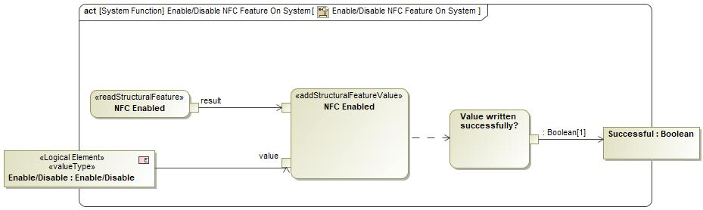

Figure 22: Enable/Disable NFC Feature On System

### Function requirements

REQ-NFC-ES-66 Enable/Disable NFC Feature: Successful Write

The function Enable/Disable NFC Feature on System shall return "Successful" == "True" if the value of the "NFC Enable" configuration parameter of the calling system was written succesfully.

REQ-NFC-ES-70 Enable/Disable NFC Feature On System: Enabled

When the function Enable/Disable NFC Feature on System is called with "Enable/Disable" == "Enable", it shall set "NFC Enabled" configuration parameter to "True".

REQ-NFC-ES-74 Enable/Disable NFC Feature On System: Disabled

When the function Enable/Disable NFC Feature on System is called with "Enable/Disable" == "Disabled", it shall set "NFC Enabled" configuration parameter to "False".

REQ-NFC-ES-75 Enable/Disable NFC Feature: Unsuccessful Write

The function Enable/Disable NFC Feature on System shall return "Successful" == "False" if the value of the "NFC Enable" configuration parameter of the calling system was not written succesfully.

REQ-NFC-ES-361 NFC Service Tool: Enabling or Disabling NFC Feature on System

The NFC Service tool shall be able to Enable or Disable the NFC Feature for each impacted system by:

- Establishing communication with the target system

- Unlocking target system using key/seed retrieved by NFC Service Cloud after providing it valid technician credentials

- Transmitting a specific write data by id request to either enable or disable the feature on system

### Function Usages

## -1358808721.jpg Handle NFC Local Event

### Function Overview

#### Description

Called whenever an NFC Command Complete Message is received. Performs any housekeeping that is necessary in response to changes that have occurred in the NFC system (for example, updating MyKey tables in response to key adds/deletes).

Function is allocated to:

* -1630405514.jpg Body Control System <<Logical>>

### Logical Function Interfaces

#### Logical Inputs

**Function Inputs**

|  |  |  |
| --- | --- | --- |
| **Input Name** | **Data type** | **Description** |
| Command Type | 1624642619.jpg NFC Command Type | The type of command that was completed (or not completed) by the NFC system. |
| Successful | -123237053.jpg Pairing Request Outcome | Whether the NFC command in question was executed successfully on the NFC system. |
| NFC Key Index | 2106322276.jpg Integer | If the command relates to a specific key in the NFC system, this property indicates the NFC key index of that key. Otherwise, it is undefined and optional. |

#### Logical Parameters

No logical parameters.

#### Logical Outputs

#### Logical Signals

No signals sent.

No signals received.

### Function Modeling

#### State Charts / Activity Diagrams / Sequence Diagrams / Decision Tables

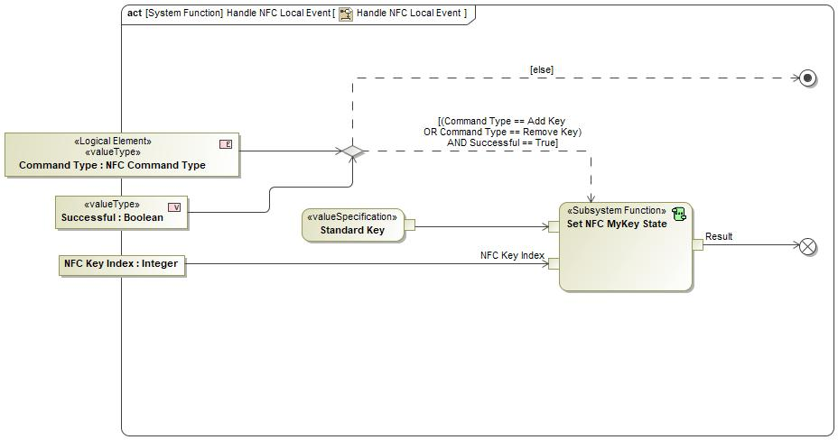

Figure 23: Handle NFC Local Event

### Function requirements

REQ-NFC-ES-63 Handle NFC Command Complete: Not successful

When the Handle NFC Command Complete function is called with:

- Successful == False; OR both:

- Command Type != Add Key; AND

- Command Type != Delete Key

Then the Handle NFC Command Complete function shall take no additional actions

REQ-NFC-ES-80 Handle NFC Command Complete: Successful Key Add

When the Handle NFC Command Complete function is called with:

- "NFC Command Type" == Add Key; AND

- "Successful" == True

Then the Handle NFC Command Complete function shall call Set NFC MyKey State with:

- New Mykey Level = Standard Key

- NFC Key Index = the NFC Key Index status parameter to the Handle NFC Command Complete function

REQ-NFC-ES-88 Handle NFC Command Complete: Successful Key Delete

When the Handle NFC Command Complete function is called with:

- Command Type == Delete Key; AND

- Successful == True

Then the Handle NFC Command Complete function shall call Set NFC MyKey State with:

- New Mykey Level = Standard Key

NFC Key Index = the NFC Key Index status signal received by the Handle NFC Command Complete function

### Function Usages

1173124843.jpg Add a Physical NFC Card - Retail

1173124843.jpg NFC-DK-UC-001 - owner pairing

1173124843.jpg NFC-DK-UC-002 - Change Owner Device

1173124843.jpg Owner Sends Manage Key

1173124843.jpg NFC-DK-UC-014 - Owner Device is Wiped Locally

1173124843.jpg NFC-DK-UC-013 - Owner Terminates Friend Key In Native App

1173124843.jpg NFC-DK-UC-009/010 - Friend Device Wiped Remotely/Security Breach

1173124843.jpg NFC-DK-UC-018/019 Vehicle Removed From Primary/Secondary Account

1173124843.jpg NFC-DK-UC-015/016 - Owner Device Wiped Remotely/Security Breach

1173124843.jpg NFC-DK-UC-005 - Owner Terminates Friend Key On Native App

1173124843.jpg NFC-DK-UC-011/12 - Owner/Friend Terminate Friend Key In Ford Mobile App

## -1358808721.jpg Handle NFC Tap

### Function Overview

#### Description

Handle NFC Tap receives every NFC Tap event that occurs and determines what actions, if any, to take as a result.

Function is allocated to:

* -1630405514.jpg Body Control System <<Logical>>

### Logical Function Interfaces

#### Logical Inputs

**Function Inputs**

|  |  |  |
| --- | --- | --- |
| **Input Name** | **Data type** | **Description** |
| Tap Duration | 1624642619.jpg NFC Tap Duration | The detected logical duration of the NFC Tap event. This is not the literal duration (in seconds), but rather a classification - either "short tap" or "long tap". The NFC system is responsible for determining which category the tap falls into. |
| NFC Key Index | 431835576.jpg Integer | The index maintained by the NFC system indicating which NFC device caused the NFC Tap event. |
| Device Paired | 431835576.jpg Boolean | The "Device Paired" parameter indicates whether the NFC device that caused the tap event is a device that is paired with the vehicle. |
| Tap Location | 1624642619.jpg NFC Location | The location of the NFC reader where the tap event occurred. |

**Variable Reads**

|  |  |  |  |
| --- | --- | --- | --- |
| **Variable Name** | **Data type** | **Description** | **Implementation Signal** |
| Waiting For New NFC MyKey | 2106322276.jpg Boolean | The Waiting For New NFC MyKey property is set to TRUE when the user has initiated the process of creating a new MyKey. When Waiting For New NFC MyKey is TRUE, the Body Control System will configure the NFC device that triggers the next authorized NFC tap to be a MyKey. |  |
| Door Lock State | 1624642619.jpg Door Lock Status | The current state of the vehicle's door locks, as tracked by the locking subsystem of the Body Control System. |  |
| Secure Idle Status | 2106322276.jpg Boolean | The status of the vehicle's Secure Idle feature. |  |

#### Logical Parameters

No logical parameters.

#### Logical Outputs

**Variables Written**

|  |  |  |  |
| --- | --- | --- | --- |
| **Variable Name** | **Data type** | **Description** | **Implementation Signal** |
| Waiting For New NFC MyKey | 2106322276.jpg Boolean | The Waiting For New NFC MyKey property is set to TRUE when the user has initiated the process of creating a new MyKey. When Waiting For New NFC MyKey is TRUE, the Body Control System will configure the NFC device that triggers the next authorized NFC tap to be a MyKey. |  |

#### Logical Signals

**Sent**

|  |  |  |
| --- | --- | --- |
| **Signal Name** | **Description** | **Realizing Element** |
| NFC MyKey - Creation Status | Transmitted from the Body Control System to the Display System to provide feedback on the state of the Body Control System during a MyKey creation operation. |  |

No signals received.

### Function Modeling

#### State Charts / Activity Diagrams / Sequence Diagrams / Decision Tables

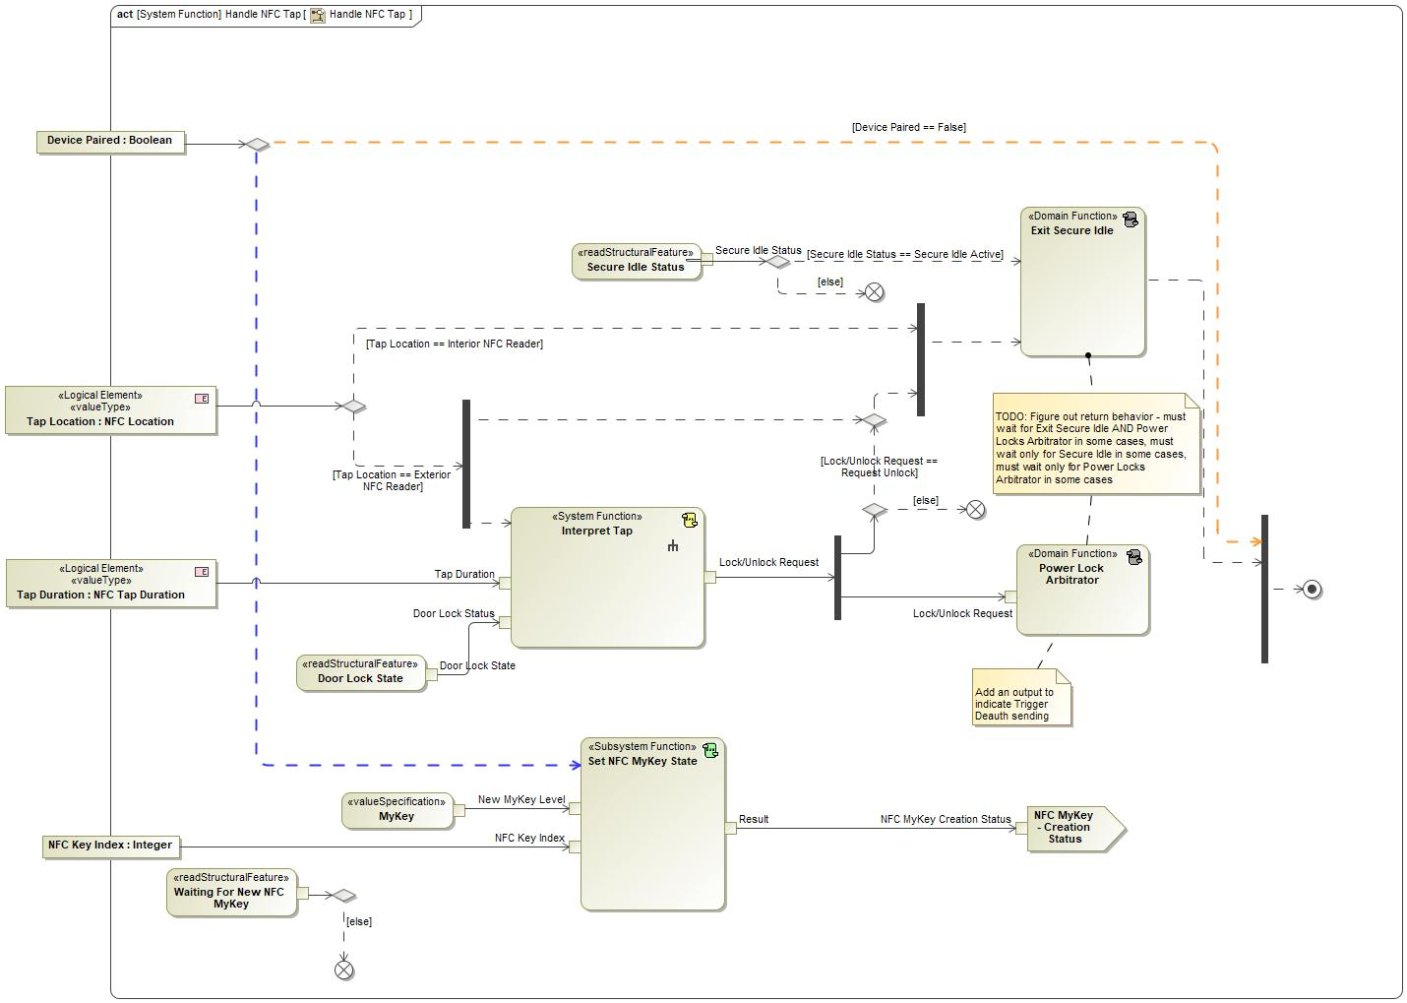

Figure 24: Handle NFC Tap

### Function requirements

REQ-NFC-ES-33 Handle NFC Tap - MyKey creation

When function "Handle NFC Tap" is called with:

- "Device Paired" status == [True]; AND

- "Tap Location" status == [Interior NFC Reader]; AND

- "Waiting for new NFC MyKey" runtime status of Body Control System = [True]

then the Body Control System shall call the "Set NFC MyKey State" function with the following parameters:

- New MyKey Level = [MyKey]

- NFC Key Index = [NFC Key Index]

When the function "Set NFC MyKey State" returns, the Body Control System shall output an "NFC MyKey - Creation Status" message with the "NFC MyKey Creation Status" signal set to the "Result" output of the "Set NFC MyKey State" function.

REQ-NFC-ES-67 Handle NFC Tap - call Power Locks Arbitrator

When the function "Interpret Tap" is called within "Handle NFC Tap" function and returns, the Body Control System shall call the "Power Lock Arbitrator" function with the output parameter "Lock/Unlock Request" from "Interpret Tap" function as the status parameter to the "Power Lock Arbitrator" function

REQ-NFC-ES-76 Handle NFC Tap - no action on unauthorized tap

When the function Handle NFC Tap is called with:

Device Paired status == [False]

Waiting for New NFC MyKey internal state of the Body Control System == [False],

Then the function shall return immediately with no additional action required

REQ-NFC-ES-123 Handle NFC Tap - call Interpret Tap for authorized exterior taps

"When the function "Handle NFC Tap" is called with:

- "Device Paired" status = [True]; AND

- "Tap Location" status = [Exterior NFC Reader]

then the Body Control System shall call the "Interpret Tap" function with the following parameters:

- "Tap Duration" status = [Tap Duration]

- "Door Lock Status" status = [Door Lock State]

REQ-NFC-ES-247 Handle NFC Tap - MyKey creation unsuccessful device not paired to vehicle

When function "Handle NFC Tap" is called with:

- "Device Paired" status == "False"; AND

- "Tap Location" status == "Interior NFC Reader"; AND

- "Waiting for new NFC MyKey" property of Body Control System = "True"

Then the Body Control System shall transmit output message "NFC MyKey - Creation Status" = "Unsuccessful - Device not paired to the vehicle" and set "Waiting for New MyKey" property of the Body Control System = "False"

REQ-NFC-ES-251 Handle NFC Tap - Setting waiting for New NFC MyKey to false

The function "Handle NFC Tap" shall set the "Waiting for New NFC MyKey" to False after transmitting an "NFC MyKey - Creation Status" signal with any of the following values:

- Successful

- Unsuccessful - Already MyKey

- Unsuccessful - Device not Paired to vehicle

REQ-NFC-ES-398 Interpret Tap/Handle NFC Tap: Do not act if long tap received without preceding short tap

If the Body Control System receives a long tap event (NFC Tap message with "Tap Duration" == "Long Tap" without receiving a short tap event (NFC Tap message with "Tap Duration" == "Short Tap") immediately beforehand, it shall not take any action on the long tap (for example, locking or unlocking vehicle doors).

For the purposes of this requirement, "immediately beforehand" means a short tap message which has the same "Key Index" value, received less than five seconds before the associated long tap message.

**Rationale**: The NFC Controller guarantees that long tap events will not be sent without preceding short tap events. If a long tap is received without a short tap, a system error should be presumed and no action should be taken.

*This requirement references the following elements:*

* -1020699506.jpg NFC Tap Message (Logical Signal)
* 1240798529.jpg Long Tap (Enumeration Literal of 1624642619.jpg NFC Tap Duration)
* -463997144.jpg Tap Duration (Property of -1020699506.jpg NFC Tap Message)
* 1240798529.jpg Short Tap (Enumeration Literal of 1624642619.jpg NFC Tap Duration)
* -463997144.jpg Key Index (Property of -1020699506.jpg NFC Tap Message)
* 1624642619.jpg NFC Tap Duration (Value Type)

### Function Usages

1173124843.jpg Unlock/Lock/Double Lock a Vehicle with an NFC Device

## -1358808721.jpg Handle Start Button Press

### Function Overview

#### Description

Handle start button press will result in the vehicle starting or stopping, exiting remote start, and setting the current mykey level based on receiving a key search response from the NFC System

Function is allocated to:

* -1630405514.jpg Body Control System <<Logical>>

### Logical Function Interfaces

#### Logical Inputs

**Variable Reads**

|  |  |  |  |
| --- | --- | --- | --- |
| **Variable Name** | **Data type** | **Description** | **Implementation Signal** |
| Starting Key Type | 1624642619.jpg NFC Key Type | If the vehicle is running (ignition in RUN or ACC), and it was started by an NFC access card or CCC-compatible digital key, this variable contains the key type of the key that started the vehicle, which is one of the below:  Factory Key = Vehicle was started with a "Factory" NFC Key  Retail User Key = Vehicle was started with an NFC Key that was programmed to the vehicle through the in-vehicle display  Fleet User Key = Vehicle was started with an NFC Key that was remotely programmed to the vehicle through the fleet management system  If the vehicle is not running, or if a key other than an NFC access card/CCC digital key started the vehicle, this variable is null. |  |
| Remote Start Active | 2106322276.jpg Boolean | The state of the vehicle's Remote Start feature. |  |
| Ignition Status | -123237053.jpg Ignition Status | The state of the vehicle's ignition. |  |

#### Logical Parameters

No logical parameters.

#### Logical Outputs

**Variables Written**

|  |  |  |  |
| --- | --- | --- | --- |
| **Variable Name** | **Data type** | **Description** | **Implementation Signal** |
| Starting Key Type | 1624642619.jpg NFC Key Type | If the vehicle is running (ignition in RUN or ACC), and it was started by an NFC access card or CCC-compatible digital key, this variable contains the key type of the key that started the vehicle, which is one of the below:  Factory Key = Vehicle was started with a "Factory" NFC Key  Retail User Key = Vehicle was started with an NFC Key that was programmed to the vehicle through the in-vehicle display  Fleet User Key = Vehicle was started with an NFC Key that was remotely programmed to the vehicle through the fleet management system  If the vehicle is not running, or if a key other than an NFC access card/CCC digital key started the vehicle, this variable is null. |  |

#### Logical Signals

**Sent**

|  |  |  |
| --- | --- | --- |
| **Signal Name** | **Description** | **Realizing Element** |
| Key Search Request | A message sent from the Body Control System to the NFC System to determine whether the NFC system is in the "starting authorized" state. This message is triggered by a number of user actions (pressing brake pedal, opening door, etc). |  |

**Received**

|  |  |  |
| --- | --- | --- |
| **Signal Name** | **Description** | **Realizing Element** |
| Key Search Response | The message that is sent by the NFC System to the Body Control System in response to a Key Search Request. This reply is sent whether or not the NFC System is in the starting authorized state. This message constitutes starting authorization when the Authorized runtime variable is True. |  |

### Function Modeling

#### State Charts / Activity Diagrams / Sequence Diagrams / Decision Tables

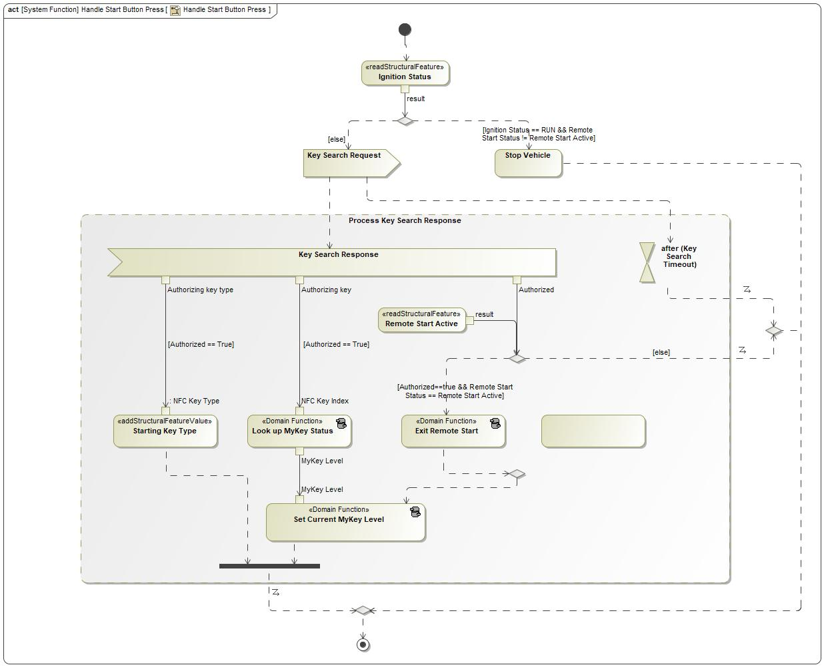

Figure 25: Handle Start Button Press

### Function requirements

REQ-NFC-ES-68 Handle Start Button Press:

Exit Remote Start

If the Body Control System sends a Key Search Request to the NFC System as a result of the user attempting to enter a motive state from Remote Start, and the NFC System replies with a Key Search Response message whose "Authorized" property is True, then the Body Control System shall allow the vehicle to enter a motive state (exit Remote Start).

REQ-NFC-ES-71 Handle Start Button Press:

Start the vehicle

Handle Start Button Press shall call the "Start the Vehicle" function when the following conditions are true:

- Key Search Response received within "Key Search Timeout" of Key Search Request; AND

- Authorized signal of Key Search Response message == True; AND

- Ignition Status of Body Control System != Run; AND

- Remote Start Status of Body Control System != Remote Start Active

REQ-NFC-ES-89 Handle Start Button Press: Set Current MyKey Level

After the Body Control System receives a valid key search response from the NFC System that results in starting the vehicle or entering a motive state, it shall apply the MyKey restrictions (admin vs. MyKey status) associated with the NFC key identified by the NFC Key Index in the Key Search Response received from the NFC Controller.

REQ-NFC-ES-90 Handle Start Button Press: Store Starting Key Index

When the vehicle is started (ignition changes to RUN), or enters a motive state, and an NFC device authorized starting, the Body Control System shall store the key index of the NFC key that authorized starting, as provided by the NFC System in the Starting Authorization Response message.

When the vehicle is started with a non-NFC key, this value may be stored as null, or the index of the non-NFC key that authorized starting may be stored.

**Rationale**: Storing the Starting Key Type is done to track the starting key type for the duration of the ignition cycle. This value is read to determine whether the in-vehicle display system should enable access to specific menus.

*This requirement references the following elements:*

* 270704727.jpg Publish current NFC Key Type (System Requirement)

REQ-NFC-ES-99 Handle Start Button Press: Sending Key Search Request

When the Handle Start Button Press function is called and Ignition status != Run, the Body Control System shall transmit a Key Search Request and initiate/reset the "Key Search Timeout" timer.

REQ-NFC-ES-150 Handle Start Button Press: do not start vehicle or enter motive state if Key Search Response is not authorized

After the Body Control System sends a Key Search Request message to authorize vehicle starting or entering a motive state, if a "Key Search Response" message is received whose "Authorized" property is False, then the Body Control System shall not allow vehicle starting or motive state entry unless another valid vehicle key is present.

REQ-NFC-ES-395 Starting key priority

If the NFC System is in the Starting Authorized state, and another type of valid vehicle key is present when the user attempts to start the vehicle, the NFC key shall be considered the "starting key" for the purposes of REQ-NFC-ES-18.

For example, if the user has scanned a valid NFC key, and then attempts to start the vehicle while a valid PEPS fob is inside the vehicle cabin, the NFC key shall be the starting key, and the key information published in the signals described in REQ-NFC-ES-18 shall be the index and key type of the NFC key.

**Rationale**: We need to define starting key priority so that the user has a consistent experience when starting the vehicle with multiple keys present.

As an active (non-passive) key type, NFC should be prioritized because this type of key is activated only with a positive user action.

*This requirement references the following elements:*

* 270704727.jpg Publish current NFC Key Type (System Requirement)

## -1358808721.jpg Interpret Tap

### Function Overview

#### Description

This function interprets an user's NFC Tap to determine whether the user action should be interpreted as an unlock request or a lock request.

Function is allocated to:

* -1630405514.jpg Body Control System <<Logical>>

### Logical Function Interfaces

#### Logical Inputs

**Function Inputs**

|  |  |  |
| --- | --- | --- |
| **Input Name** | **Data type** | **Description** |
| Tap Duration | 1624642619.jpg NFC Tap Duration | The logical duration of the NFC tap that was detected. |
| Door Lock Status | 1624642619.jpg Door Lock Status | The state of the vehicle’s door locks. |

#### Logical Parameters

No logical parameters.

#### Logical Outputs

**Function Outputs**

|  |  |  |
| --- | --- | --- |
| **Output Name** | **Data type** | **Description** |
| Lock/Unlock Request | 1624642619.jpg Locking Request | A locking request whose value is the interpreted user intent. |

#### Logical Signals

No signals sent.

No signals received.

### Function Modeling

#### State Charts / Activity Diagrams / Sequence Diagrams / Decision Tables

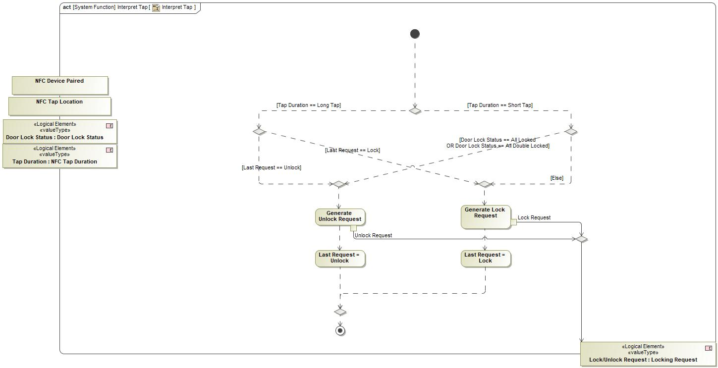

Figure 26: Interpret Tap

### Function requirements

REQ-NFC-ES-34 Interpret Tap - Short tap lock

"When the function "Interpret Tap" is called with:

- "Tap Authorized" status = [True]; AND

- "Tap Location" status = [Exterior NFC Reader]; AND

- "Tap Duration" status = [Tap Duration] (Short Tap); AND

- "Door Lock Status" != [Door Lock State] (All Doors Locked or All Doors Double Locked)

then the Interpret Tap function shall return with output parameter "Lock/Unlock Request" = [Lock]"

REQ-NFC-ES-36 Interpret Tap - short tap unlock

"When the function "Interpret Tap" is called with:

- "Tap Authorized" status = [True] &

- "Tap Location" status = [Exterior NFC Reader]

- "Tap Duration" status = [Tap Duration] (Short Tap)

- "Door Lock Status" = [Door Lock State] (All Doors Locked or All Doors Double Locked)

then the Interpret Tap function shall return with the output parameter "Lock/Unlock Request" = [Unlock]."

REQ-NFC-ES-91 Interpret Tap - Long Tap sends second lock request

"When the function "Interpret Tap" is called with:

- "Tap Authorized" status = [True]; AND

- "Tap Location" status = [Exterior NFC Reader]; AND

- "Tap Duration" status = [Tap Duration] (Long Tap); AND

- "Last Request" status = "Lock"

then the Interpret Tap function shall return with the output parameter "Lock/Unlock Request" = "Lock"."

REQ-NFC-ES-96 Interpret Tap - Long Tap sends second unlock request

"When the function "Interpret Tap" is called with:

- "Tap Authorized" status = [True]; AND

- "Tap Location" status = [Exterior NFC Reader]; AND

- "Tap Duration" status = [Tap Duration] (Long Tap); AND

- "Last Request" status = "Unock"

then the Interpret Tap function shall return with the output parameter "Lock/Unlock Request" = "Unlock"."

REQ-NFC-ES-398 Interpret Tap/Handle NFC Tap: Do not act if long tap received without preceding short tap

If the Body Control System receives a long tap event (NFC Tap message with "Tap Duration" == "Long Tap" without receiving a short tap event (NFC Tap message with "Tap Duration" == "Short Tap") immediately beforehand, it shall not take any action on the long tap (for example, locking or unlocking vehicle doors).

For the purposes of this requirement, "immediately beforehand" means a short tap message which has the same "Key Index" value, received less than five seconds before the associated long tap message.

**Rationale**: The NFC Controller guarantees that long tap events will not be sent without preceding short tap events. If a long tap is received without a short tap, a system error should be presumed and no action should be taken.

*This requirement references the following elements:*

* -1020699506.jpg NFC Tap Message (Logical Signal)
* 1240798529.jpg Long Tap (Enumeration Literal of 1624642619.jpg NFC Tap Duration)
* -463997144.jpg Tap Duration (Property of -1020699506.jpg NFC Tap Message)
* 1240798529.jpg Short Tap (Enumeration Literal of 1624642619.jpg NFC Tap Duration)
* -463997144.jpg Key Index (Property of -1020699506.jpg NFC Tap Message)
* 1624642619.jpg NFC Tap Duration (Value Type)

### Function Usages

1173124843.jpg Unlock/Lock/Double Lock a Vehicle with an NFC Device

## -1358808721.jpg Monitor MyKey Creation Status

### Function Overview

#### Description

This function exits the Body Control System out of its "waiting for MyKey" state if the user does not take any action or the system does no create a MyKey within a specified time frame

Function is allocated to:

* -1630405514.jpg Body Control System <<Logical>>

### Logical Function Interfaces

#### Logical Inputs

**Variable Reads**

|  |  |  |  |
| --- | --- | --- | --- |
| **Variable Name** | **Data type** | **Description** | **Implementation Signal** |
| Waiting For New NFC MyKey | 2106322276.jpg Boolean | The Waiting For New NFC MyKey property is set to TRUE when the user has initiated the process of creating a new MyKey. When Waiting For New NFC MyKey is TRUE, the Body Control System will configure the NFC device that triggers the next authorized NFC tap to be a MyKey. |  |

#### Logical Parameters

No logical parameters.

#### Logical Outputs

**Variables Written**

|  |  |  |  |
| --- | --- | --- | --- |
| **Variable Name** | **Data type** | **Description** | **Implementation Signal** |
| Waiting For New NFC MyKey | 2106322276.jpg Boolean | The Waiting For New NFC MyKey property is set to TRUE when the user has initiated the process of creating a new MyKey. When Waiting For New NFC MyKey is TRUE, the Body Control System will configure the NFC device that triggers the next authorized NFC tap to be a MyKey. |  |

#### Logical Signals

**Sent**

|  |  |  |
| --- | --- | --- |
| **Signal Name** | **Description** | **Realizing Element** |
| NFC MyKey - Creation Status | Transmitted from the Body Control System to the Display System to provide feedback on the state of the Body Control System during a MyKey creation operation. |  |
| NFC MyKey - Ready For New MyKey | This signal is sent from the Body Control System to the HMI system to indicate that the request for MyKey creation was received, and the Body Control System will make the next scanned NFC device a MyKey. |  |

No signals received.

### Function Modeling

#### State Charts / Activity Diagrams / Sequence Diagrams / Decision Tables

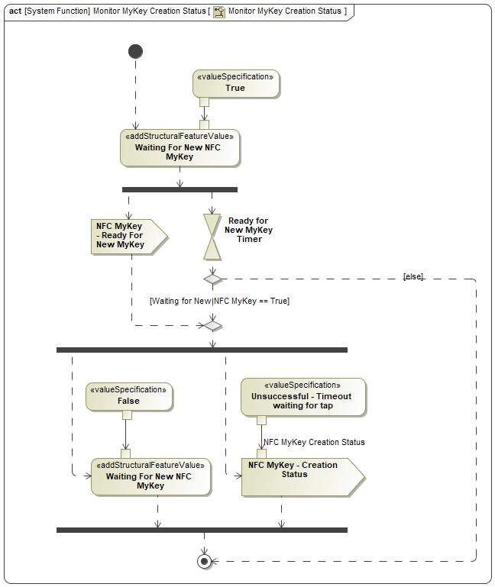

Figure 27: Monitor MyKey Creation Status

### Function requirements

REQ-NFC-ES-246 Monitor MyKey Creation Status: Set Waiting for New MyKey to False after timer expiration

The Body Control system shall set its "Waiting for New MyKey" runtime status to false and transmit an "NFC MyKey - Creation Status" message with "NFC MyKey Creation Status" Signal = "Unsuccessful - Timeout waiting for tap" when the following conditions occur:

- Waiting for New NFC MyKey property of the Body Control System == True

- Ready for New MyKey Timer expired

**Rationale**: The body control system needs to exit its local MyKey Creation mode if a user does not take any actions within a predefined timeframe

REQ-NFC-ES-250 Monitor MyKey Creation Status: Set Waiting for New MyKey to True and initializing timer

Upon initialization, the Monitor MyKey Creation Status shall:

- Set the Waiting for New NFC MyKey property of the Body Control System = True

- Emit an NFC MyKey - Ready For New MyKey message

- Initiate the Ready for New MyKey Timer for "Waiting for Tap Message" duration

**Rationale**: The body control system is responsible for the creation of new mykeys within a predefined time frame after initialization

### Function Usages

## -1745828276.jpg Set NFC MyKey State

### Function Overview

#### Description

Given an NFC Key Index and a specified MyKey level, update the Body Control System's internal MyKey tables to set that NFC Key to that MyKey level.

Function is allocated to:

* -1630405514.jpg Body Control System <<Logical>>

### Logical Function Interfaces

#### Logical Inputs

**Function Inputs**

|  |  |  |
| --- | --- | --- |
| **Input Name** | **Data type** | **Description** |
| NFC Key Index | 431835576.jpg Integer | The NFC Key Index of the key whose record is to be updated. |

#### Logical Parameters

No logical parameters.

#### Logical Outputs

**Function Outputs**

|  |  |  |
| --- | --- | --- |
| **Output Name** | **Data type** | **Description** |
| Result | 1624642619.jpg NFC MyKey Creation Result | Whether the MyKey table update was completed successfully. |

#### Logical Signals

No signals sent.

No signals received.

### Function Modeling

#### State Charts / Activity Diagrams / Sequence Diagrams / Decision Tables

No diagrams internal to function specified.

### Function requirements

REQ-NFC-ES-2 Update MyKey Level

When the Body Control System receives the Update MyKey Level signal, the Body Control System shall call the Make an NFC Device a MyKey function using the fingerprint parameter of the Update MyKey Level signal.

REQ-NFC-ES-16 NFC Key Index - assignment

Whenever a new NFC device pairing is created, the NFC System shall assign an NFC Key Index to that NFC pairing. The NFC Key Index for a pairing shall be unique among all current NFC pairings stored on the vehicle, and it shall remain unchanged until the pairing is removed from the vehicle.

**Rationale**: NFC Key Index is used by Body Control System to identify NFC devices

REQ-NFC-ES-248 Set NFC MyKey State - Successful

If set NFC MyKey State is called with an NFC Key Index that has not been mapped to a MyKey, it shall return

NFC MyKey Creation Status - Result = "Successful"

REQ-NFC-ES-249 Set NFC MyKey State - Unsuccessful, already a MyKey

If set NFC MyKey State is called with an NFC Key Index that has been previously mapped to a MyKey, it shall return

NFC MyKey Creation Status - Result = "Unsuccessful - Already MyKey"

### Function Usages

1173124843.jpg Unlock/Lock/Double Lock a Vehicle with an NFC Device

1173124843.jpg Make an NFC Device a MyKey

1173124843.jpg Add a Physical NFC Card - Retail

1173124843.jpg NFC-DK-UC-001 - owner pairing

1173124843.jpg Owner Sends Manage Key

1173124843.jpg NFC-DK-UC-009/010 - Friend Device Wiped Remotely/Security Breach

1173124843.jpg NFC-DK-UC-018/019 Vehicle Removed From Primary/Secondary Account

1173124843.jpg NFC-DK-UC-015/016 - Owner Device Wiped Remotely/Security Breach

1173124843.jpg NFC-DK-UC-005 - Owner Terminates Friend Key On Native App

1173124843.jpg NFC-DK-UC-011/12 - Owner/Friend Terminate Friend Key In Ford Mobile App

# Revision History

|  |  |  |
| --- | --- | --- |
| Revision | Description | Responsible |
| 2020-05-22 | Initial Functional Specification release for UPV0 | Abonnel1, Fehsan2,  Ekarpins |
| 2020-08-24 | Updated release for UPV1, capturing feedback from internal stakeholders | Abonnel1, Fehsan2,  Ekarpins |
| 2021-03-11 | Add scenario section - Chapter 4    Removed Functions:   * Lookup MyKey Status * Set Current MyKey Level * Transmit body control system related indication     Add Functions:   * Display NFC Cluster Message     Update Logical System Properties    Added new Logical Messages and Logical Data Types    Update the Logical Function Interface for the following functions:   * Deauthorize Starting * Handle Start Button Press * Monitor MyKey Creation Status   Updated Requirements:   * REQ-NFC-ES-18 * REQ-NFC-ES-61 * REQ-NFC-ES-203 * REQ-NFC-ES-283 * REQ-NFC-ES-284     Added Requirements:   * REQ-NFC-ES-303 * REQ-NFC-ES-330 * REQ-NFC-ES-331 * REQ-NFC-ES-332 * REQ-NFC-ES-338 * REQ-NFC-ES-339 * REQ-NFC-ES-356 * REQ-NFC-ES-359 * REQ-NFC-ES-361 * REQ-NFC-ES-395 * REQ-NFC-ES-398     Remove Requirements:   * REQ-NFC-ES-49 * REQ-NFC-ES-66 * REQ-NFC-ES-70 * REQ-NFC-ES-71 * REQ-NFC-ES-74 * REQ-NFC-ES-81 * REQ-NFC-ES-89 * REQ-NFC-ES-90 * REQ-NFC-ES-99 * REQ-NFC-ES-103 | abonnel1, adelong2, fehsan2, ekarpins, rsepulv6, jwolf53 |
| 2021-06-07 | Update system properties:   * Starting Key Index: add description   Add system requirements:   * REQ-NFC-ES-110 (no behavior changes, requirement was omitted from last release) * REQ-NFC-ES-131 (no behavior changes, requirement was omitted from last release) * REQ-NFC-ES-132 (no behavior changes, requirement was omitted from last release) * REQ-NFC-ES-133 (no behavior changes, requirement was omitted from last release) * REQ-NFC-ES-152 (no behavior changes, requirement was omitted from last release) * REQ-NFC-ES-185 (no behavior changes, requirement was omitted from last release) * REQ-NFC-ES-186 (no behavior changes, requirement was omitted from last release) * REQ-NFC-ES-208 (no behavior changes, requirement was omitted from last release)   Add new system requirements:   * REQ-NFC-ES-401 * REQ-NFC-ES-405   Section 4.2, “Display NFC Cluster Message”  Updated:   * REQ-NFC-ES-402 * REQ-NFC-ES-321 * REQ-NFC-ES-323 (no text changes, title was incorrect) * REQ-NFC-ES-331 (no text changes, title was incorrect)   Added:   * REQ-NFC-GE2-2 * REQ-NFC-GE2-3 * REQ-NFC-GE2-4 * REQ-NFC-GE2-5   Section 5.6, “Handle Start Button Press”  Added:   * REQ-NFC-ES-68 (no behavior changes, requirement was omitted from last release) * REQ-NFC-ES-71 (no behavior changes, requirement was omitted from last release) * REQ-NFC-ES-89 (no behavior changes, requirement was omitted from last release) * REQ-NFC-ES-90 (no behavior changes, requirement was omitted from last release) * REQ-NFC-ES-99 (no behavior changes, requirement was omitted from last release) * REQ-NFC-ES-150 (no behavior changes, requirement was omitted from last release)   Data Dictionary:   * Removed irrelevant data elements from all sections. |  |

## Template Revisions

|  |  |  |  |  |
| --- | --- | --- | --- | --- |
| Version | Rev. | Date | Description | Responsible |
| *1* | *0* | *2016-02-26* | *Initial version, derived from FDS* | *Jbaden1* |
| *1* | *1* | *2016-02-26* | *Word properties corrected* | *Jbaden1* |
| *1* | *2* | *2016-03-10* | *Clean up of document meta data (Word properties)* | *Jbaden1* |
| *1* | *3* | *2016-03-22* | * *Footer formatting corrected (Issue 19)* * *“Constraints” chapter renamed to “Input Requirements” (Issue 20)* | *Jbaden1* |
| *1* | *4* | *2016-04-20* | * *Broken Wiki links repaired* | *Jbaden1* |
| *2* | *0* | *2016-06-10* | * *Document metadata adapted. Prepared for new macros* * *DTC table removed* * *HMI function added as a chapter (details still to be refined)* * *Signal / Parameter IDs column deleted interface tables* | *Jbaden1* |
| *2* | *1* | *2016-07-14* | * *Converted to SysML diagrams* * *HMI section further elaborated* * *Template version added to footer* * *Dedicated Startup / Shutdown sections removed (only hints added)* * *Data Dictionary reworked and Signal / Parameter IDs column re-introduced* | *Jbaden1* |
| *2* | *2* | *2016-12-07* | * *Minor formatting changes* | *Jbaden1* |
| *3* |  |  | *Skipped to synchronize with Specification_Macros.dotm* |  |
| *4* |  |
| *5* | *0* | *2017-01-13* | * *Meta data updated for specification macros, version 3.1* * *SW Unit chapter removed for the time being* * *Green boxes added for user hints* | *Jbaden1* |
| *5* | *1* | *2017-01-18* | * *Some additional hints.* * *Hyperlinks highlighted in hints* | *Jbaden1* |
| *6* | *0* | *2017-04-28* | * *Editorial change. Hints added to chapter 4.1.4* * *Chapter “Traceability Matrix” removed* | *Jbaden1* |
| *6* | *0* | *2018-04-28* | * *CR69/63: New chapters added for Functional Safety (FTTI and Technical Safety Requirements)* * *CR53: New coversheet + additional meta-data* * *CR76: merge sections for configuration and for calibration parameters into one on Function Level* | *Jbaden1* |
| *6* | *0* | *2018-08-06* | * *CR66: Fix version numbering in footer of Function Spec* | *Jbaden1* |
| *6* | *0* | *2018-09-28* | * *Broken links to RE Wiki repaired* | *Jbaden1* |
| *6* | *0* | *2018-10-31* | * *Minor corrections on cover sheet and in footer to be more GIS compliant and VSEM aligned* * *“Overview” and “Description” exchanged in headings (following common sense)* | *Jbaden1* |
| *6* | *0* | *2018-11-12* | * *Explanatory text in Variants” section revised* * *Functional Safety modifications as agreed with FuSa core team (Baseline: November 2018 Dearborn On-Site)* | *Jbaden1* |
| *M* |  | *2019-04-02* | * *Initial version of SysML report template* | *snuesch* |
| *M* |  | *2019-04-05* | * *Improved dialog boxes to select function group* | *snuesch* |

## Template Revisions

*#Important: Do not change this section*

|  |  |  |  |  |
| --- | --- | --- | --- | --- |
| Version | Rev. | Date | Description | Responsible |
| *1* | *0* | *2016-02-26* | *Initial version, derived from FDS* | *Jbaden1* |
| *1* | *1* | *2016-02-26* | *Word properties corrected* | *Jbaden1* |
| *1* | *2* | *2016-03-10* | *Clean up of document meta data (Word properties)* | *Jbaden1* |
| *1* | *3* | *2016-03-22* | * *Footer formatting corrected (Issue 19)* * *“Constraints” chapter renamed to “Input Requirements” (Issue 20)* | *Jbaden1* |
| *1* | *4* | *2016-04-20* | * *Broken Wiki links repaired* | *Jbaden1* |
| *2* | *0* | *2016-06-10* | * *Document metadata adapted. Prepared for new macros* * *DTC table removed* * *HMI function added as a chapter (details still to be refined)* * *Signal / Parameter IDs column deleted interface tables* | *Jbaden1* |
| *2* | *1* | *2016-07-14* | * *Converted to SysML diagrams* * *HMI section further elaborated* * *Template version added to footer* * *Dedicated Startup / Shutdown sections removed (only hints added)* * *Data Dictionary reworked and Signal / Parameter IDs column re-introduced* | *Jbaden1* |
| *2* | *2* | *2016-12-07* | * *Minor formatting changes* | *Jbaden1* |
| *3* |  |  | *Skipped to synchronize with Specification_Macros.dotm* |  |
| *4* |  |
| *5* | *0* | *2017-01-13* | * *Meta data updated for specification macros, version 3.1* * *SW Unit chapter removed for the time being* * *Green boxes added for user hints* | *Jbaden1* |
| *5* | *1* | *2017-01-18* | * *Some additional hints.* * *Hyperlinks highlighted in hints* | *Jbaden1* |
| *6* | *0* | *2017-04-28* | * *Editorial change. Hints added to chapter 4.1.4* * *Chapter “Traceability Matrix” removed* | *Jbaden1* |
| *6* | *0* | *2018-04-28* | * *CR69/63: New chapters added for Functional Safety (FTTI and Technical Safety Requirements)* * *CR53: New coversheet + additional meta-data* * *CR76: merge sections for configuration and for calibration parameters into one on Function Level* | *Jbaden1* |
| *6* | *0* | *2018-08-06* | * *CR66: Fix version numbering in footer of Function Spec* | *Jbaden1* |
| *6* | *0* | *2018-09-28* | * *Broken links to RE Wiki repaired* | *Jbaden1* |
| *6* | *0* | *2018-10-31* | * *Minor corrections on cover sheet and in footer to be more GIS compliant and VSEM aligned* * *“Overview” and “Description” exchanged in headings (following common sense)* | *Jbaden1* |
| *6* | *0* | *2018-11-12* | * *Explanatory text in Variants” section revised* * *Functional Safety modifications as agreed with FuSa core team (Baseline: November 2018 Dearborn On-Site)* | *Jbaden1* |
| *M* |  | *2019-04-02* | * *Initial version of SysML report template* | *snuesch* |
| *M* |  | *2019-04-05* | * *Improved dialog boxes to select function group* | *snuesch* |

# Appendix

## Data Dictionary

### Logical Messages

Device Entered Field

|  |  |
| --- | --- |
| **Name** | **Device Entered Field** |
| **Description** | To indicate that a device has entered within the detection range of an NFC Reader Antenna |
| **Realized by** |  |

**Parameters/Owned Signals**

|  |  |  |  |
| --- | --- | --- | --- |
| **Name** | **Type** | **Description** | **Realized By** |
| -463997144.jpg Location | 1624642619.jpg NFC Location | Whether a device was detected at an interior or exterior reader antenna's field |  |
| -463997144.jpg AID | 1624642619.jpg AID | Application Identifier - This will determine if the device being scanned at the NFC Reader is a phone that is owner pairing or not, or if it is a card. |  |

Device Exited Field

|  |  |
| --- | --- |
| **Name** | **Device Exited Field** |
| **Description** | To indicate that a device has exited the detection range of an NFC Reader after being detected. |
| **Realized by** |  |

**Parameters/Owned Signals**

|  |  |  |  |
| --- | --- | --- | --- |
| **Name** | **Type** | **Description** | **Realized By** |
| -463997144.jpg Location | 1624642619.jpg NFC Location | Whether a device has exited the detection range of an interior or exterior reader antenna's field |  |

Diagnostic Session Request

|  |  |
| --- | --- |
| **Name** | **Diagnostic Session Request** |
| **Description** | Request from the Service tool to the target system to initiate a diagnositc session |
| **Realized by** |  |

**Parameters/Owned Signals**

|  |  |  |  |
| --- | --- | --- | --- |
| **Name** | **Type** | **Description** | **Realized By** |
| -463997144.jpg Session | 1624642619.jpg Diagnostic Session Type |  |  |

Diagnostic Session Result

|  |  |
| --- | --- |
| **Name** | **Diagnostic Session Result** |
| **Description** | Result from the target system back to the Service tool, indicating its diagnostic session |
| **Realized by** |  |

**Parameters/Owned Signals**

|  |  |  |  |
| --- | --- | --- | --- |
| **Name** | **Type** | **Description** | **Realized By** |
| -463997144.jpg Session | 1624642619.jpg Diagnostic Session Type |  |  |
| -463997144.jpg Status | 2106322276.jpg Boolean |  |  |

Key Search Request

|  |  |
| --- | --- |
| **Name** | **Key Search Request** |
| **Description** | A message sent from the Body Control System to the NFC System to determine whether the NFC system is in the "starting authorized" state. This message is triggered by a number of user actions (pressing brake pedal, opening door, etc). |
| **Realized by** |  |

Key Search Response

|  |  |
| --- | --- |
| **Name** | **Key Search Response** |
| **Description** | The message that is sent by the NFC System to the Body Control System in response to a Key Search Request. This reply is sent whether or not the NFC System is in the starting authorized state. This message constitutes starting authorization when the Authorized runtime variable is True. |
| **Realized by** |  |

**Parameters/Owned Signals**

|  |  |  |  |
| --- | --- | --- | --- |
| **Name** | **Type** | **Description** | **Realized By** |
| -463997144.jpg Authorized | 2106322276.jpg Boolean | Whether the NFC system authorizes starting. |  |
| -463997144.jpg Authorizing key | 2106322276.jpg Integer | If starting is authorized, the index of the NFC device that authorized starting. If starting is not authorized, undefined. |  |
| -463997144.jpg Authorizing key type | 1624642619.jpg NFC Key Type | The type of the NFC key that authorized starting (factory key, retail user key, fleet user key ). |  |

Key Search Trigger

|  |  |
| --- | --- |
| **Name** | **Key Search Trigger** |
| **Description** |  |
| **Realized by** |  |

Manufacturing Pairing Event

|  |  |
| --- | --- |
| **Name** | **Manufacturing Pairing Event** |
| **Description** | A signal emitted by the NFC System each time a manufacturing pairing event occurs. A manufacturing pairing event is when the NFC System attempts to add a new factory card pairing because it is in Factory Pairing Mode and a card is presented. This signal is used to trigger feedback behavior for the assembly technician (e.g., flashing the turn signals, or presenting a message in the cluster). |
| **Realized by** |  |

**Parameters/Owned Signals**

|  |  |  |  |
| --- | --- | --- | --- |
| **Name** | **Type** | **Description** | **Realized By** |
| -463997144.jpg Successful |  | Whether the detected NFC key card was paired successfully. |  |

Master Reset Command

|  |  |
| --- | --- |
| **Name** | **Master Reset Command** |
| **Description** | The signal that is emitted when a Master Reset event is triggered, whether it was triggered through the in-vehicle HMI or remotely (for fleets). This signal is used by the NFC System to trigger the NFC System's Master Reset behavior. |
| **Realized by** |  |

Modem Deauthorization

|  |  |
| --- | --- |
| **Name** | **Modem Deauthorization** |
| **Description** | We expect this signal to be sent when the vehicle's modem becomes deauthorized for any reason. |
| **Realized by** |  |

NFC Cluster Message

|  |  |
| --- | --- |
| **Name** | **NFC Cluster Message** |
| **Description** | Message sent from the Body Control System to the Driver Information System that indicates which NFC-specific driver warning message should be displayed. |
| **Realized by** |  |

**Parameters/Owned Signals**

|  |  |  |  |
| --- | --- | --- | --- |
| **Name** | **Type** | **Description** | **Realized By** |
| -463997144.jpg Indication | 1624642619.jpg NFC Cluster Message | Which message should be displayed on the cluster. |  |

NFC Device Detected

|  |  |
| --- | --- |
| **Name** | **NFC Device Detected** |
| **Description** | Updated and sent when an NFC Device is detected at a Reader |
| **Realized by** |  |

**Parameters/Owned Signals**

|  |  |  |  |
| --- | --- | --- | --- |
| **Name** | **Type** | **Description** | **Realized By** |
| -463997144.jpg Location | 1624642619.jpg NFC Location | Whether an NFC Device was detected at an interior or exterior reader |  |
| -463997144.jpg Device Type | 1624642619.jpg NFC Device Type | The device type is defined by the authentication protocol supported by the device. Ford NFC Cards are devices that support the Ford-specific NFC authentication protocol. |  |

NFC Local Event

|  |  |
| --- | --- |
| **Name** | **NFC Local Event** |
| **Description** | This is emitted by the NFC system whenever a valid command is received by the system, after the NFC System finishes executing the command. A valid command is one that is syntactically correct and has a valid signature from Ford.  For example, this signal is emitted during the process for creating a new NFC key card pairing, when the actual pairing command is received and executed by the NFC system.  Multiple systems on the vehicle consume this message to trigger behaviors when key changes occur: for example, when a key is added to the vehicle, the HMI system uses this signal to trigger a confirmation pop-up, and the Body Control System uses this signal as a trigger to clear the associated MyKey table entry. |
| **Realized by** |  |

**Parameters/Owned Signals**

|  |  |  |  |
| --- | --- | --- | --- |
| **Name** | **Type** | **Description** | **Realized By** |
| -463997144.jpg Command Type | 1624642619.jpg NFC Command Type | The type of command that was completed (or not completed). |  |
| -463997144.jpg Outcome | -123237053.jpg Pairing Request Outcome | The result of the pairing request - whether it was approved, denied, timed out, etc. |  |
| -463997144.jpg Key Index | 2106322276.jpg Integer | If the command relates to a specific key in the NFC system, this property indicates the NFC key index of that key. |  |
| -463997144.jpg FESN | 2106322276.jpg FESN | If the command relates to a specific NFC key card, the FESN of that key card. Undefined otherwise. |  |

NFC MyKey - Creation Status

|  |  |
| --- | --- |
| **Name** | **NFC MyKey - Creation Status** |
| **Description** | Transmitted from the Body Control System to the Display System to provide feedback on the state of the Body Control System during a MyKey creation operation. |
| **Realized by** |  |

**Parameters/Owned Signals**

|  |  |  |  |
| --- | --- | --- | --- |
| **Name** | **Type** | **Description** | **Realized By** |
| -463997144.jpg NFC MyKey Creation Status | 1624642619.jpg NFC MyKey Creation Result | A signal from the Body Control System indicating the status of a MyKey creation operation. |  |

NFC MyKey - Ready For New MyKey

|  |  |
| --- | --- |
| **Name** | **NFC MyKey - Ready For New MyKey** |
| **Description** | This signal is sent from the Body Control System to the HMI system to indicate that the request for MyKey creation was received, and the Body Control System will make the next scanned NFC device a MyKey. |
| **Realized by** |  |

NFC MyKey - Wait for New MyKey

|  |  |
| --- | --- |
| **Name** | **NFC MyKey - Wait for New MyKey** |
| **Description** | This signal is sent from the HMI system to the Body Control System when the user requests MyKey creation. The signal indicates that the Body Control System should make the next NFC device scanned a MyKey. |
| **Realized by** |  |

NFC Tap Message

|  |  |
| --- | --- |
| **Name** | **NFC Tap Message** |
| **Description** | This message is emitted by the NFC system every time a transaction is completed with any compatible NFC device (Ford NFC key card or CCC-compliant smart device). This includes non-authorized devices - scanning a device that is not paired with the vehicle will still generate an NFC Tap.  This message is consumed by multiple systems in the vehicle to trigger behaviors when an NFC device is tapped. For example, the Body Control System uses this message to trigger vehicle locking/unlocking on an exterior device tap. |
| **Realized by** |  |

**Parameters/Owned Signals**

|  |  |  |  |
| --- | --- | --- | --- |
| **Name** | **Type** | **Description** | **Realized By** |
| -463997144.jpg Paired | 2106322276.jpg Boolean | Whether the device that was scanned is authorized to this vehicle (i.e., it is paired). True if the device was authorized. |  |
| -463997144.jpg Tap Duration | 1624642619.jpg NFC Tap Duration | Whether the user performed a short tap or a long tap. A short tap occurs whenever an NFC device was held at the reader for any duration long enough to perform a transaction. A separate NFC Tap message is emitted with Tap Duration = Long Tap if the user continues to hold the device at the reader for longer than the long tap threshold (a second or two). |  |
| -463997144.jpg Location | 1624642619.jpg NFC Location | The location of the NFC reader where the tap event occurred. |  |
| -463997144.jpg Key Index | 2106322276.jpg Integer | The internal index of the NFC key that was tapped, if that key was authorized to the vehicle. If the key was not authorized, this value is undefined. |  |

Start Button Press

|  |  |
| --- | --- |
| **Name** | **Start Button Press** |
| **Description** | This signal is emitted by some part of the vehicle whenever the START/STOP button is pressed by a user. |
| **Realized by** |  |

Starting Authorized Status Indication

|  |  |
| --- | --- |
| **Name** | **Starting Authorized Status Indication** |
| **Description** | This message is continuously emitted by the NFC system, and indicates whether the NFC System is in the "starting authorized" state, and if so how much time remains until that authorization expires. It is consumed by the Body System in order to determine whether the "key not found" or "ready to start" cluster messages should be displayed. |
| **Realized by** |  |

**Parameters/Owned Signals**

|  |  |  |  |
| --- | --- | --- | --- |
| **Name** | **Type** | **Description** | **Realized By** |
| -463997144.jpg Time Remaining | 2106322276.jpg period duration[second] | The number of seconds remaining until the NFC System exits the Starting Authorized state, if it is authorized, or zero otherwise. |  |

Starting Key Information

|  |  |
| --- | --- |
| **Name** | **Starting Key Information** |
| **Description** | A signal continuously transmitted by the Body Control System with information about the key that started the vehicle. |
| **Realized by** |  |

**Parameters/Owned Signals**

|  |  |  |  |
| --- | --- | --- | --- |
| **Name** | **Type** | **Description** | **Realized By** |
| -463997144.jpg Starting Key Source | -123237053.jpg Starting Authorization Source | Whether a digital key, BLE-PaaK, Keyfob, or *reserved* device was used to start the vehicle |  |
| -463997144.jpg Starting Key Index | 2106322276.jpg Integer | The specific key index (used for managing MyKey restrictions) of the key used to start the vehicle |  |
| -463997144.jpg Starting Key Type | 1624642619.jpg NFC Key Type | If the starting key is a User Key, Factory Key, or Neither (applicable for all non-Digital Key devices) |  |

Trigger Deauthorization

|  |  |
| --- | --- |
| **Name** | **Trigger Deauthorization** |
| **Description** | Trigger Deauthorization is a signal sent from the Body Control System to the NFC System to cause the NFC System to exit the Starting Authorized state when either of the follow conditions occur:  - A vehicle is started  - An exterior door lock occurs |
| **Realized by** |  |

Trigger Reauthorization

|  |  |
| --- | --- |
| **Name** | **Trigger Reauthorization** |
| **Description** | Message is updated and sent to reauthorize a device on system wake-up, if it had been left on the reader prior to wake-up |
| **Realized by** |  |

**Parameters/Owned Signals**

|  |  |  |  |
| --- | --- | --- | --- |
| **Name** | **Type** | **Description** | **Realized By** |
| -463997144.jpg Location | 1624642619.jpg NFC Location | Whether the device was detected at an Interior or Exterior reader |  |

Vehicle Cluster Message

|  |  |
| --- | --- |
| **Name** | **Vehicle Cluster Message** |
| **Description** | Existing message sent from the Body Control System to the Driver Information System that causes specific warning messages to be displayed on the cluster. |
| **Realized by** |  |

**Parameters/Owned Signals**

|  |  |  |  |
| --- | --- | --- | --- |
| **Name** | **Type** | **Description** | **Realized By** |
| -463997144.jpg Indication |  | Which message should be displayed on the cluster. |  |

### Logical Parameters

Indication delay

|  |  |
| --- | --- |
| **Parameter Name** | **Indication delay** |
| **Description** | The duration that the Body Control System will transmit its Drive Info indication related signal with non-NULL values before transitioning/transmitting NULL  Default duration = 1 second |
| **Owner** | -1630405514.jpg  Body Control System |
| **Type** | period duration[second] |
| **Implementation Element** |  |

Key Search Timeout

|  |  |
| --- | --- |
| **Parameter Name** | **Key Search Timeout** |
| **Description** | The duration that the BCM will wait to receive responses to the Key Search Request after |
| **Owner** | -1630405514.jpg  Body Control System |
| **Type** | period duration |
| **Implementation Element** |  |

NFC Cluster Warning Display Duration

|  |  |
| --- | --- |
| **Parameter Name** | **NFC Cluster Warning Display Duration** |
| **Description** | The duration that an NFC cluster message should remain visible before expiring. |
| **Owner** | -1630405514.jpg  Body Control System |
| **Type** | period duration[second] |
| **Implementation Element** |  |

Ready for New MyKey Timer

|  |  |
| --- | --- |
| **Parameter Name** | **Ready for New MyKey Timer** |
| **Description** | The duration that the Body Control System will wait to complete its MyKey programming related operations before exiting the MyKey creation process.  Default value = 30 seconds |
| **Owner** | -1630405514.jpg  Body Control System |
| **Type** | period duration[second] |
| **Implementation Element** |  |

### Logical Data Types (encodings)

1624642619.jpg Door Lock Status

The status of a vehicle's door locks.

**Encoding** **values**

|  |  |  |
| --- | --- | --- |
| **Enumeration Value** | **Enumeration Value Description** | |
| All Locked | All vehicle doors are locked |
| Driver Door Unlocked | The last command issued to the vehicle's power door locks was to unlock the driver door. |
| All Double Locked | The last command sent to the vehicle's electric door locks was to double-lock all of the doors. |
| All Unlocked | All vehicle doors are unlocked |

2106322276.jpg FESN

A Ford Electronic Serial Number.

-123237053.jpg Ignition Status

The state of the vehicle's ignition.

*Realized by implementation element:*

**Encoding** **values**

|  |  |  |
| --- | --- | --- |
| **Enumeration Value** | **Enumeration Value Description** | |
| Off | Vehicle ignition is OFF |
| Run/Start | Vehicle ignition is in Run/Start (Run position after engine has been started) |
| Accessory | Vehicle ignition is in Accessory (or Run position without engine started) |

1624642619.jpg Key Type

This shows the type of the key on the vehicle as defined by Section 17 in the CCC Specification.

**Encoding** **values**

|  |  |  |
| --- | --- | --- |
| **Enumeration Value** | **Enumeration Value Description** | |
| OWNER | The device is an owner device. |
| SHARED | The device is a shared/friend device. |

2106322276.jpg Local Digital Key Record

Digital key record that is local to the vehicle.

**Encoding** **values**

|  |  |  |
| --- | --- | --- |
| **Enumeration Value** | **Enumeration Value Description** | |
| KTS Confirmed |  |
| Key Status |  |
| Key Type |  |
| End Point PK |  |
| Vehicle SK |  |
| Vehicle PK |  |
| Profile |  |
| Date From |  |
| Date To |  |
| Slot ID |  |

2106322276.jpg Local Pairing Record

**Encoding** **values**

|  |  |  |
| --- | --- | --- |
| **Enumeration Value** | **Enumeration Value Description** | |
| Friendly Name |  |
| Key Type |  |
| Pairing ID |  |
| Key Index | The internal index of the NFC key, which is unique within all of the pairings stored in the module. |
| Device Type |  |

1624642619.jpg Locking Request

A request issued to the Body Control System's Power Locks Arbitrator, requesting a lock or unlock of the vehicle's doors. The exact behavior that this request triggers may vary based on the vehicle's configuration parameter and state.

**Encoding** **values**

|  |  |  |
| --- | --- | --- |
| **Enumeration Value** | **Enumeration Value Description** | |
| Unlock | To indicate when a central unlock command is transmitted |
| Lock | To indicate when a central lock command is transmitted |

1624642619.jpg Locking Requestor

Status of how the vehicle was previously locked

**Encoding** **values**

|  |  |  |
| --- | --- | --- |
| **Enumeration Value** | **Enumeration Value Description** | |
| Interior trim switch | Vehicle was locked using the interior trim switch |
| Else | Vehicle was locked not using the interior trim switch |

1624642619.jpg Locking Source

The originator of a locking request.

**Encoding** **values**

|  |  |  |
| --- | --- | --- |
| **Enumeration Value** | **Enumeration Value Description** | |
| NFC Tap | Locked the vehicle using an exterior nfc reader |
| Interior Trim Switch | Locked the vehicle using the interior trim switch |
| Phone as a Key | Locked the vehicle from the exterior using a Phone as a key device |
| Keyfob | Locked from the exterior using a passive KeyFob |
| Door Cylinder | Locked from the exterior using a mechanical key |

1624642619.jpg MyKey Level

The active MyKey Level of a specific vehicle starting device while it is in use

**Encoding** **values**

|  |  |  |
| --- | --- | --- |
| **Enumeration Value** | **Enumeration Value Description** | |
| MyKey | A vehicle was started with a device that has MyKey restrictions in place |
| Standard Key | A vehicle was started with a device that does not have MyKey restrictions in place |
| N/A | MyKey Level cannot be determined |

1624642619.jpg NFC Cluster Message

The NFC feature-related messages that can be displayed in the vehicle's cluster.

**Encoding** **values**

|  |  |  |
| --- | --- | --- |
| **Enumeration Value** | **Enumeration Value Description** | |
| Scan Digital Key To Drive | Cluster message prompting the user to scan an authorized NFC device in order to start or drive the vehicle |
| To Drive Press Brake And Start Button | Cluster message prompting the user to start the vehicle after they have scanned their NFC device |
| Null | No NFC feature-related indication requested. |
| Scan Digital Key And Press Brake To Shift Gear | Cluster message prompting the user to scan an NFC device in order to exit Secure Idle or Remote Start |
| Digital Key Programming Successful | Cluster message indicating that an attempt to pair an NFC device while in Factory Pairing Mode was successful |
| Digital Key Programming Fault | Cluster message indicating that an attempt to pair an NFC device while in Factory Pairing Mode has failed |

1624642619.jpg NFC Command Type

The types of commands that can be issued by the NFC Cloud Backend System to the NFC System.

**Encoding** **values**

|  |  |  |
| --- | --- | --- |
| **Enumeration Value** | **Enumeration Value Description** | |
| Add Key | Create a new pairing on a vehicle with the specified NFC key. |
| Delete Key | Remove a specific NFC key pairing. |
| Request Key List | Transmit the list of paired and pending NFC keys to the cloud backend. |
| Clear All Keys | Delete multiple/all User Keys |
| Restore Keys | Restore all factory and user keys (as part of module swap) |

1624642619.jpg NFC Device Type

The device type is defined by the authentication protocol supported by the device. Ford NFC Cards are devices that support the Ford-specific NFC authentication protocol.

**Encoding** **values**

|  |  |  |
| --- | --- | --- |
| **Enumeration Value** | **Enumeration Value Description** | |
| Ford NFC Card | A Ford provided NFC Card |
| CCC Smart Device | A smart device i.e. mobile phone or wearable |

1624642619.jpg NFC Event Type

The NFC System's response to completing or attempting a specific device management, or configuration related request

**Encoding** **values**

|  |  |  |
| --- | --- | --- |
| **Enumeration Value** | **Enumeration Value Description** | |
| Key Pair - Success | The NFC System has received a key pairing command and executed it successfully. The key in question can now be used to access the vehicle. |
| Key Pair - Failure | The NFC System has received a key pairing command, but could not execute it successfully for some reason. The key in question may, but likely cannot, be used to access the vehicle. |
| Key Unpair - Success | The NFC System has received a key unpairing command and executed it successfully. The key in question can no longer be used to access the vehicle. |
| Key Unpair - Failure | The NFC System has received a key unpairing command but could not execute it successfully for some reason. The key in question can likely still be used to access the vehicle, but is not guaranteed to. |
| Enable Feature - Success | The NFC System received a command to enable the NFC feature behavior, and it was executed successfully. |
| Disable Feature - Failure | The NFC System received a command to disable the NFC feature behavior, but it could not be executed successfully for some reason. The NFC System is in an undefined state. |
| Enable Feature - Failure | The NFC System received a command to enable the NFC feature behavior, but it could not be executed successfully for some reason. The NFC System is in an undefined state. |
| Disable Feature - Success | The NFC System received a command to disable the NFC feature behavior, and it was executed successfully. |
| Master Reset - Success | The NFC System received a Master Reset signal locally on the vehicle, and successfully performed all of the appropriate actions in response (e.g., deleting keys). |
| Master Reset - Failure | The NFC System received a Master Reset signal locally on the vehicle, but one or more of the actions performed in response to the Master Reset event did not complete successfully. The NFC system is in an undefined state. |
| Modem Deauthorization - Success | The NFC System received a modem deauthorization event signal locally on the vehicle, and successfully performed all of the appropriate actions in response (e.g., deleting keys). |
| Modem Deauthorization - Failure | The NFC System received a modem deauthorization event signal locally on the vehicle, but one or more of the actions performed in response to the modem deauthorization event event did not complete successfully. The NFC system is in an undefined state. |
| Manufacturing Key Pairing - Success | The NFC System has successfully paired an NFC Device to the vehicle while it was in the "Factory programming allowed" state, during assembly. |

1624642619.jpg NFC Key Type

The categories of keys that can exist in the NFC System.

**Encoding** **values**

|  |  |  |
| --- | --- | --- |
| **Enumeration Value** | **Enumeration Value Description** | |
| Factory Key | NFC Card/device that was paired to the vehicle during assembly |
| Retail User Key | NFC Card/device that was programmed to the vehicle using the in-vehicle controls, (fleet management feature not active) |
| N/A | Key type cannot be determined |
| Fleet User Key | NFC Card/device that was remotely programmed to the vehicle while it was enrolled in the fleet management feature |

1624642619.jpg NFC Location

The possible locations where an NFC tap event can occur.

**Encoding** **values**

|  |  |  |
| --- | --- | --- |
| **Enumeration Value** | **Enumeration Value Description** | |
| Interior Reader | An NFC reader that can be accessed from the interior of the vehicle. |
| Exterior Reader | An NFC reader that can be accessed from the exterior of the vehicle with the doors locked. |

1624642619.jpg NFC MyKey Creation Result

The possible outcomes of an NFC MyKey creation operation.

*Realized by implementation element:*

1654194005.jpg NfcMyKeyCreate_D_Stat

**Encoding** **values**

|  |  |  |
| --- | --- | --- |
| **Enumeration Value** | **Enumeration Value Description** | |
| Successful | The MyKey creation was successful. |
| Unsuccessful - Already MyKey | The creation of the specified MyKey was unsuccessful because it is already configured as a MyKey. |
| Unsuccessful - Timeout waiting for tap | The driver did not take any additional actions for a set time (30 seconds by default) after initiating the MyKey creation process |
| Unsuccessful - Device not paired to vehicle | The device targeted for MyKey programming is not programmed to the vehicle |

1624642619.jpg NFC Tap Duration

The logical duration of a detected tap at one of the vehicle's NFC readers.

**Encoding** **values**

|  |  |  |
| --- | --- | --- |
| **Enumeration Value** | **Enumeration Value Description** | |
| Short Tap | NFC Device was detected, authenticated, and kept within the readers range for less than 1 second |
| Long Tap | NFC Device was detected, authenticated, and kept within the readers range for 1-2.5 seconds |

2106322276.jpg Pairing ID

A unique identifier for a specific key pairing (digital key or NFC access card) on a vehicle. Pairing IDs are unique in context of a specific vehicle (i.e., two vehicles may have the same Pairing ID for different pairings, but the same Pairing ID can never be re-used on the same vehicle) and a specific pairing instance (i.e., if a pairing is deleted and recreated, the recreated pairing will have a new Pairing ID).

-123237053.jpg Secure Idle Status

The state of the vehicle's Secure Idle feature.

*Realized by implementation element:*

**Encoding** **values**

|  |  |  |
| --- | --- | --- |
| **Enumeration Value** | **Enumeration Value Description** | |
| Secure Idle Active | The vehicle is locked in secure idle - cannot shift out of park while vehicle is running |
| Secure Idle Inactive | The vehicle has exited secure idle - vehicle can shift out of Park while vehicle is running |
| Secure Idle Unknown | State of secure idle cannot be determined |

-123237053.jpg Starting Authorization Source

*Realized by implementation element:*

**Encoding** **values**

|  |  |  |
| --- | --- | --- |
| **Enumeration Value** | **Enumeration Value Description** | |
| Digital Key | A Ford NFC access card, or a CCC-compatible digital key stored on a smart device. |
| PaaK Gen1 | A Phone-as-a-Key device that is not compatible with the CCC Digital Key standard. |
| Key Fob/IKT | A passive-start vehicle keyfob. |
| null | A bladed key with an in-key transponder. |

2106322276.jpg VIN

A Vehicle Identification Number in 17-character FMVSS 115 or ISO 3779 format.

### Technical Signals

#### GSDB Signals

AdminMyKeyTot_No_Actl

|  |  |
| --- | --- |
| **Signal Name** | **AdminMyKeyTot_No_Actl** |
| **Description** | Provides indication status of how many admin keys exist |
| **Encoding** | 427440319.jpg UnitlessValue8bit_ET |
| **Transmitter** | 391907273.jpg BCM |
| **Receiver** | 391907273.jpg APIM |
| **Logical Signal** |  |

DK_OwnPairEvent_St

|  |  |
| --- | --- |
| **Signal Name** | **DK_OwnPairEvent_St** |
| **Description** |  |
| **Encoding** | 427440319.jpg DK_OwnPairEvent_ET |
| **Transmitter** |  |
| **Receiver** |  |
| **Logical Signal** | -463997144.jpg Type |

DK_OwnPairPercent_Actl

|  |  |
| --- | --- |
| **Signal Name** | **DK_OwnPairPercent_Actl** |
| **Description** |  |
| **Encoding** |  |
| **Transmitter** |  |
| **Receiver** |  |
| **Logical Signal** | -463997144.jpg Event |

Ext1_AID

|  |  |
| --- | --- |
| **Signal Name** | **Ext1_AID** |
| **Description** | Indicates the AID that is present and selected on the NFC device (9 bytes in length) |
| **Encoding** | 427440319.jpg UnitlessValue9Bytes_ET |
| **Transmitter** | 391907273.jpg NFC Reader |
| **Receiver** | 391907273.jpg NFAM |
| **Logical Signal** |  |

Ext1_APDU_CLA

|  |  |
| --- | --- |
| **Signal Name** | **Ext1_APDU_CLA** |
| **Description** | Instruction class - indicates the type of command, e.g. interindustry or proprietary. Part of Command APDU sent from Reader to Device |
| **Encoding** | 427440319.jpg UnitlessValue8bit_ET |
| **Transmitter** | 391907273.jpg NFAM |
| **Receiver** | 391907273.jpg NFC Reader |
| **Logical Signal** |  |

Ext1_APDU_Data

|  |  |
| --- | --- |
| **Signal Name** | **Ext1_APDU_Data** |
| **Description** | The actual command data sent over APDU as part of the command |
| **Encoding** | 427440319.jpg UnitlessValue255bit_ET |
| **Transmitter** | 391907273.jpg NFAM |
| **Receiver** | 391907273.jpg NFC Reader |
| **Logical Signal** |  |

Ext1_APDU_INS

|  |  |
| --- | --- |
| **Signal Name** | **Ext1_APDU_INS** |
| **Description** | Instruction code - indicates the specific command, e.g. "write data". Part of Command APDU sent from Reader to Device |
| **Encoding** | 427440319.jpg UnitlessValue8bit_ET |
| **Transmitter** | 391907273.jpg NFAM |
| **Receiver** | 391907273.jpg NFC Reader |
| **Logical Signal** |  |

Ext1_APDU_Len

|  |  |
| --- | --- |
| **Signal Name** | **Ext1_APDU_Len** |
| **Description** | Indicates length of command data to follow as part of Command APDU sent from Reader to Device |
| **Encoding** | 427440319.jpg UnitlessValue8bit_ET |
| **Transmitter** | 391907273.jpg NFAM |
| **Receiver** | 391907273.jpg NFC Reader |
| **Logical Signal** |  |

Ext1_APDU_Param

|  |  |
| --- | --- |
| **Signal Name** | **Ext1_APDU_Param** |
| **Description** | Instruction parameters for the command, e.g. offset into file at which to write the data. Part of Command APDU sent from Reader to Device |
| **Encoding** | 427440319.jpg UnitlessValue16bit_ET |
| **Transmitter** | 391907273.jpg NFAM |
| **Receiver** | 391907273.jpg NFC Reader |
| **Logical Signal** |  |

Ext1_APDU_RspLen

|  |  |
| --- | --- |
| **Signal Name** | **Ext1_APDU_RspLen** |
| **Description** | Indicated length of response data to expect from Device as part of Reponse APDU |
| **Encoding** | 427440319.jpg UnitlessValue8bit_ET |
| **Transmitter** | 391907273.jpg NFAM |
| **Receiver** | 391907273.jpg NFC Reader |
| **Logical Signal** |  |

Ext1_APDU_Rsp_Data

|  |  |
| --- | --- |
| **Signal Name** | **Ext1_APDU_Rsp_Data** |
| **Description** | Data received from Device as part of Response APDU |
| **Encoding** | 427440319.jpg UnitlessValue255bit_ET |
| **Transmitter** | 391907273.jpg NFC Reader |
| **Receiver** | 391907273.jpg NFAM |
| **Logical Signal** |  |

Ext1_APDU_StatByte

|  |  |
| --- | --- |
| **Signal Name** | **Ext1_APDU_StatByte** |
| **Description** | Command processing status provided back from device as part of Response APDU |
| **Encoding** | 427440319.jpg UnitlessValue16bit_ET |
| **Transmitter** | 391907273.jpg NFC Reader |
| **Receiver** | 391907273.jpg NFAM |
| **Logical Signal** |  |

Ext1_Card_Infield_D_Stat

|  |  |
| --- | --- |
| **Signal Name** | **Ext1_Card_Infield_D_Stat** |
| **Description** | Indicated whether an NFC Device is within or has exited the detection range of an NFC Reader |
| **Encoding** | 427440319.jpg Ext1_Card_Infield_D_Stat_ET |
| **Transmitter** | 391907273.jpg NFC Reader |
| **Receiver** | 391907273.jpg NFAM |
| **Logical Signal** |  |

Ext1_FaultStatus

|  |  |
| --- | --- |
| **Signal Name** | **Ext1_FaultStatus** |
| **Description** | Indicates whether there is an active fault at the reader or during communication with the device |
| **Encoding** | 427440319.jpg Ext1_FaultStatus_ET |
| **Transmitter** | 391907273.jpg NFC Reader |
| **Receiver** | 391907273.jpg NFAM |
| **Logical Signal** |  |

Ext1_UID_Data

|  |  |
| --- | --- |
| **Signal Name** | **Ext1_UID_Data** |
| **Description** | Indicated the NFC Devices Unique Identifier |
| **Encoding** | 427440319.jpg UnitlessValue256bit_ET |
| **Transmitter** | 391907273.jpg NFC Reader |
| **Receiver** | 391907273.jpg NFAM |
| **Logical Signal** |  |

FactoryReset_Rq

|  |  |
| --- | --- |
| **Signal Name** | **FactoryReset_Rq** |
| **Description** | Request to reset back to factory defaults |
| **Encoding** | 427440319.jpg ModemResetDRq_ET |
| **Transmitter** |  |
| **Receiver** | 391907273.jpg NFAM |
| **Logical Signal** | -1020699506.jpg Master Reset Command |

Ignition_Status

|  |  |
| --- | --- |
| **Signal Name** | **Ignition_Status** |
| **Description** | Ignition status of the vehicle |
| **Encoding** | 427440319.jpg Ignition_Status_ET |
| **Transmitter** |  |
| **Receiver** |  |
| **Logical Signal** |  |

ImmoMsgTxt_D_Rq

|  |  |
| --- | --- |
| **Signal Name** | **ImmoMsgTxt_D_Rq** |
| **Description** | Provides a trigger indication to IPC after BCM system performs key search |
| **Encoding** | 427440319.jpg immoMsgTxt_D_Rq_ET |
| **Transmitter** | 391907273.jpg BCM |
| **Receiver** | 391907273.jpg IPC |
| **Logical Signal** | -911403252.jpg Key Search Request  -1020699506.jpg Vehicle Cluster Message  -463997144.jpg Indication |

KeyMykeysTot_No_Actl

|  |  |
| --- | --- |
| **Signal Name** | **KeyMykeysTot_No_Actl** |
| **Description** | Provides indication of total count for how many mykeys exist |
| **Encoding** | 427440319.jpg UnitlessValue8bit_ET |
| **Transmitter** | 391907273.jpg BCM |
| **Receiver** | 391907273.jpg APIM |
| **Logical Signal** |  |

LifeCycMde_D_Actl

|  |  |
| --- | --- |
| **Signal Name** | **LifeCycMde_D_Actl** |
| **Description** | Indicates the status of the vehicle mode (Factory, Transport, Normal) |
| **Encoding** | 427440319.jpg LifeCycMdeDActl_ET |
| **Transmitter** |  |
| **Receiver** |  |
| **Logical Signal** |  |

LocationServices_3

|  |  |
| --- | --- |
| **Signal Name** | **LocationServices_3** |
| **Description** | Provides network time from GNSS to vehicle |
| **Encoding** | 427440319.jpg Unitless64bit_ET |
| **Transmitter** |  |
| **Receiver** |  |
| **Logical Signal** |  |

ModemAuthrz_D_Stat

|  |  |
| --- | --- |
| **Signal Name** | **ModemAuthrz_D_Stat** |
| **Description** | Provides modem authorization status |
| **Encoding** | 427440319.jpg ModemAuthrzDStat_ET |
| **Transmitter** |  |
| **Receiver** |  |
| **Logical Signal** | -1020699506.jpg Modem Deauthorization |

ModemReset_D_Rq

|  |  |
| --- | --- |
| **Signal Name** | **ModemReset_D_Rq** |
| **Description** | Instructs specific components to perform a reset |
| **Encoding** | 427440319.jpg ModemResetDRq_ET |
| **Transmitter** |  |
| **Receiver** |  |
| **Logical Signal** | -1020699506.jpg Modem Deauthorization |

NFC_Enable_Status

|  |  |
| --- | --- |
| **Signal Name** | **NFC_Enable_Status** |
| **Description** | Whether the NFC Feature is "Enabled" or "Disabled" on the NFC System |
| **Encoding** | 427440319.jpg DisableEnable_ET |
| **Transmitter** |  |
| **Receiver** |  |
| **Logical Signal** |  |

NFC_FaultDisable_Status

|  |  |
| --- | --- |
| **Signal Name** | **NFC_FaultDisable_Status** |
| **Description** | If a fault has caused the NFC System to "Disable" the NFC feature on the NFC System |
| **Encoding** | 427440319.jpg DisableEnable_ET |
| **Transmitter** |  |
| **Receiver** |  |
| **Logical Signal** |  |

NFC_Polling_Freq

|  |  |
| --- | --- |
| **Signal Name** | **NFC_Polling_Freq** |
| **Description** | Frequency of polling. 10Hz by default |
| **Encoding** | 2106322276.jpg frequency[hertz] |
| **Transmitter** |  |
| **Receiver** |  |
| **Logical Signal** |  |

NfcDevcAuthrzT_Actl

|  |  |
| --- | --- |
| **Signal Name** | **NfcDevcAuthrzT_Actl** |
| **Description** | Provides the seconds of time left in the authorization window. |
| **Encoding** | 427440319.jpg UnitlessValue8bit_ET |
| **Transmitter** | 391907273.jpg ECG  391907273.jpg NFAM |
| **Receiver** | 391907273.jpg ECG  391907273.jpg BCM |
| **Logical Signal** | -1020699506.jpg Starting Authorized Status Indication |

NfcDevcAuthrzT_B_Rq

|  |  |
| --- | --- |
| **Signal Name** | **NfcDevcAuthrzT_B_Rq** |
| **Description** | This signal is responsible for sending a request to cancel authorization when exterior lock status = lock |
| **Encoding** | 427440319.jpg NullValid_ET |
| **Transmitter** | 391907273.jpg BCM  391907273.jpg ECG |
| **Receiver** | 391907273.jpg NFAM  391907273.jpg ECG |
| **Logical Signal** | -1020699506.jpg Trigger Deauthorization |

NfcDevcCmd_No_Actl

|  |  |
| --- | --- |
| **Signal Name** | **NfcDevcCmd_No_Actl** |
| **Description** | The key index of the key related to this event, if any |
| **Encoding** | 427440319.jpg UnitlessValue8bit_ET |
| **Transmitter** | 391907273.jpg ECG  391907273.jpg NFAM |
| **Receiver** | 391907273.jpg ECG  391907273.jpg BCM |
| **Logical Signal** | -463997144.jpg Key Index |

NfcDevcDetct_D_Stat

|  |  |
| --- | --- |
| **Signal Name** | **NfcDevcDetct_D_Stat** |
| **Description** | Indicates the location of the detected device |
| **Encoding** | 427440319.jpg NFCDevcDetct_D_Stat |
| **Transmitter** | 391907273.jpg ECG  391907273.jpg NFAM |
| **Receiver** | 391907273.jpg ECG  391907273.jpg BCM |
| **Logical Signal** | -463997144.jpg Location |

NfcDevcKeyType_D_Stat

|  |  |
| --- | --- |
| **Signal Name** | **NfcDevcKeyType_D_Stat** |
| **Description** | Provides Indication for the type of the Near Field Communication (NFC) device - Factory or User. |
| **Encoding** | 427440319.jpg UserFactoryNull_D_ET |
| **Transmitter** | 391907273.jpg ECG  391907273.jpg NFAM |
| **Receiver** | 391907273.jpg ECG  391907273.jpg BCM |
| **Logical Signal** | -1020699506.jpg Key Search Response  -463997144.jpg Authorizing key type |

NfcDevcPair_D_Stat

|  |  |
| --- | --- |
| **Signal Name** | **NfcDevcPair_D_Stat** |
| **Description** | Provides indication when a device is paired so vehicle can blink the lights, lock/unlock doors, display cluster popups. |
| **Encoding** | 427440319.jpg SuccessFailNull_D_ET |
| **Transmitter** | 391907273.jpg ECG  391907273.jpg NFAM |
| **Receiver** | 391907273.jpg BCM  391907273.jpg ECG |
| **Logical Signal** | -1020699506.jpg Manufacturing Pairing Event |

NfcDevcSearchBStat_No_Cnt

|  |  |
| --- | --- |
| **Signal Name** | **NfcDevcSearchBStat_No_Cnt** |
| **Description** | Counter for dependability evaluation of NfcDevcSearch_B_Stat signal. |
| **Encoding** | 427440319.jpg UnitlessValue4bit_ET |
| **Transmitter** | 391907273.jpg ECG  391907273.jpg NFAM |
| **Receiver** | 391907273.jpg BCM  391907273.jpg ECG |
| **Logical Signal** | -1020699506.jpg Key Search Response |

NfcDevcSearchBStat_No_Crc

|  |  |
| --- | --- |
| **Signal Name** | **NfcDevcSearchBStat_No_Crc** |
| **Description** | Cyclic Redundancy Check (CRC) for dependability evaluation of NfcDevcSearch_B_Stat signal. |
| **Encoding** | 427440319.jpg UnitlessValue8bit_ET |
| **Transmitter** | 391907273.jpg ECG  391907273.jpg NFAM |
| **Receiver** | 391907273.jpg ECG  391907273.jpg BCM |
| **Logical Signal** | -1020699506.jpg Key Search Response |

NfcDevcSearchId_No_Actl

|  |  |
| --- | --- |
| **Signal Name** | **NfcDevcSearchId_No_Actl** |
| **Description** | The Near Field Communication (NFC) key index of the key that is authorizing vehicle start, if starting is authorized. |
| **Encoding** | 427440319.jpg UnitlessValue8bit_ET |
| **Transmitter** | 391907273.jpg NFAM  391907273.jpg ECG |
| **Receiver** | 391907273.jpg ECG  391907273.jpg BCM |
| **Logical Signal** | -1020699506.jpg Key Search Response  -463997144.jpg Authorizing key |

NfcDevcSearch_B_Rq

|  |  |
| --- | --- |
| **Signal Name** | **NfcDevcSearch_B_Rq** |
| **Description** | Key Search request from the vehicle control function |
| **Encoding** | 427440319.jpg ActiveInactive_ET |
| **Transmitter** | 391907273.jpg ECG  391907273.jpg BCM  391907273.jpg NFAM |
| **Receiver** | 391907273.jpg NFAM  391907273.jpg ECG |
| **Logical Signal** | -1020699506.jpg Key Search Request |

NfcDevcSearch_B_Stat

|  |  |
| --- | --- |
| **Signal Name** | **NfcDevcSearch_B_Stat** |
| **Description** | Search request result |
| **Encoding** | 427440319.jpg ValidInvalidNull_ET |
| **Transmitter** | 391907273.jpg ECG  391907273.jpg NFAM |
| **Receiver** | 391907273.jpg ECG  391907273.jpg BCM |
| **Logical Signal** | -1020699506.jpg Key Search Response |

NfcDevcSearch_No_Rq

|  |  |
| --- | --- |
| **Signal Name** | **NfcDevcSearch_No_Rq** |
| **Description** | Signal that includes rolling count transmitted by the Body Control Module (BCM) and used to synchronize specific signals with corresponding specific event. |
| **Encoding** | 427440319.jpg UnitlessValue3bit_ET |
| **Transmitter** | 391907273.jpg BCM  391907273.jpg ECG |
| **Receiver** | 391907273.jpg ECG  391907273.jpg NFAM |
| **Logical Signal** | -1020699506.jpg Key Search Request |

NfcDevcSrch1_No_Actl

|  |  |
| --- | --- |
| **Signal Name** | **NfcDevcSrch1_No_Actl** |
| **Description** | Signal that includes rolling count transmitted by the Near Field Authorization Module (NFAM) and used to align a search request with the corresponding search result, synchronized with NfcDevcSrch2_No_Actl |
| **Encoding** | 427440319.jpg UnitlessValue3bit_ET |
| **Transmitter** | 391907273.jpg NFAM |
| **Receiver** | 391907273.jpg ECG  391907273.jpg BCM |
| **Logical Signal** | -1020699506.jpg Key Search Response |

NfcDevcSrch2_No_Actl

|  |  |
| --- | --- |
| **Signal Name** | **NfcDevcSrch2_No_Actl** |
| **Description** | Signal that includes rolling count transmitted by the Near Field Authorization Module (NFAM) and used to align a search request with the corresponding search result, synchronized with NfcDevcSrch1_No_Actl |
| **Encoding** | 427440319.jpg UnitlessValue3bit_ET |
| **Transmitter** | 391907273.jpg ECG  391907273.jpg NFAM |
| **Receiver** | 391907273.jpg ECG  391907273.jpg BCM |
| **Logical Signal** | -1020699506.jpg Key Search Response |

NfcDevcTap1_No_Rq

|  |  |
| --- | --- |
| **Signal Name** | **NfcDevcTap1_No_Rq** |
| **Description** | Event counter transmitted during "tap" event, synchronized with NfcDevcTap2_No_Rq |
| **Encoding** | 427440319.jpg UnitlessValue3bit_ET |
| **Transmitter** | 391907273.jpg ECG  391907273.jpg NFAM |
| **Receiver** | 391907273.jpg ECG  391907273.jpg BCM |
| **Logical Signal** | -1020699506.jpg NFC Tap Message |

NfcDevcTap2_No_Rq

|  |  |
| --- | --- |
| **Signal Name** | **NfcDevcTap2_No_Rq** |
| **Description** | Event counter transmitted during "tap" event, synchronized with NfcDevcTap_No_Rq_QM |
| **Encoding** | 427440319.jpg UnitlessValue3bit_ET |
| **Transmitter** | 391907273.jpg NFAM  391907273.jpg ECG |
| **Receiver** | 391907273.jpg ECG  391907273.jpg BCM |
| **Logical Signal** | -1020699506.jpg NFC Tap Message |

NfcDevcTapDur_D_Stat

|  |  |
| --- | --- |
| **Signal Name** | **NfcDevcTapDur_D_Stat** |
| **Description** | Provides Indication for the Tap duration, short or long; used by the Body Control Module (BCM) logic to understand what action to take. |
| **Encoding** | 427440319.jpg LongShortNull_D_ET |
| **Transmitter** | 391907273.jpg NFAM  391907273.jpg ECG |
| **Receiver** | 391907273.jpg ECG  391907273.jpg BCM |
| **Logical Signal** | -463997144.jpg Tap Duration |

NfcDevcTapId_No_Actl

|  |  |
| --- | --- |
| **Signal Name** | **NfcDevcTapId_No_Actl** |
| **Description** | Indicates keyindex of 1 of up to 255 Near Field Communication (NFC) enabled devices and corresponds to the device found. |
| **Encoding** | 427440319.jpg UnitlessValue8bit_ET |
| **Transmitter** | 391907273.jpg ECG  391907273.jpg NFAM |
| **Receiver** | 391907273.jpg BCM  391907273.jpg ECG |
| **Logical Signal** | -1020699506.jpg NFC Tap Message |

NfcDevcTapPard_B_Stat

|  |  |
| --- | --- |
| **Signal Name** | **NfcDevcTapPard_B_Stat** |
| **Description** | Provides Indication when the Tap Event is authorized or not authorized |
| **Encoding** | 427440319.jpg YesNo_ET |
| **Transmitter** | 391907273.jpg NFAM  391907273.jpg ECG |
| **Receiver** | 391907273.jpg ECG  391907273.jpg BCM |
| **Logical Signal** | -1020699506.jpg NFC Tap Message |

NfcDevc_D_Cmd

|  |  |
| --- | --- |
| **Signal Name** | **NfcDevc_D_Cmd** |
| **Description** | Indicates what kind of command was requested |
| **Encoding** | 427440319.jpg NfcDevcCmd_D_Rq_ET |
| **Transmitter** | 391907273.jpg ECG  391907273.jpg NFAM |
| **Receiver** | 391907273.jpg ECG  391907273.jpg BCM |
| **Logical Signal** | -463997144.jpg Command Type |

NfcDevc_D_Dsply

|  |  |
| --- | --- |
| **Signal Name** | **NfcDevc_D_Dsply** |
| **Description** | This signal is transmitted by Body Control Module (BCM) as a result of key search to trigger Near Field Communication (NFC) related warnings in cluster. |
| **Encoding** | 427440319.jpg NfcDevcDsply_D_Rq_ET |
| **Transmitter** | 391907273.jpg BCM |
| **Receiver** | 391907273.jpg IPC |
| **Logical Signal** | -1020699506.jpg NFC Cluster Message  -463997144.jpg Indication |

NfcDevc_D_Stat

|  |  |
| --- | --- |
| **Signal Name** | **NfcDevc_D_Stat** |
| **Description** | Indicates the status of Near Field Communication (NFC) Command. |
| **Encoding** | 427440319.jpg SuccessFailNull_D_ET |
| **Transmitter** | 391907273.jpg ECG  391907273.jpg NFAM |
| **Receiver** | 391907273.jpg BCM  391907273.jpg ECG |
| **Logical Signal** | -463997144.jpg Outcome |

NfcKeySearchMessage_No_Cnt

|  |  |
| --- | --- |
| **Signal Name** | **NfcKeySearchMessage_No_Cnt** |
| **Description** | Counter for dependability evaluation of NfcKeySearchMessage message. |
| **Encoding** | 427440319.jpg UnitlessValue4bit_ET |
| **Transmitter** | 391907273.jpg ECG  391907273.jpg BCM |
| **Receiver** | 391907273.jpg ECG  391907273.jpg NFAM |
| **Logical Signal** | -1020699506.jpg Key Search Request |

NfcKeySearchMessage_No_Crc

|  |  |
| --- | --- |
| **Signal Name** | **NfcKeySearchMessage_No_Crc** |
| **Description** | Cyclic Redundancy Check (CRC) for dependability evaluation of NfcKeySearchMessage message. |
| **Encoding** | 427440319.jpg UnitlessValue8bit_ET |
| **Transmitter** | 391907273.jpg ECG  391907273.jpg BCM |
| **Receiver** | 391907273.jpg ECG  391907273.jpg NFAM |
| **Logical Signal** | -1020699506.jpg Key Search Request |

NfcMyKeyCreate_D_Rq

|  |  |
| --- | --- |
| **Signal Name** | **NfcMyKeyCreate_D_Rq** |
| **Description** | A request to create a new MyKey from an NFC device |
| **Encoding** | 427440319.jpg RequestNull_ET |
| **Transmitter** | 391907273.jpg APIM |
| **Receiver** | 391907273.jpg BCM |
| **Logical Signal** | -1020699506.jpg NFC MyKey - Wait for New MyKey |

NfcMyKeyCreate_D_Stat

|  |  |
| --- | --- |
| **Signal Name** | **NfcMyKeyCreate_D_Stat** |
| **Description** | Provides indication status when mykey has been created |
| **Encoding** | 427440319.jpg NfcMyKeyCreate_D_Stat_ET |
| **Transmitter** | 391907273.jpg BCM |
| **Receiver** | 391907273.jpg APIM |
| **Logical Signal** | 1624642619.jpg NFC MyKey Creation Result  -1020699506.jpg NFC MyKey - Ready For New MyKey  -463997144.jpg NFC MyKey Creation Status  -1020699506.jpg NFC MyKey - Creation Status |

NfcSerial_D_Rq

|  |  |
| --- | --- |
| **Signal Name** | **NfcSerial_D_Rq** |
| **Description** | Signal used to as part of initiating NFAM module provisioning process |
| **Encoding** | 427440319.jpg NFCProvDID_ET |
| **Transmitter** | 391907273.jpg ECG |
| **Receiver** | 391907273.jpg NFAM |
| **Logical Signal** |  |

NfcTapMessage_ASIL_No_Cnt

|  |  |
| --- | --- |
| **Signal Name** | **NfcTapMessage_ASIL_No_Cnt** |
| **Description** | Counter for dependability evaluation of NfcTapMessage_ASIL message. |
| **Encoding** | 427440319.jpg UnitlessValue4bit_ET |
| **Transmitter** | 391907273.jpg NFAM  391907273.jpg ECG |
| **Receiver** | 391907273.jpg ECG  391907273.jpg BCM  391907273.jpg NFAM |
| **Logical Signal** | -1020699506.jpg NFC Tap Message |

NfcTapMessage_ASIL_No_Crc

|  |  |
| --- | --- |
| **Signal Name** | **NfcTapMessage_ASIL_No_Crc** |
| **Description** | Cyclic Redundancy Check (CRC) for dependability evaluation of NfcTapMessage_ASIL messagel. |
| **Encoding** | 427440319.jpg UnitlessValue8bit_ET |
| **Transmitter** | 391907273.jpg NFAM  391907273.jpg ECG |
| **Receiver** | 391907273.jpg BCM  391907273.jpg ECG  391907273.jpg NFAM |
| **Logical Signal** | -1020699506.jpg NFC Tap Message |

PwPckTq_D_Stat

|  |  |
| --- | --- |
| **Signal Name** | **PwPckTq_D_Stat** |
| **Description** | Provides indication if the vehicle is in motive or non-motive mode: PwPckTq_D_Stat = 0x0 (PwPckOff_TqNotAvailable) e.g. engine is not running  PwPckTq_D_Stat = 0x1 (PwPckOn_TqNotAvailable) e.g. engine is running in NonMotive mode  PwPckTq_D_Stat = 0x2 (StartInprgrss_TqNotAvail) e.g. engine is cranking  PwPckTq_D_Stat = 0x3 (PwPckOn_TqAvailable) e.g. engine is running in Motive mode |
| **Encoding** | 427440319.jpg PwPckTqDStat_ET |
| **Transmitter** | 391907273.jpg ECG |
| **Receiver** | 391907273.jpg NFAM |
| **Logical Signal** |  |

Remote_Start_Status

|  |  |
| --- | --- |
| **Signal Name** | **Remote_Start_Status** |
| **Description** | Provides indication if vehicle is in Remote start mode |
| **Encoding** | 427440319.jpg RemoteStartStatus_ET |
| **Transmitter** |  |
| **Receiver** |  |
| **Logical Signal** | -911403252.jpg Remote Start Status  -463997144.jpg Remote Start Status |

Veh_Lock_Status

|  |  |
| --- | --- |
| **Signal Name** | **Veh_Lock_Status** |
| **Description** | Provides indication of vehicle lock status |
| **Encoding** | 427440319.jpg Veh_Lock_Status_ET |
| **Transmitter** |  |
| **Receiver** |  |
| **Logical Signal** |  |

### Technical Parameters

StartingAuthorizationTimeout

|  |  |
| --- | --- |
| **Name** | StartingAuthorizationTimeout |
| **Description** |  |
| **Encoding Type** |  |
| **ECU** | NFAM |

NfcLongTapDelay

|  |  |
| --- | --- |
| **Name** | NfcLongTapDelay |
| **Description** | Configuration time delay between transmitting a "short" tap event and a "long" tap event while the NFC Device is kept within the field |
| **Encoding Type** |  |
| **ECU** | NFAM |

Vehicle Start to Notification Display delay

|  |  |
| --- | --- |
| **Name** | Vehicle Start to Notification Display delay |
| **Description** |  |
| **Encoding Type** |  |
| **ECU** | NFAM |

Local Pending expiration duration

|  |  |
| --- | --- |
| **Name** | Local Pending expiration duration |
| **Description** |  |
| **Encoding Type** |  |
| **ECU** | NFAM |

NumberOfFactoryCards

|  |  |
| --- | --- |
| **Name** | NumberOfFactoryCards |
| **Description** | The number of NFC factory cards that should be present on the vehicle.  The number of paired factory cards is checked against this value. If the two do not match, a DTC is set, unless the NFC feature is being managed by a fleet. |
| **Encoding Type** |  |
| **ECU** | NFAM |

NfcFeatureMode

|  |  |
| --- | --- |
| **Name** | NfcFeatureMode |
| **Description** | The operation mode of the feature (fleet or retail).  This is configured to "Fleet" when the vehicle is enrolled in a fleet and subscribed to the fleet NFC management feature. Otherwise, it is "Retail". |
| **Encoding Type** |  |
| **ECU** | NFAM |

NfcControllerResponseTimeout

|  |  |
| --- | --- |
| **Name** | NfcControllerResponseTimeout |
| **Description** |  |
| **Encoding Type** |  |
| **ECU** | APIM |

FESN

|  |  |
| --- | --- |
| **Name** | FESN |
| **Description** |  |
| **Encoding Type** |  |
| **ECU** | NFAM |

## Glossary

### Definitions

| **Definition** | **Description** |
| --- | --- |
| Pairing | A pairing is a relationship between a specific NFC device and a specific vehicle.  When an NFC device and a vehicle are paired, the NFC device can generally be used to unlock and start the vehicle, although it may be possible to limit specific permissions (e.g., trunk unlocking) granted to a particular NFC device. |

Table 2: Definitions used in this document

### Abbreviations

No acronyms specified.

Document ends here.